Ibraahim Daahir Muuse
ID: C6240166

Chapter 1: Introduction to Linux and Ubuntu
10 commands in this chapter, in the order the topics appear in the slides.
COMMAND INVENTORY FOR THIS CHAPTER
Command | Slide topic
whoami | 1.10 Lab: your first five commands
pwd | 1.10 Lab: your first five commands
ls | 1.10 Lab: your first five commands
cat | 1.10 Lab: your first five commands
uname | 1.10 Lab: your first five commands
apt | 1.5 Distributions and families (Debian family)
dpkg | 1.5 Distributions and families (Debian family)
yum | 1.5 Distributions and families (Red Hat family)
dnf | 1.5 Distributions and families (Red Hat family)
zypper | 1.5 Distributions and families (SUSE family)

1.1 whoami
Slide topic: 1.10 Lab: your first five commands
Definition
Displays the name of the user account that the current shell session is running as (the effective user ID translated into a name). Use it to quickly check that you are logged in as an ordinary user rather than root.
Why students use this command
Use it to confirm which account you are working as before you run commands that change the system.
Syntax
whoami [OPTION]
Options and shortcuts
Option / Shortcut | Name | Description & Example Usage
--help | Show the usage summary and exit | Function: show the usage summary and exit.  Example: whoami --help
--version | Print the version of the GNU coreutils whoami | Function: print the version of the GNU coreutils whoami and exit.  Example: whoami --version | head -n 1
Examples
$ whoami
$ whoami --version | head -n 1
$ echo $USER
Terminal output
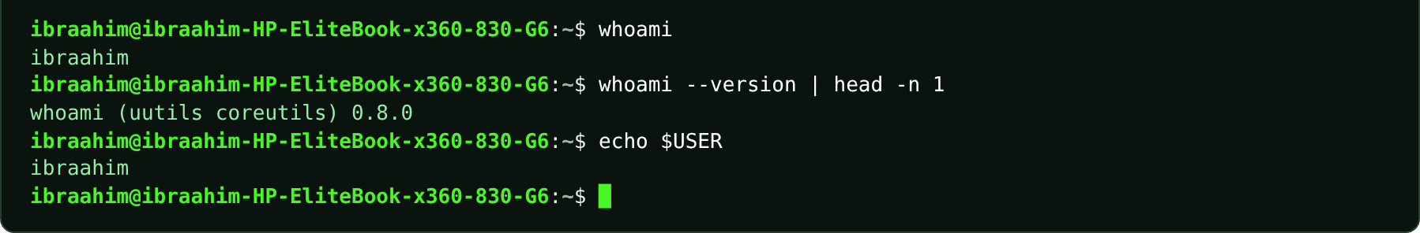

1.2 pwd
Slide topic: 1.10 Lab: your first five commands
Definition
Print Working Directory: outputs the full (absolute) path of the folder you are currently in. Check it before copying, moving or deleting anything so you know exactly where you are working.
Why students use this command
Use it to confirm your location before copying, moving or deleting files.
Syntax
pwd [-L | -P]
Options and shortcuts
Option / Shortcut | Name | Description & Example Usage
(none) | Print the current directory as an absolute path | Function: print the current directory as an absolute path (logical, -L, is the default in Bash).  Example: pwd
-L | Logical | Function: print the path as you reached it, keeping symbolic links in the name.  Example: pwd -L
-P | Physical | Function: resolve all symbolic links and print the real path.  Example: ln -s /var/log ~/logs-link; cd ~/logs-link; pwd; pwd -P; cd; rm ~/logs-link
--help | Show the usage summary of the external pwd | Function: show the usage summary of the external pwd program.  Example: /bin/pwd --help
Examples
$ pwd
$ cd /var/log
$ pwd
$ cd
$ pwd
$ ln -s /var/log ~/logs-link; cd ~/logs-link; pwd; pwd -P; cd; rm ~/logs-link
Terminal output
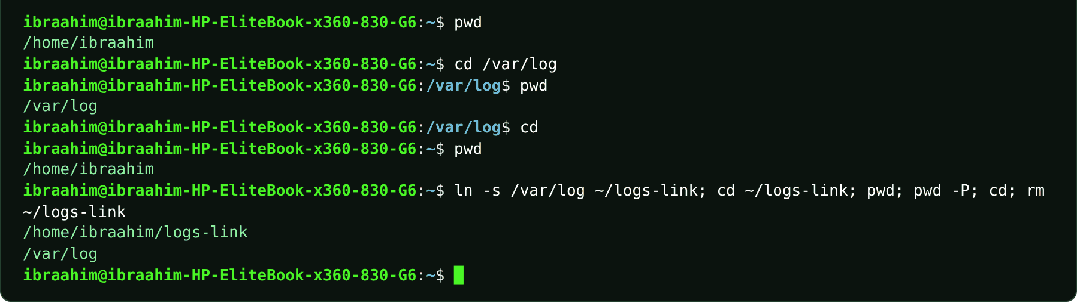

1.3 ls
Slide topic: 1.10 Lab: your first five commands
Definition
Shows what is inside a directory, listing only file names by default. Options reveal hidden entries, long-format details (file type, permissions, link count, owner, group, size, date), human-readable sizes and inode numbers. It is used throughout for navigation, file work and the link examples.
Why students use this command
Use it to see which files and folders exist in a directory and to inspect their details.
Syntax
ls [OPTION]... [FILE]...
Options and shortcuts
Option / Shortcut | Name | Description & Example Usage
(none) | Names only, in alphabetical order, hidden names left | Function: names only, in alphabetical order, hidden names left out.  Example: ls
-a, --all | Include hidden entries | Function: include hidden entries (names starting with a dot), plus . and ..  Example: ls -a
-l, --format=long | Long listing | Function: one line per entry with type + permissions, link count, owner, group, size, modification time, name.  Example: ls -l
-h, --human-readable | With -l, print sizes as K, M, G | Function: with -l, print sizes as K, M, G instead of bytes.  Example: ls --human-readable -l notes.txt
-la / -lah | Short options can be combined behind one dash | Function: short options can be combined behind one dash: everything, long format, readable sizes.  Example: ls -la
-1 | One name per line | Function: one name per line.  Example: ls -1
-i | Print the inode number of each entry | Function: print the inode number of each entry (used for the hard-link examples).  Example: ls -i
-d | List the directory itself, not its contents | Function: list the directory itself, not its contents.  Example: ls -d /etc /var
-F | Mark entry types | Function: / directory, * executable, @ symbolic link (the alias ll uses -alF).  Example: ls -F ~
-R, --recursive | List sub-directories recursively | Function: list sub-directories recursively.  Example: ls -R ~/Documents
-S / -t / -r | Sort by size / by modification time / | Function: sort by size / by modification time / reverse the order.  Example: ls -lt
--help | Show the usage summary | Function: show the usage summary.  Example: ls --help
Examples
$ mkdir -p ~/Documents ~/Downloads
$ printf "Linux tools help.\n" > ~/notes.txt
$ ls /
$ ls
$ ls -a
$ ls -l
$ ls -lh
$ ls -la
$ ls -lah ~
$ ls --all
$ ls --human-readable -l notes.txt
$ ls --all --format=long | head -n 4
$ ls -1
$ ls -li notes.txt
$ ls -l /etc | head -n 5
$ ls /sys/class/net
$ ls /proc | head -n 8
$ ls -a ~
$ ls -d /etc /var
$ ls -F ~
$ ls -lS /etc | head -n 4
$ ls /usr/bin/ls
$ ls /hme
Terminal output
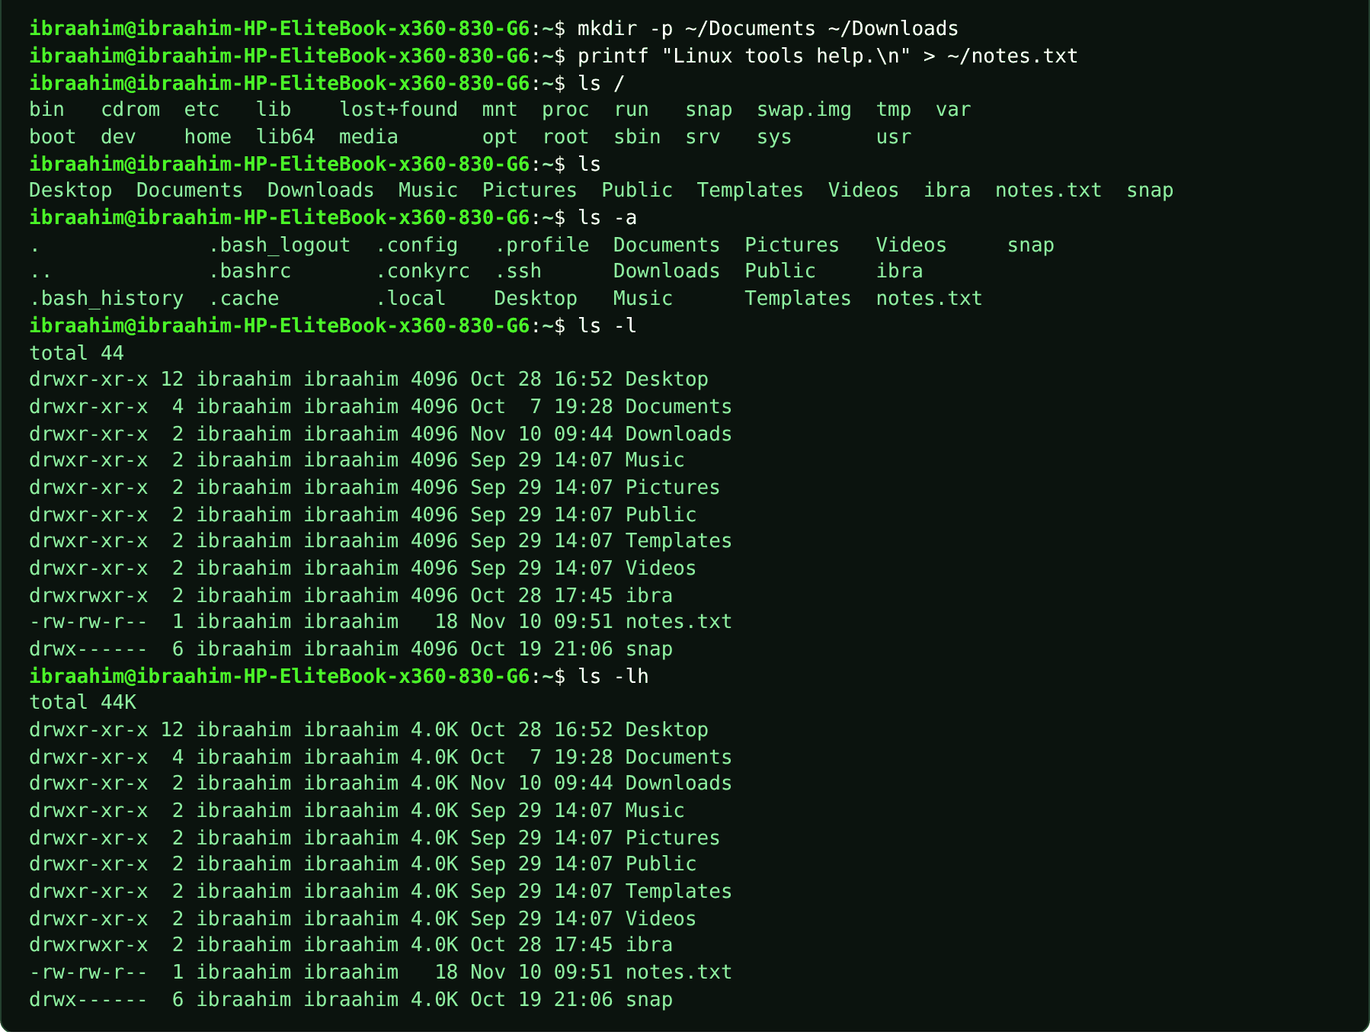
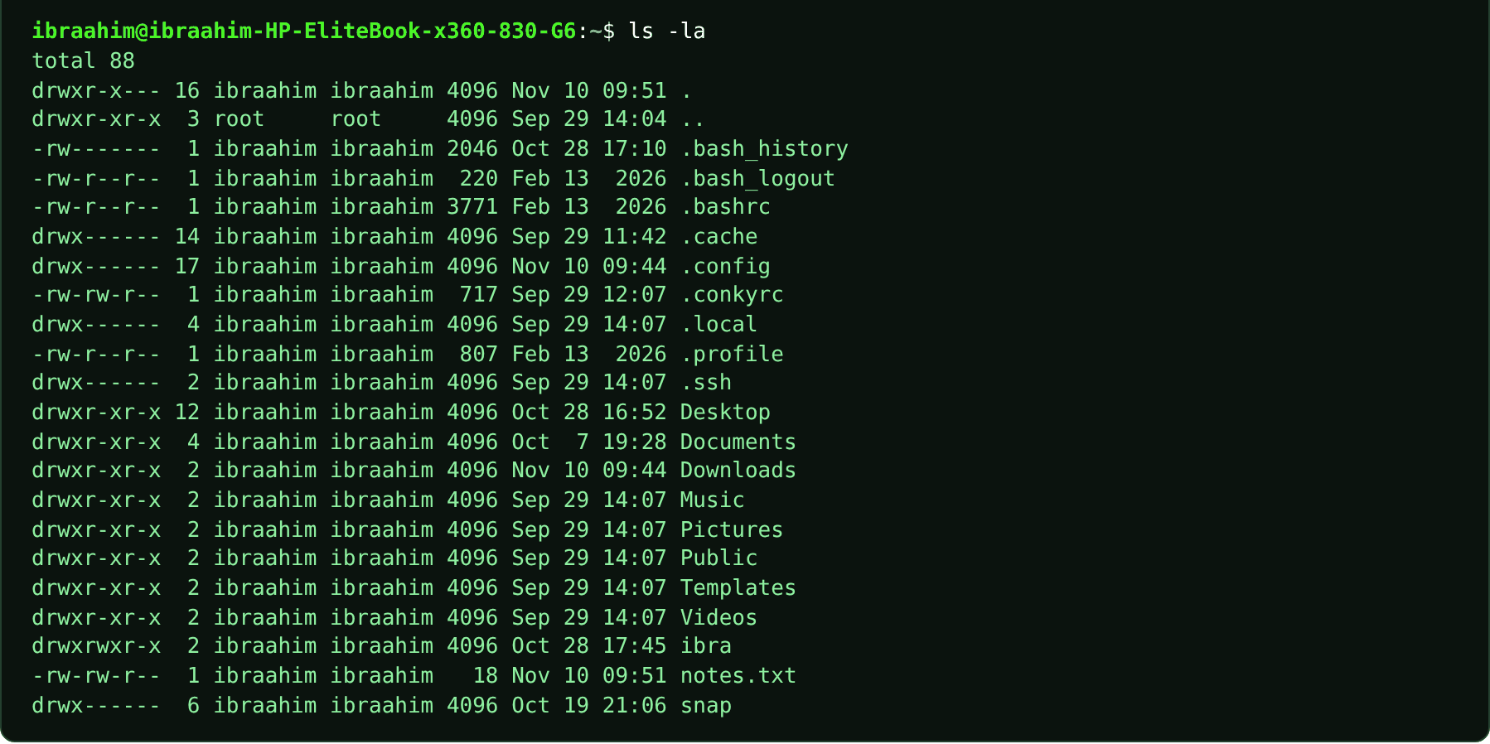
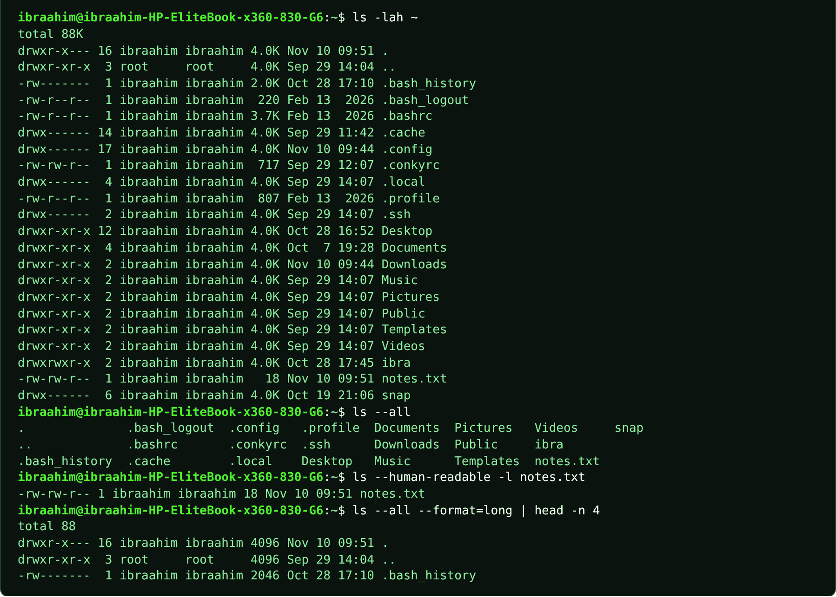
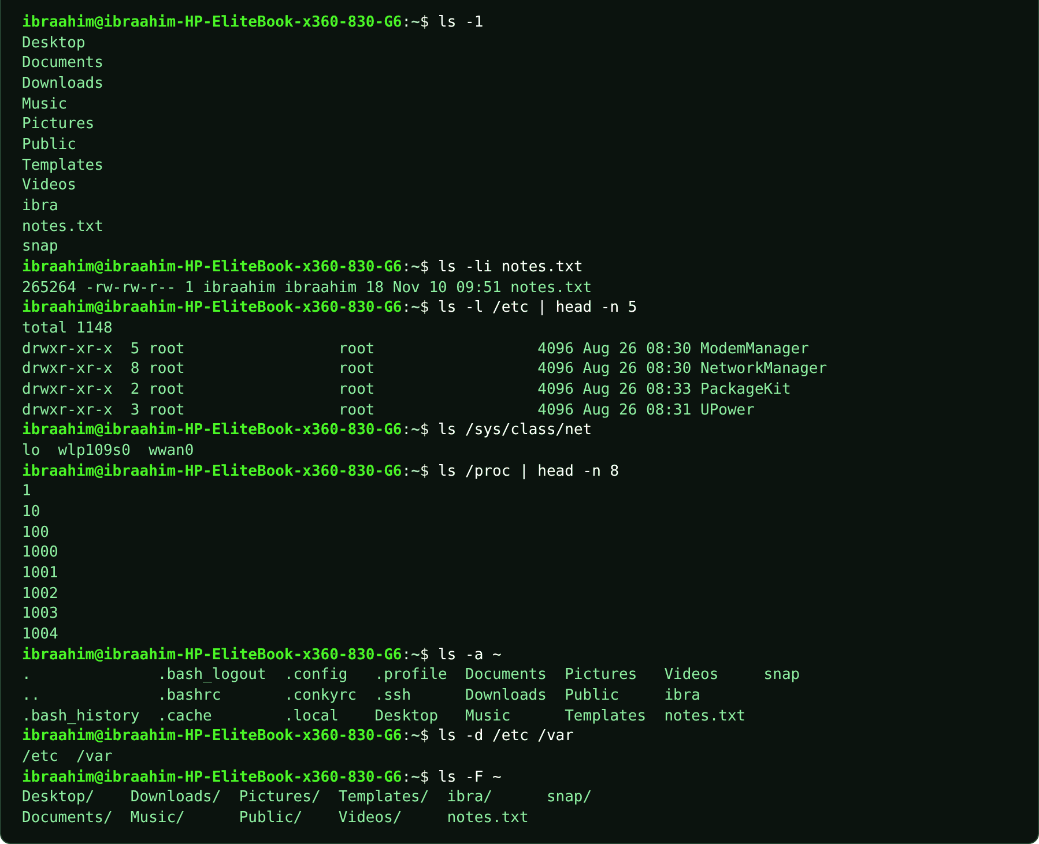
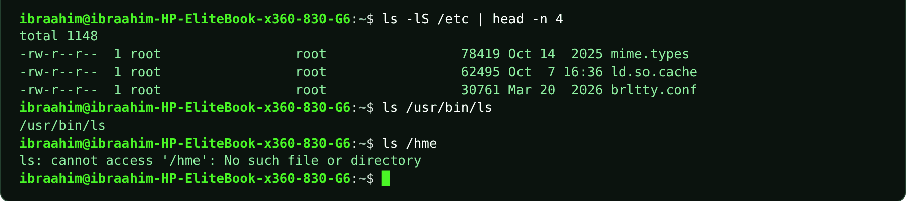

1.4 cat
Slide topic: 1.10 Lab: your first five commands
Definition
Concatenate: writes the contents of one or more files to the screen (standard output) in the order listed, and can also merge files together. Chapter 1 uses it to read /etc/os-release; Chapter 3 uses it to display sample files and to take input from standard input.
Why students use this command
Use it to read short files quickly or to join several files into one stream.
Syntax
cat [OPTION]... [FILE]...
Options and shortcuts
Option / Shortcut | Name | Description & Example Usage
(no file) | Read standard input until Ctrl+D and copy it | Function: read standard input until Ctrl+D and copy it to the screen.  Example: cat (type text, then press Ctrl+D)
-n, --number | Number all output lines | Function: number all output lines.  Example: cat -n project/README.md
-b, --number-nonblank | Number only non-empty lines | Function: number only non-empty lines.  Example: cat -b notes.txt
-A, --show-all | Show tabs | Function: show tabs (^I), line ends ($) and control characters.  Example: cat -A names.txt
-s, --squeeze-blank | Collapse repeated blank lines into one | Function: collapse repeated blank lines into one.  Example: cat -s notes.txt
--help | Show the usage summary | Function: show the usage summary.  Example: cat --help
Examples
$ cat /etc/os-release
$ mkdir -p ~/ch1demo/project; cd ~/ch1demo
$ printf "Ali\nHodan\nYusuf\n" > names.txt
$ printf "Linux project\n" > project/README.md
$ cat names.txt
$ cat -n project/README.md
$ cat names.txt project/README.md
$ cat -A names.txt
$ cat
Terminal output
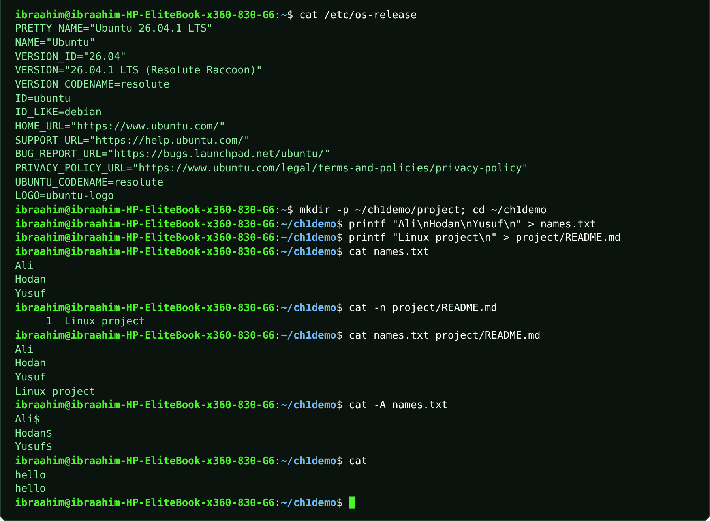

1.5 uname
Slide topic: 1.10 Lab: your first five commands
Definition
Reports information about the running kernel and the machine. uname -r gives the kernel release (used in Chapter 1 to tell the kernel apart from the distribution), and uname -s gives the kernel name (Linux on Ubuntu, Darwin on macOS). Chapter 4 adds -m, -n and -a.
Why students use this command
Use it to find out which kernel and platform your system is running.
Syntax
uname [-a] [-s] [-n] [-r] [-v] [-m] [-p] [-i] [-o]
Options and shortcuts
Option / Shortcut | Name | Description & Example Usage
(none) | Same as -s | Function: same as -s: the kernel name.  Example: uname
-s | Kernel name | Function: kernel name (Linux; Darwin on macOS).  Example: uname -s
-r | Kernel release, for example 6.8.0-85-generic | Function: kernel release, for example 6.8.0-85-generic.  Example: uname -r
-v | Kernel version string | Function: kernel version string (build number and date).  Example: uname -v
-m | Machine hardware name / CPU architecture | Function: machine hardware name / CPU architecture (x86_64, aarch64).  Example: uname -m
-n | Network node hostname | Function: network node hostname.  Example: uname -n
-o | Operating system name | Function: operating system name (GNU/Linux).  Example: uname -o
-a | All of the above on one line, ready | Function: all of the above on one line, ready to paste into a lab report.  Example: uname -a
Examples
$ uname
$ uname -s
$ uname -r
$ uname -v
$ uname -m
$ uname -n
$ uname -o
$ uname -a
$ uname -s # on a Mac Terminal
Terminal output
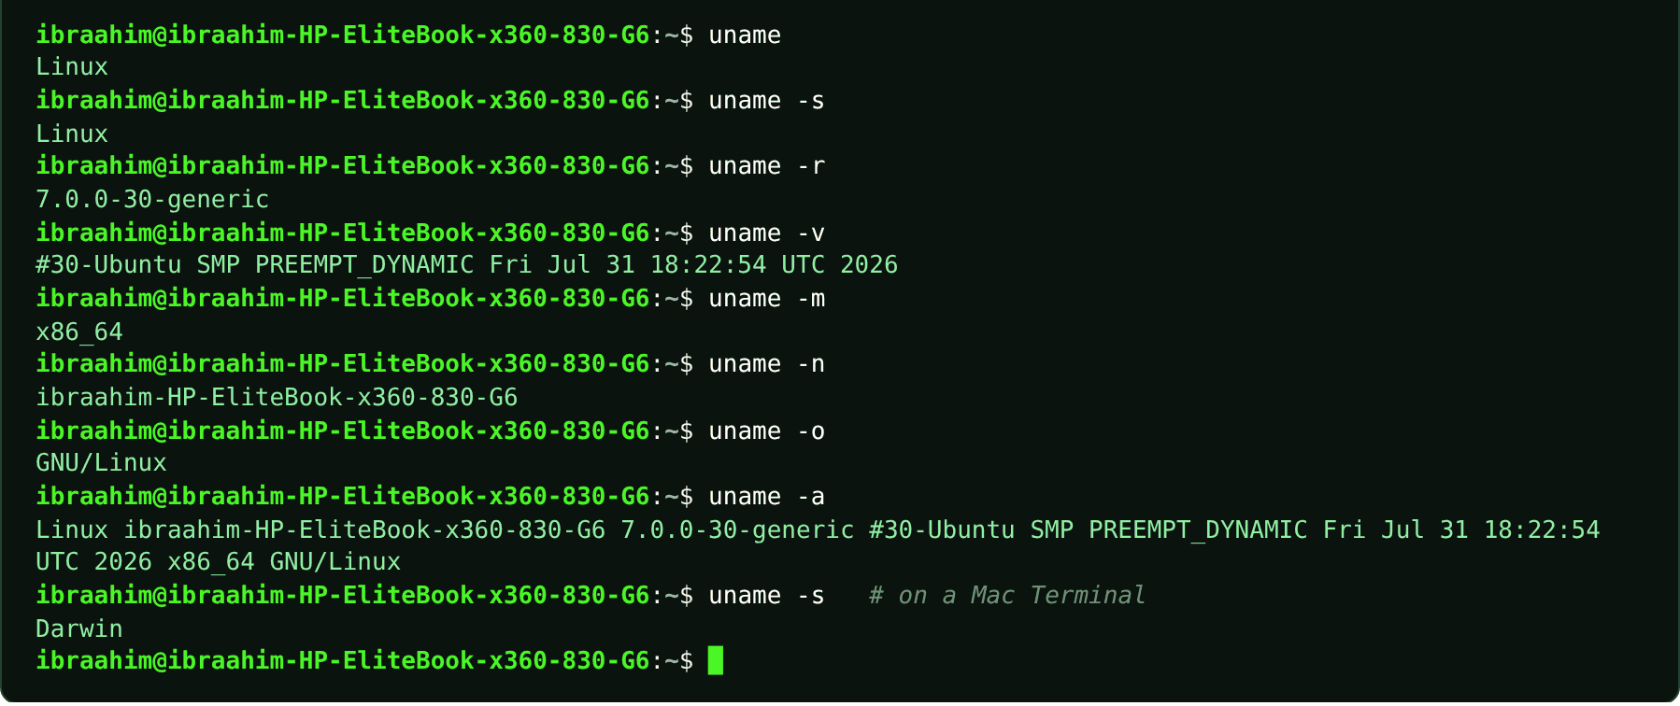

1.6 apt
Slide topic: 1.5 Distributions and families (Debian family)
Definition
The software package manager of the Debian family, including Ubuntu. It installs, upgrades, searches for and removes programs. The course identifies it as the tool to use on Ubuntu, and Chapter 2 shows Ubuntu proposing sudo apt install sl when a command is missing. Full software management is covered in Chapter 6.
Why students use this command
Use it to install, update and remove software on Ubuntu from the command line.
Syntax
apt [OPTIONS] COMMAND [PACKAGE...]
Options and shortcuts
Option / Shortcut | Name | Description & Example Usage
update | Refresh the list of available packages | Function: refresh the list of available packages (needs sudo).  Example: sudo apt update
upgrade | Install newer versions of installed packages | Function: install newer versions of installed packages (needs sudo).  Example: sudo apt upgrade
install PKG | Install a package and its dependencies | Function: install a package and its dependencies (needs sudo).  Example: sudo apt install sl
remove PKG | Remove a package but keep its configuration | Function: remove a package but keep its configuration (needs sudo).  Example: sudo apt remove sl
search WORD | Search package names and descriptions | Function: search package names and descriptions.  Example: apt search locomotive
show PKG | Display package details | Function: display package details.  Example: apt show sl
list --installed | List installed packages | Function: list installed packages.  Example: apt list --installed 2>/dev/null | head -n 4
--version | Print the apt version | Function: print the apt version.  Example: apt --version
Examples
$ apt --version
$ apt list --installed 2>/dev/null | head -n 4
$ sudo apt update
$ sudo apt install sl
Terminal output
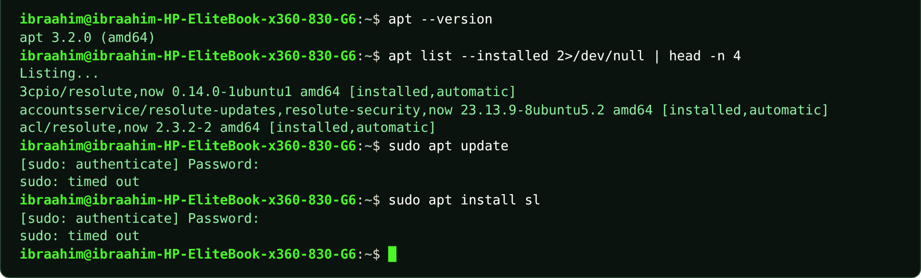

1.7 dpkg
Slide topic: 1.5 Distributions and families (Debian family)
Definition
The low-level package tool that apt relies on in Debian-family systems. It works with individual .deb files and with the database of installed packages.
Why students use this command
Use it to install a downloaded .deb file or to query what is installed.
Syntax
dpkg [OPTION]... ACTION
Options and shortcuts
Option / Shortcut | Name | Description & Example Usage
-l [PATTERN] | List installed packages | Function: list installed packages (optionally matching a pattern).  Example: dpkg -l bash
-L PKG | List the files a package installed | Function: list the files a package installed.  Example: dpkg -L bash | head -n 5
-S FILE | Find which package owns a file | Function: find which package owns a file.  Example: dpkg -S /usr/bin/ls
-s PKG | Show the status of an installed package | Function: show the status of an installed package.  Example: dpkg -s bash | head -n 4
-i FILE.deb | Install a local .deb file | Function: install a local .deb file (needs sudo).  Example: sudo dpkg -i package.deb
--version | Print the dpkg version | Function: print the dpkg version.  Example: dpkg --version | head -n 1
Examples
$ dpkg --version | head -n 1
$ dpkg -l bash
$ dpkg -s bash | head -n 4
$ dpkg -L bash | head -n 5
$ dpkg -S /usr/bin/ls
Terminal output
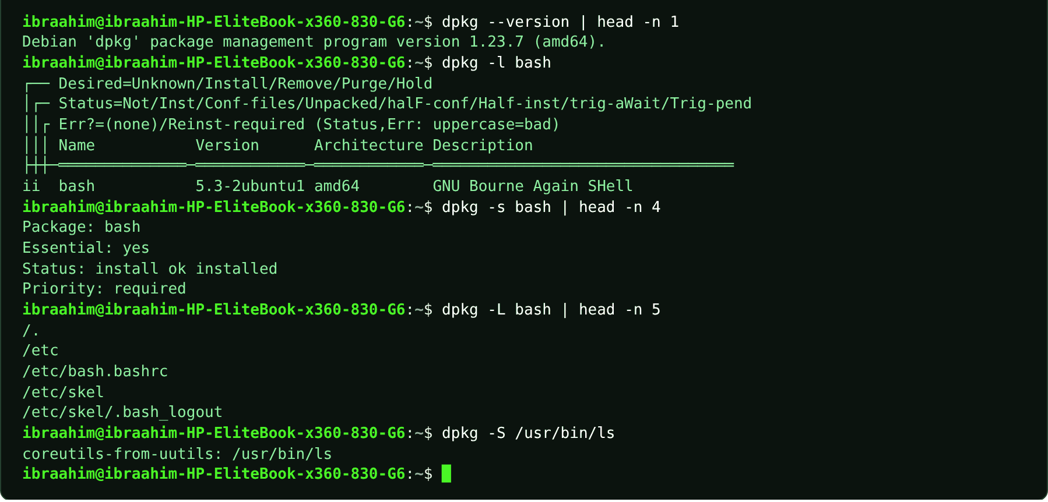

1.8 yum
Slide topic: 1.5 Distributions and families (Red Hat family)
Definition
The older package manager of the Red Hat family (RHEL, CentOS). The course uses it as an example of Red Hat wording ("yum install…") that should not be copied onto Ubuntu, where the command does not exist.
Why students use this command
Use it to recognize Red Hat-style package commands and tell them apart from Ubuntu's apt.
Syntax
yum [OPTIONS] COMMAND [PACKAGE...]
Options and shortcuts
Option / Shortcut | Name | Description & Example Usage
install PKG | Install a package | Function: install a package.  Example: yum install httpd
update | Update installed packages | Function: update installed packages.  Example: sudo yum update
remove PKG | Remove a package | Function: remove a package.  Example: sudo yum remove httpd
search WORD | Search for a package | Function: search for a package.  Example: yum search editor
-y | Answer yes to all questions | Function: answer yes to all questions.  Example: sudo yum -y update
Examples
$ yum install httpd
$ yum install httpd # on Ubuntu
Terminal output
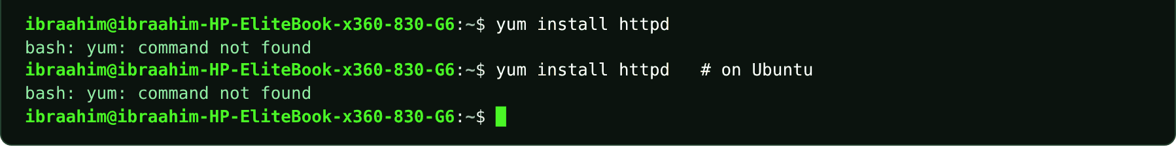

1.9 dnf
Slide topic: 1.5 Distributions and families (Red Hat family)
Definition
The modern package manager of the Red Hat family (Fedora, RHEL, Rocky). It succeeds yum and works with .rpm packages.
Why students use this command
Use it to manage software on modern Fedora, RHEL and Rocky systems.
Syntax
dnf [OPTIONS] COMMAND [PACKAGE...]
Options and shortcuts
Option / Shortcut | Name | Description & Example Usage
install PKG | Install a package | Function: install a package.  Example: dnf install nano
upgrade | Update all packages | Function: update all packages.  Example: sudo dnf upgrade
remove PKG | Remove a package | Function: remove a package.  Example: sudo dnf remove httpd
search WORD | Search for a package | Function: search for a package.  Example: dnf search nano
info PKG | Show package information | Function: show package information.  Example: dnf info nano
-y | Answer yes to all questions | Function: answer yes to all questions.  Example: sudo dnf -y upgrade
Examples
$ dnf install nano
$ dnf search nano
Terminal output
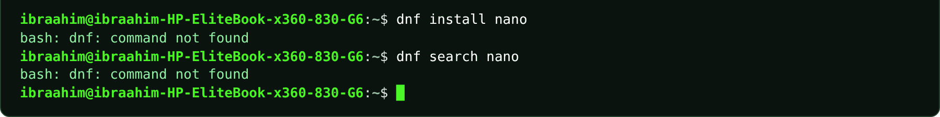

1.10 zypper
Slide topic: 1.5 Distributions and families (SUSE family)
Definition
The package manager of the SUSE family (openSUSE, SLES). It installs .rpm packages, and YaST is its graphical counterpart.
Why students use this command
Use it to manage software on SUSE-based systems such as openSUSE.
Syntax
zypper [OPTIONS] COMMAND [PACKAGE...]
Options and shortcuts
Option / Shortcut | Name | Description & Example Usage
install PKG | Install a package | Function: install a package.  Example: zypper install nano
refresh | Refresh repository data | Function: refresh repository data.  Example: sudo zypper refresh
remove PKG | Remove a package | Function: remove a package.  Example: sudo zypper remove nano
search WORD | Search for a package | Function: search for a package.  Example: zypper search editor
update | Update installed packages | Function: update installed packages.  Example: sudo zypper update
Examples
$ zypper install nano
Terminal output

Chapter 2: Linux System Architecture, Command Line, and File Management
16 commands in this chapter, in the order the topics appear in the slides.
COMMAND INVENTORY FOR THIS CHAPTER
Command | Slide topic
echo | 2.3 The terminal and Bash / 2.6 Quoting / 2.7 Variables
history | 2.3 The terminal and Bash
man | 2.5 Getting help: man, --help, and info
info | 2.5 Getting help: man, --help, and info
help | 2.5 Getting help: man, --help, and info
touch | 2.6 Quoting, escaping and wildcards / 2.10 Creating files
export | 2.7 Variables, PATH, and ~/.bashrc
cd | 2.9 Navigating with pwd, cd, and ls
mkdir | 2.10 Creating and managing files
rmdir | 2.10 Creating and managing files
cp | 2.10 Creating and managing files
mv | 2.10 Creating and managing files
rm | 2.10 Creating and managing files
sudo | 2.7 Variables, PATH (first appears in the "command not found" hint)
sl | 2.7 Variables, PATH, and ~/.bashrc
ll | 2.7 Variables, PATH, and ~/.bashrc

2.1 echo
Slide topic: 2.3 The terminal and Bash / 2.6 Quoting / 2.7 Variables
Definition
Outputs its arguments to the screen. It is the main way the course demonstrates the shell at work: reading variables ($SHELL, $HOME, $USER, $PATH, $$), showing how quotes and escapes behave, and adding lines to files through redirection. In Bash, echo is a built-in.
Why students use this command
Use it to print text or variable values and to write simple lines into files.
Syntax
echo [-n] [-e] [STRING]...
Options and shortcuts
Option / Shortcut | Name | Description & Example Usage
-n | Do not print the trailing newline | Function: do not print the trailing newline.  Example: echo -n "Somalia"; echo
-e | Interpret backslash escapes such as \n and \t | Function: interpret backslash escapes such as \n and \t.  Example: echo -e "one\ttwo"
$NAME | The shell replaces it with the variable value | Function: the shell replaces it with the variable value before echo runs.  Example: NAME=Ali; echo $NAME
"..." | Double quotes keep spaces but still expand $ | Function: double quotes keep spaces but still expand $.  Example: echo "Hello $USER"
'...' | Single quotes keep everything exactly as typed | Function: single quotes keep everything exactly as typed.  Example: echo 'Hello $USER'
\$ | Backslash protects one character | Function: backslash protects one character: \$HOME prints $HOME.  Example: echo \$HOME
$$ | Special variable | Function: the PID of the current shell.  Example: echo $$
$? | Special variable | Function: the exit status of the last command (0 = success).  Example: true; echo $?; false; echo $?
Examples
$ echo $SHELL
$ echo Hello $USER
$ echo "Hello $USER"
$ echo 'Hello $USER'
$ echo \$HOME
$ echo $HOME $USER
$ echo $PATH
$ echo $$
$ true; echo $?; false; echo $?
$ echo -n "Somalia"; echo
$ echo -e "one\ttwo"
$ mkdir -p ~/lab; cd ~/lab; echo "added" >> log.txt; cat log.txt
Terminal output
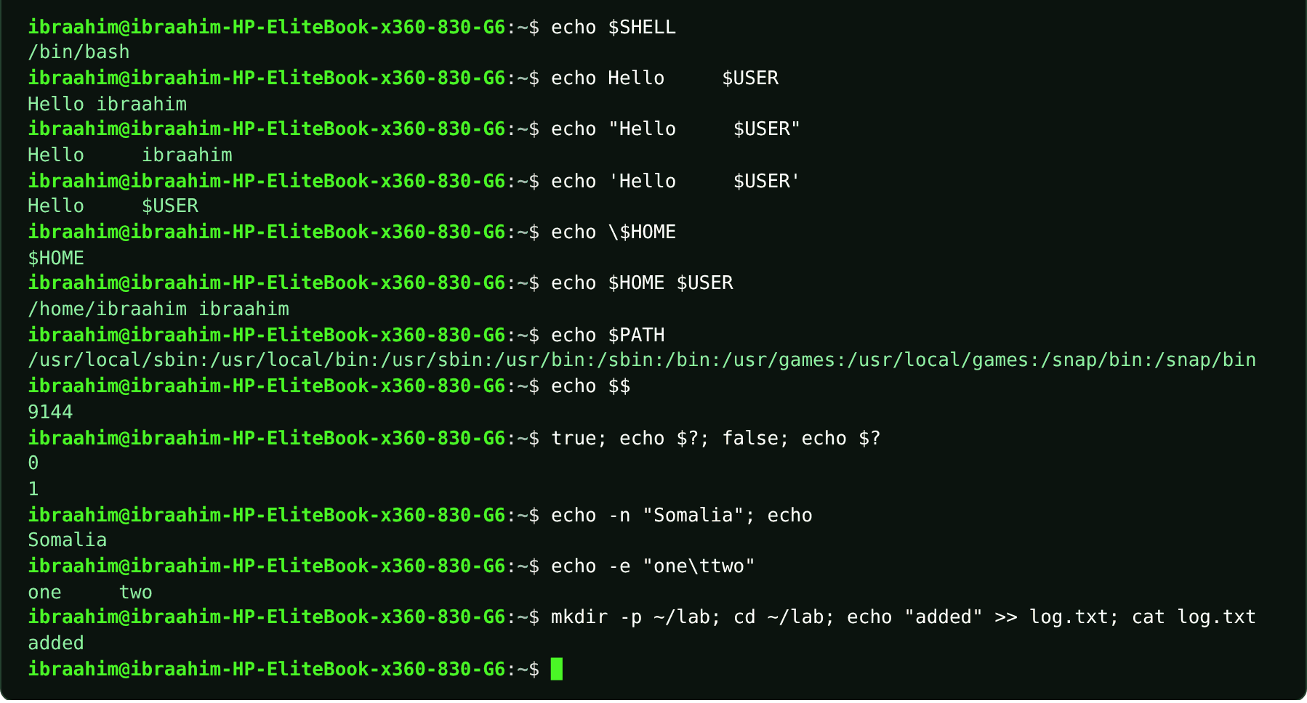

2.2 history
Slide topic: 2.3 The terminal and Bash
Definition
Displays the numbered list of commands that Bash has remembered. Bash writes this list to ~/.bash_history when the shell exits. Related shortcuts (Up/Down arrows, Ctrl+R reverse search) let you reuse earlier commands. history is a shell built-in.
Why students use this command
Use it to find and repeat commands you typed earlier instead of retyping them.
Syntax
history [N] | history -c | history -d OFFSET
Options and shortcuts
Option / Shortcut | Name | Description & Example Usage
(none) | Print the whole numbered list | Function: print the whole numbered list.  Example: history
N | Print only the last N entries | Function: print only the last N entries.  Example: history 5
-c | Clear the history of this shell | Function: clear the history of this shell.  Example: history -c
-d N | Delete entry number N | Function: delete entry number N.  Example: history -d 12
!N | Run entry number N again | Function: run entry number N again.  Example: !12
!! | Run the previous command again | Function: run the previous command again.  Example: !!
Examples
$ history -c
$ pwd
$ ls ~ > /dev/null
$ cd /etc
$ cd ~
$ history
$ history 3
Terminal output
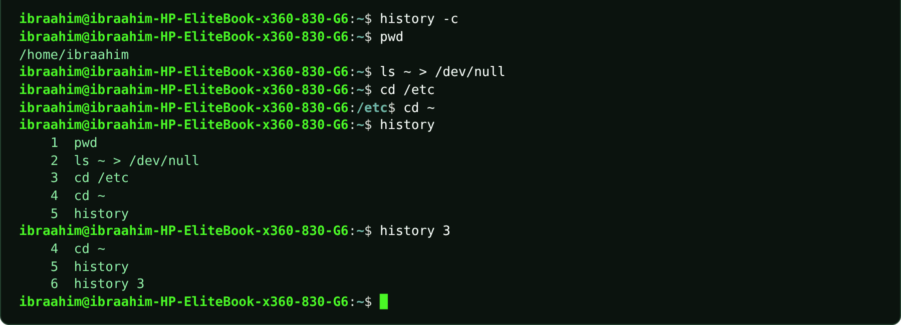

2.3 man
Slide topic: 2.5 Getting help: man, --help, and info
Definition
Opens a command's manual page in a pager. Read NAME and SYNOPSIS first; square brackets mean an item is optional. Pages are divided into sections: 1 for user commands, 5 for file formats, 8 for administration. Keys: Space moves to the next page, b goes back, /word searches, n jumps to the next match, q quits. Alternatives are command --help (a short summary) and info.
Why students use this command
Use it when you need the complete, official description of a command and its options.
Syntax
man [SECTION] PAGE
Options and shortcuts
Option / Shortcut | Name | Description & Example Usage
man ls | Open the page ls(1) | Function: open the page ls(1).  Example: type man
man 1 passwd / man 5 passwd | Section 1 is the command | Function: section 1 is the command; section 5 is the /etc/passwd file format.  Example: type man
-k WORD | Search page names and descriptions | Function: search page names and descriptions (same as apropos).  Example: man -k partition
-f PAGE | One-line description | Function: one-line description (same as whatis).  Example: man -f ls
Space / b | Next page / back a page | Function: next page / back a page.  Example: Press Space for the next page, b to go back
/word, n | Search forward, jump to the next match | Function: search forward, jump to the next match.  Example: Type /option, then press n for the next match
q | Quit the viewer | Function: quit the viewer.  Example: man rmdir # find the option that removes empty parents, then press q
command --help | Short usage summary printed straight to the screen | Function: short usage summary printed straight to the screen (works on most GNU tools).  Example: ls --help
Examples
$ mkdir --help | head -n 8
$ ls --help | head -n 6
$ type man
$ man ls
$ man cd
$ man rmdir # find the option that removes empty parents, then press q
Terminal output
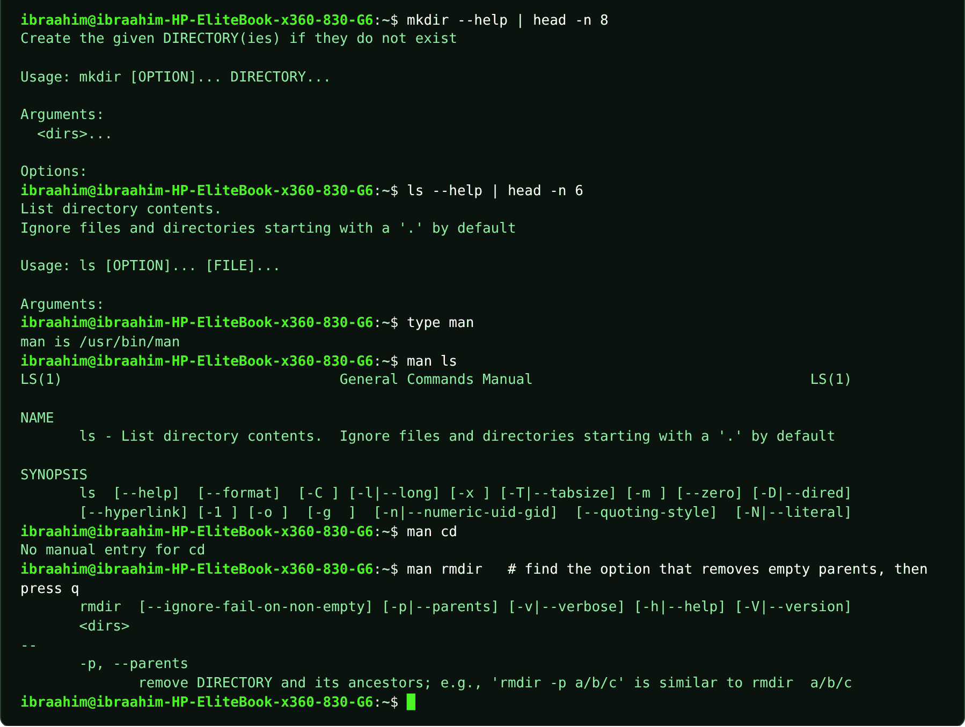

2.4 info
Slide topic: 2.5 Getting help: man, --help, and info
Definition
Opens the longer, book-style GNU documentation, with links between nodes. Use it when a man page is too brief. Keys: Space next page, n/p next or previous node, q quit.
Why students use this command
Use it when a man page is too short and you want fuller documentation.
Syntax
info [COMMAND]
Options and shortcuts
Option / Shortcut | Name | Description & Example Usage
info ls | Open the manual of ls | Function: open the manual of ls.  Example: info ls
n / p / u | Next node / previous node / up one | Function: next node / previous node / up one level.  Example: Press n (next node), p (previous node) or u (up)
Space / Backspace | Scroll forward / back | Function: scroll forward / back.  Example: Press Space to scroll forward, Backspace to scroll back
q | Quit | Function: quit.  Example: Press q
--output=FILE | Write the text to a file instead of | Function: write the text to a file instead of the viewer.  Example: info ls --output=ls-info.txt
Examples
$ info ls
Terminal output
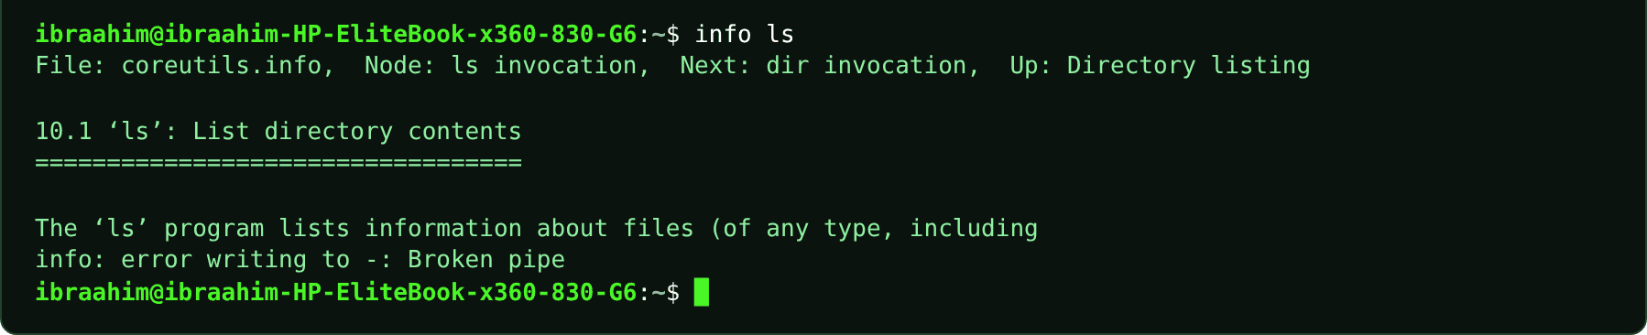

2.5 help
Slide topic: 2.5 Getting help: man, --help, and info
Definition
Displays help for Bash built-ins such as cd, export and history. Built-ins have no manual page of their own, so man cd fails; ask Bash itself instead.
Why students use this command
Use it to read the documentation of shell built-ins, which have no man page.
Syntax
help [-d] [-m] [-s] [PATTERN]
Options and shortcuts
Option / Shortcut | Name | Description & Example Usage
help cd | Describe the cd built-in | Function: describe the cd built-in.  Example: help cd | head -n 4
-s | Print only a short usage line | Function: print only a short usage line.  Example: help -s pwd
-d | Print a short description | Function: print a short description.  Example: help -d cd
-m | Print a man-page style description | Function: print a man-page style description.  Example: help -m cd
(none) | List all built-ins | Function: list all built-ins.  Example: help
Examples
$ help cd | head -n 4
$ help -s pwd
$ help | head -n 5
Terminal output
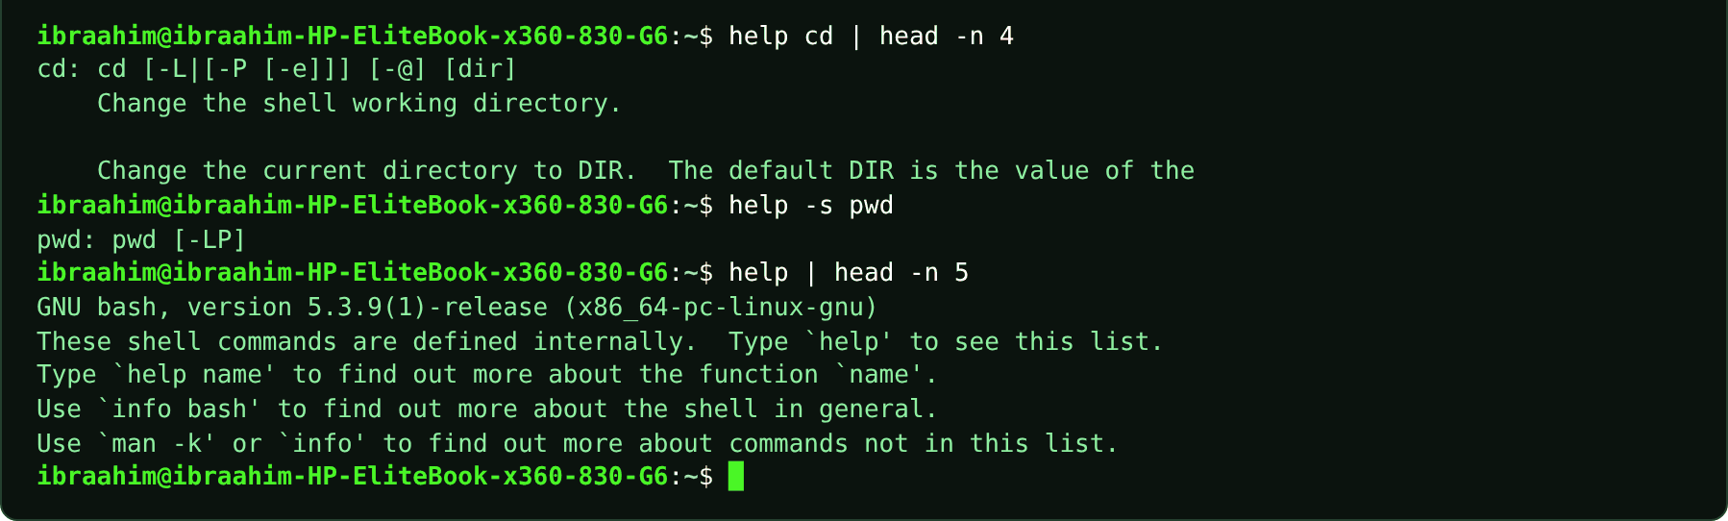

2.6 touch
Slide topic: 2.6 Quoting, escaping and wildcards / 2.10 Creating files
Definition
Creates an empty file, or refreshes the modification time of a file that already exists. The course uses it to show how quoting groups words: touch new file creates two files, whereas touch "new file" creates one.
Why students use this command
Use it to create empty practice files quickly or to update a file's timestamp.
Syntax
touch [OPTION]... FILE...
Options and shortcuts
Option / Shortcut | Name | Description & Example Usage
FILE... | One or more file names to create or | Function: one or more file names to create or refresh.  Example: touch a.txt b.txt
-c | Do not create files that do not exist | Function: do not create files that do not exist.  Example: touch -c missing.txt
-t STAMP | Set a specific time [[CC]YY]MMDDhhmm | Function: set a specific time [[CC]YY]MMDDhhmm.  Example: touch -t 202601011200 notes.txt
-d STRING | Use a date string such as "2026-03-01 10:00" | Function: use a date string such as "2026-03-01 10:00".  Example: touch -d "2026-03-01 10:00" notes.txt; ls -l notes.txt
-a / -m | Change only the access / only the modification | Function: change only the access / only the modification time.  Example: touch -m notes.txt
Examples
$ mkdir -p ~/lab; cd ~/lab
$ touch new file
$ ls
$ touch "new file"
$ ls
$ touch notes.txt todo.md
$ touch notes\*.txt
$ ls
$ touch lab1.txt lab2.txt lab10.txt photo1.jpg
$ ls -l notes.txt
$ touch -d "2026-03-01 10:00" notes.txt; ls -l notes.txt
Terminal output
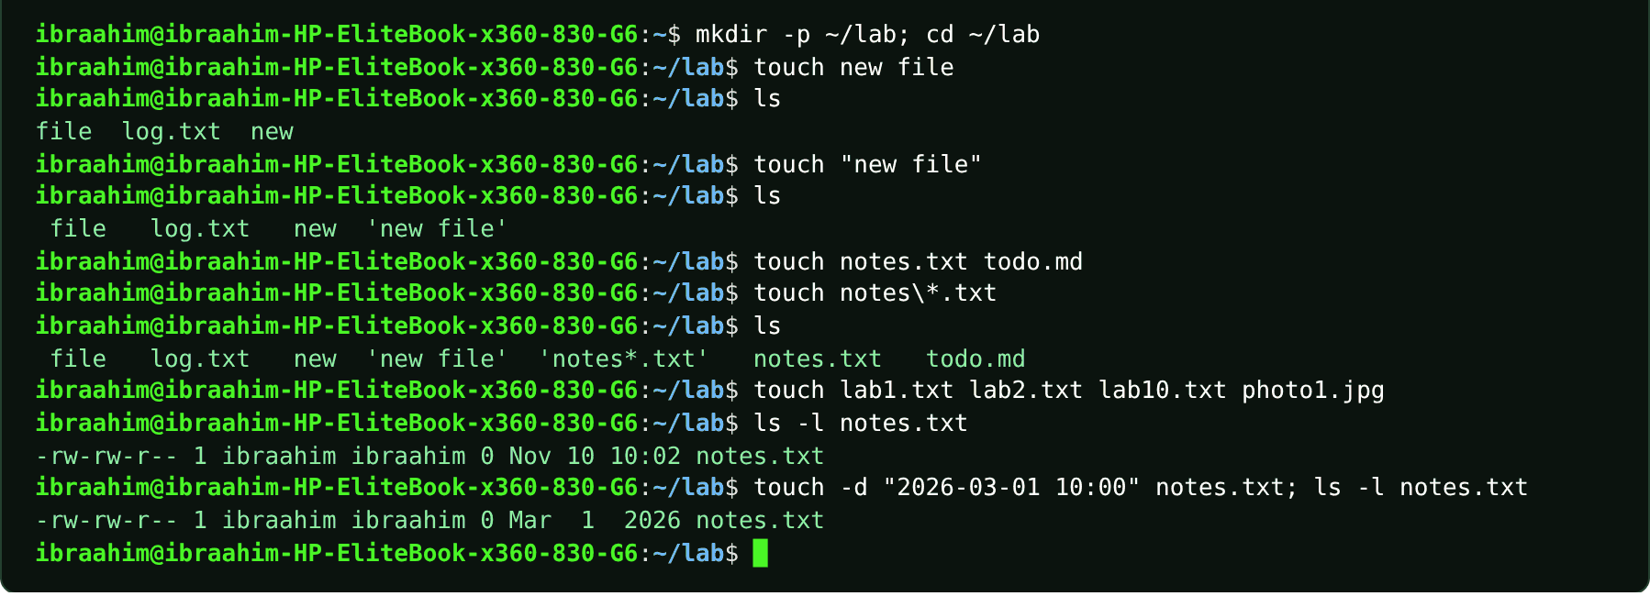

2.7 export
Slide topic: 2.7 Variables, PATH, and ~/.bashrc
Definition
Marks a shell variable so that it is passed to the environment, meaning programs launched from this shell receive a copy. NAME=value (no spaces around =) creates a shell variable and $NAME reads it. Values set at the prompt vanish when the terminal closes; add them to ~/.bashrc to make them permanent. export is a shell built-in.
Why students use this command
Use it when a program needs a configuration value passed through its environment.
Syntax
export [-p] [NAME[=VALUE]]...
Options and shortcuts
Option / Shortcut | Name | Description & Example Usage
NAME=value | Assignment | Function: create a shell variable (not a command; no spaces allowed around =).  Example: export COURSE=Linux
export NAME | Pass NAME to child programs | Function: pass NAME to child programs.  Example: export COURSE
export NAME=value | Assign and export in one step | Function: assign and export in one step.  Example: export COURSE
-p | List all exported variables | Function: list all exported variables.  Example: export -p | grep COURSE
-n NAME | Remove the export mark | Function: remove the export mark.  Example: export -n COURSE
Examples
$ COURSE=linux
$ echo $COURSE
$ bash -c 'echo "child sees: [$COURSE]"'
$ export COURSE
$ bash -c 'echo "child sees: [$COURSE]"'
$ COURSE = linux
$ export -p | grep COURSE
$ PATH="$HOME/bin:$PATH"; echo $PATH
Terminal output
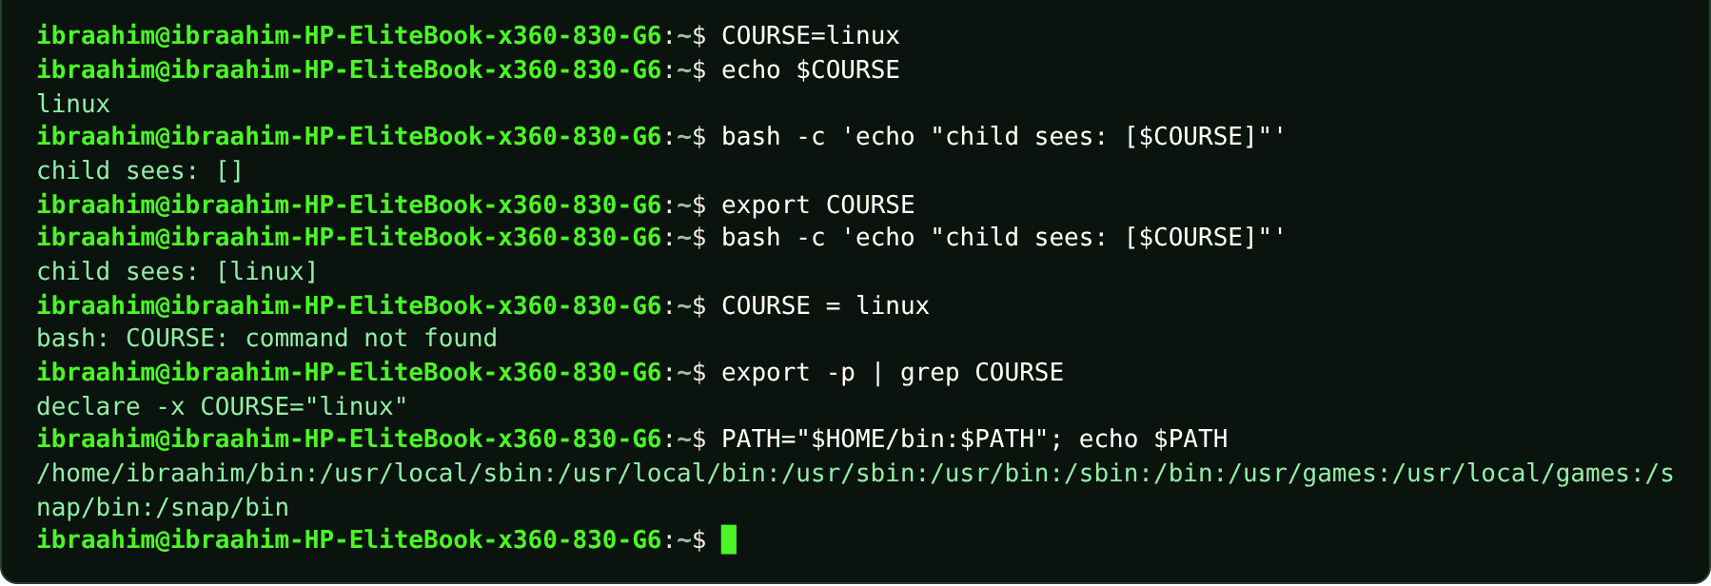

2.8 cd
Slide topic: 2.9 Navigating with pwd, cd, and ls
Definition
Change Directory: moves the shell into another directory. It is a Bash built-in (which is why man cd has no page; use help cd). An absolute path starts from /, while a relative path starts from your current location.
Why students use this command
Use it to move between directories so that later commands act on the right files.
Syntax
cd [DIRECTORY]
Options and shortcuts
Option / Shortcut | Name | Description & Example Usage
(none) / ~ | Go to your home directory | Function: go to your home directory.  Example: cd ~
/var/log | Absolute path | Function: straight to /var/log.  Example: cd /var/log
Documents | Relative path | Function: into Documents below the current directory.  Example: cd Documents
.. | Up one level to the parent | Function: up one level to the parent.  Example: cd ..
. | The current directory | Function: the current directory (no move).  Example: cd .
- | Back to the previous directory | Function: back to the previous directory (and print it).  Example: cd -
../Downloads | Relative | Function: up one level, then into Downloads.  Example: cd ../Downloads
Examples
$ pwd
$ cd /etc
$ cd ..
$ ls
$ cd ~
$ mkdir -p ~/Documents ~/Downloads
$ cd ~/Documents
$ cd ../Downloads; pwd
$ cd /home/ibra/Downloads; pwd
$ cd /var/log
$ cd ..
$ cd -
$ cd
$ pwd
$ cd ~/Documents; cd ..; cd ../..; cd ~/Documents; cd .; pwd
$ cd documents
Terminal output
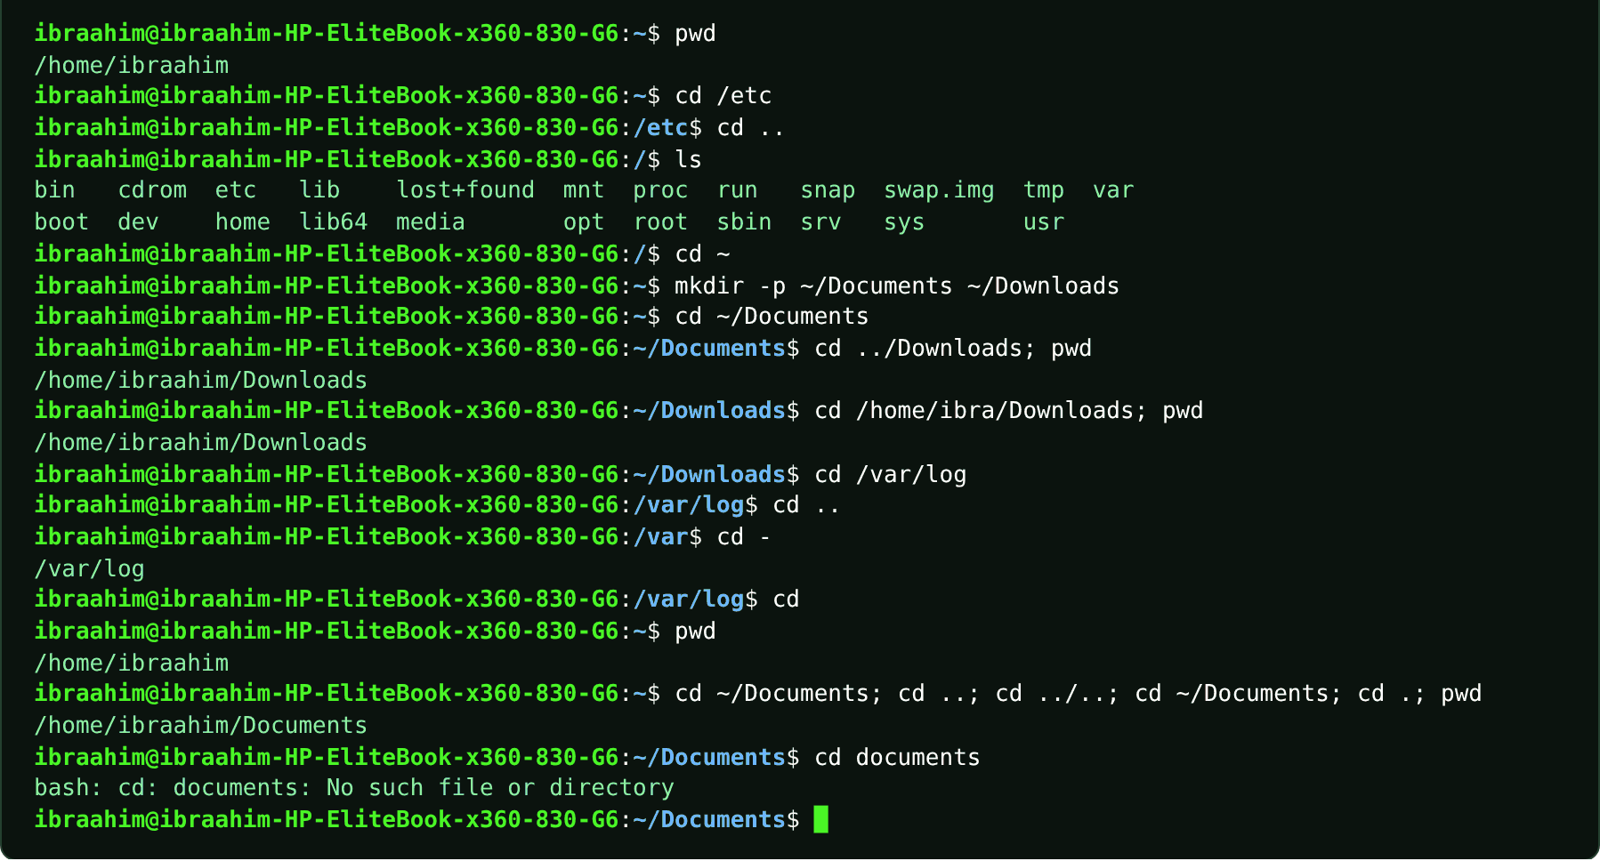

2.9 mkdir
Slide topic: 2.10 Creating and managing files
Definition
Makes new directories. With -p it also creates any missing parent directories and raises no error if the directory already exists, so a whole tree can be built in one line.
Why students use this command
Use it to create folders, including whole directory trees, for organizing work.
Syntax
mkdir [OPTION]... DIRECTORY...
Options and shortcuts
Option / Shortcut | Name | Description & Example Usage
DIRECTORY... | One or more directories to create | Function: one or more directories to create.  Example: mkdir docs photos
-p, --parents | Create parents as needed | Function: create parents as needed; no error if it already exists.  Example: mkdir -p projects/linux
-v, --verbose | Print a message for every directory created | Function: print a message for every directory created.  Example: mkdir -v backup
-m MODE | Set the permission mode | Function: set the permission mode (for example 755).  Example: mkdir -m 755 shared
--help | Show the usage summary | Function: show the usage summary.  Example: mkdir --help
Examples
$ cd ~/lab
$ mkdir week3
$ mkdir -p projects/linux
$ mkdir -v backup
$ ls
$ mkdir week3
$ mkdir -p ~/ch2lab/notes
$ mkdir ~/ch2lab/backup
$ ls ~/ch2lab
$ mkdir -p scratch && echo OK > scratch/status.txt; cat scratch/status.txt
Terminal output
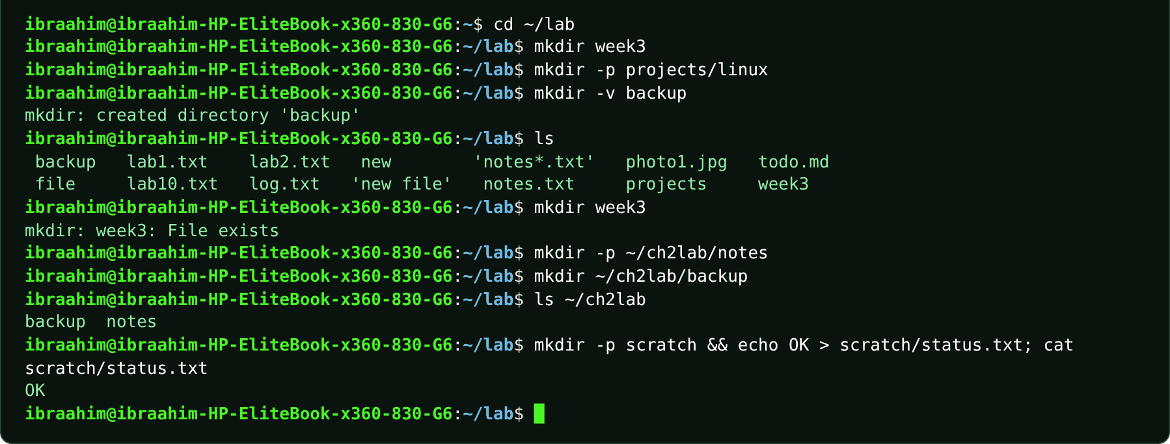

2.10 rmdir
Slide topic: 2.10 Creating and managing files
Definition
Deletes directories, but only empty ones. The "Directory not empty" error is a safeguard that protects your files.
Why students use this command
Use it to remove empty folders safely, since it refuses to delete anything that still has content.
Syntax
rmdir [OPTION]... DIRECTORY...
Options and shortcuts
Option / Shortcut | Name | Description & Example Usage
DIRECTORY... | Empty directories to remove | Function: empty directories to remove.  Example: rmdir old-folder
-p, --parents | Also remove empty parent directories | Function: also remove empty parent directories (rmdir -p a/b is like rmdir a/b a).  Example: mkdir -p a/b/c
-v | Print a message for every directory removed | Function: print a message for every directory removed.  Example: rmdir -v old-folder
--ignore-fail-on-non-empty | Do not report failures caused by non-empty directories | Function: do not report failures caused by non-empty directories.  Example: rmdir --ignore-fail-on-non-empty ~/Documents
Examples
$ cd ~/lab
$ rmdir week3
$ ls
$ rmdir projects
$ mkdir -p a/b/c
$ rmdir -p a/b/c
$ ls
Terminal output
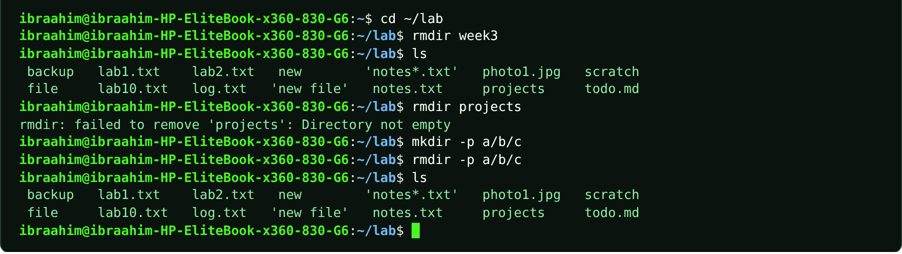

2.11 cp
Slide topic: 2.10 Creating and managing files
Definition
Copies files and directories, leaving two files afterwards. It silently overwrites an existing destination unless you add -i, and directories require -r. The course also lists cp (with ls and mv) as one of the shell's small tools in Chapter 1.
Why students use this command
Use it to make copies of files and folders, for example as a backup before editing.
Syntax
cp [OPTION]... SOURCE DEST | cp [OPTION]... SOURCE... DIRECTORY/
Options and shortcuts
Option / Shortcut | Name | Description & Example Usage
SOURCE DEST | Copy a file to a new name | Function: copy a file to a new name.  Example: cp notes.txt backup.txt
SOURCE... DIR/ | Copy one or more files into a directory | Function: copy one or more files into a directory.  Example: cp a.txt b.txt ~/Documents/
-r, -R, --recursive | Copy a directory and everything inside it | Function: copy a directory and everything inside it.  Example: cp -r notes notes-copy
-i, --interactive | Ask before overwriting | Function: ask before overwriting.  Example: cp -i notes.bak notes/day1.txt </dev/null
-v, --verbose | Show each copy as it happens | Function: show each copy as it happens.  Example: cp -v notes.txt backup.txt
-p | Preserve mode, owner and timestamps | Function: preserve mode, owner and timestamps.  Example: mkdir -p ~/ch2lab/notes ~/ch2lab/backup; cd ~/ch2lab
-a | Archive | Function: -r plus -p plus links, for backups.  Example: cp -a ~/Documents ~/Documents-backup
. | As destination | Function: copy to the current directory (cp /etc/hostname .).  Example: cp /etc/hostname .
Examples
$ mkdir -p ~/ch2lab/notes ~/ch2lab/backup; cd ~/ch2lab
$ touch notes/day1.txt notes/day2.txt "notes/week 3.txt"
$ cp notes/day1.txt backup/
$ ls backup
$ cp notes/day1.txt notes.bak
$ ls
$ cp -r notes notes-copy
$ ls notes-copy
$ cp -i notes.bak notes/day1.txt </dev/null
$ cp /etc/hostname .
$ ls
$ cd ~/ch2lab; mkdir -p projects; cp -r projects projects-copy; ls
Terminal output
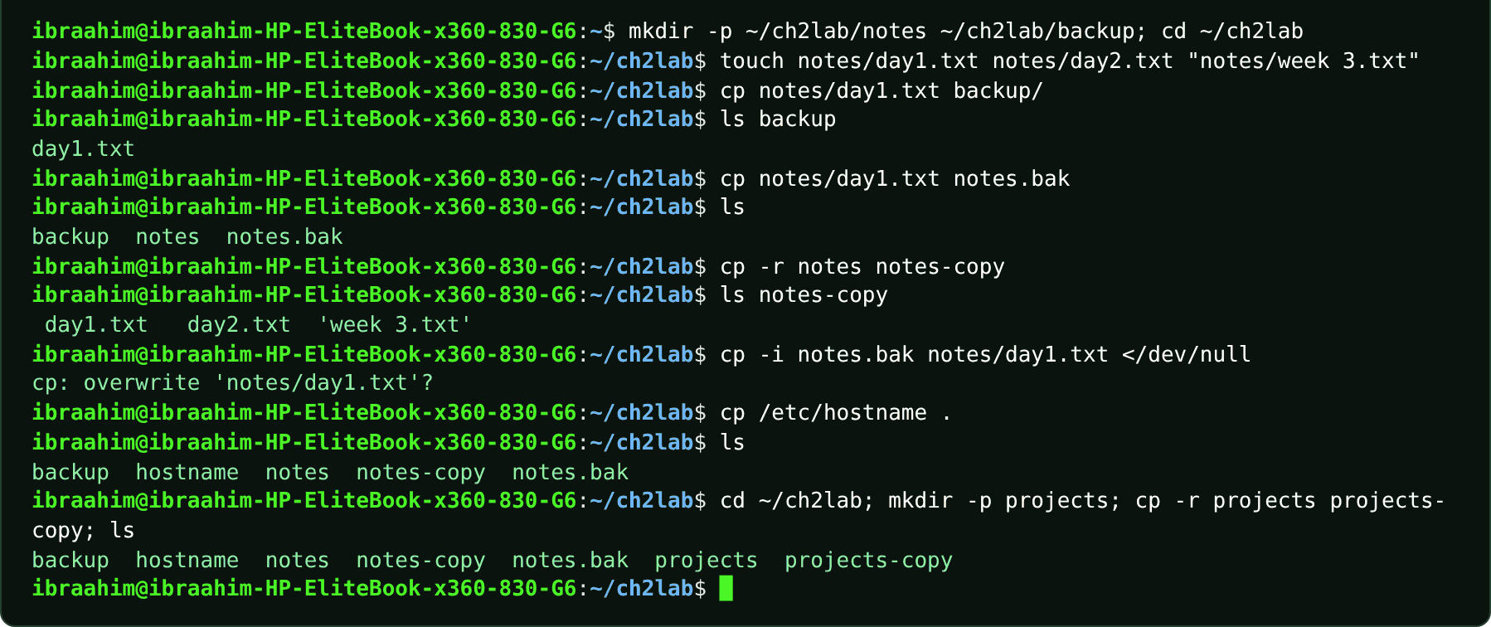

2.12 mv
Slide topic: 2.10 Creating and managing files
Definition
Moves or renames files and directories; renaming is simply moving within the same directory. Afterwards only one file remains, under a new name or in a new location. mv silently overwrites an existing destination, while -i asks first.
Why students use this command
Use it to rename files or move them to another location.
Syntax
mv [OPTION]... SOURCE DEST | mv [OPTION]... SOURCE... DIRECTORY/
Options and shortcuts
Option / Shortcut | Name | Description & Example Usage
OLD NEW | Rename in place | Function: rename in place.  Example: mv old.txt new.txt
FILE DIR/ | Move into another directory | Function: move into another directory.  Example: mv notes.txt ~/Documents/
-i, --interactive | Ask before overwriting | Function: ask before overwriting.  Example: mv -i notes.txt backup.txt
-n | Never overwrite | Function: never overwrite.  Example: mv -n notes.txt backup.txt
-v | Show each move | Function: show each move.  Example: mv -v old.txt new.txt
-u | Move only when the source is newer | Function: move only when the source is newer.  Example: mv -u notes.txt ~/Documents/
Examples
$ cd ~/ch2lab
$ mv notes/day2.txt notes/monday.txt
$ ls notes
$ touch draft.txt; mv draft.txt final.txt; ls
$ mkdir -p ~/Documents; mv final.txt ~/Documents/; ls ~/Documents
$ touch a.jpg b.jpg; mkdir -p Pictures; ls *.jpg; mv *.jpg Pictures/; ls Pictures
Terminal output
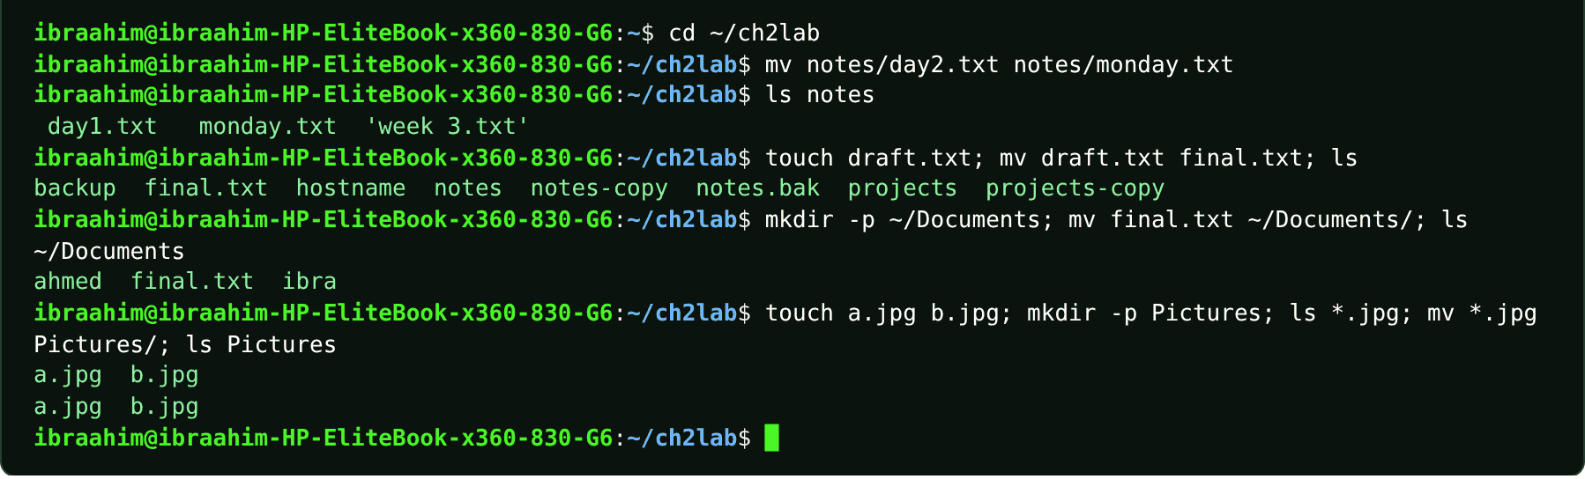

2.13 rm
Slide topic: 2.10 Creating and managing files
Definition
Permanently deletes files and directories: there is no Trash, no undo and, by default, no confirmation. -i prompts for each file, and -r deletes a directory together with everything in it. Run pwd and then ls with the same pattern before pressing Enter. The course also warns that rm * .txt (with a space) means "every file, then a file named .txt".
Why students use this command
Use it to delete files and directories you no longer need, with great care because there is no undo.
Syntax
rm [OPTION]... FILE...
Options and shortcuts
Option / Shortcut | Name | Description & Example Usage
FILE... | Remove files | Function: remove files; says nothing if it works.  Example: rm old.txt
-i | Ask "remove ...?" for each file | Function: ask "remove ...?" for each file (answer y or n).  Example: rm -i notes.bak
-r, -R | Remove a directory and its contents recursively | Function: remove a directory and its contents recursively.  Example: rm -r ~/ch2lab/notes-copy
-f | Force | Function: no questions, no errors for missing files.  Example: rm -f missing.txt
-rf DIR | Recursive and forced | Function: no questions. Avoid it.  Example: rm -rf ~/test-dir
-v | Show each removal | Function: show each removal.  Example: rm -v x.bak
-d | Remove empty directories | Function: remove empty directories.  Example: rm -d empty-folder
Examples
$ cd ~/ch2lab; mkdir -p scratch2; cd scratch2
$ touch lab1.txt lab2.txt lab10.txt notes.txt
$ ls lab*.txt
$ rm lab*.txt
$ ls
$ touch x.bak y.bak
$ rm -v x.bak
$ rm -r ~/ch2lab/notes-copy
$ cd ~/ch2lab; mkdir -p tmpdir/sub; touch tmpdir/sub/f; rm -r tmpdir; ls
$ rm -i notes.bak
$ rm -i notes-copy/*
Terminal output
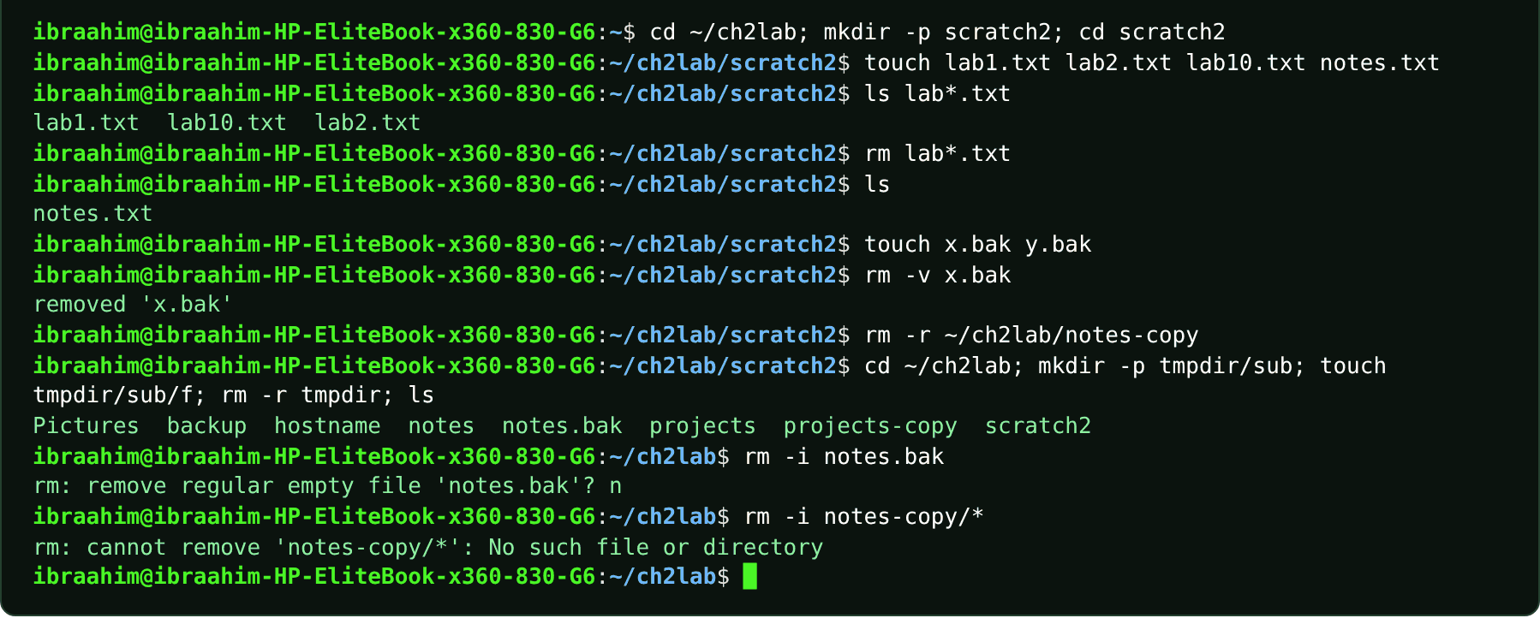

2.14 sudo
Slide topic: 2.7 Variables, PATH (first appears in the "command not found" hint)
Definition
Runs a single command with administrator (root) rights after asking for your password. It appears in Ubuntu's suggestion "sudo apt install sl", and Chapter 4 uses it for systemctl, dmesg, renice and shutdown. Users, groups and sudo are covered properly in Chapter 5.
Why students use this command
Use it to run administrative tasks, such as installing software, without logging in as root.
Syntax
sudo [OPTION] COMMAND [ARGUMENT]...
Options and shortcuts
Option / Shortcut | Name | Description & Example Usage
COMMAND | The command to run with administrator rights | Function: the command to run with administrator rights.  Example: sudo apt update
-l | List what you are allowed to run with | Function: list what you are allowed to run with sudo.  Example: sudo -l
-u USER | Run as another user instead of root | Function: run as another user instead of root.  Example: sudo -u www-data whoami
-i | Open a root login shell | Function: open a root login shell (use with care).  Example: sudo -i
-v | Refresh the cached password timestamp | Function: refresh the cached password timestamp.  Example: sudo -v
Examples
$ sudo apt install sl
$ sudo whoami
Terminal output
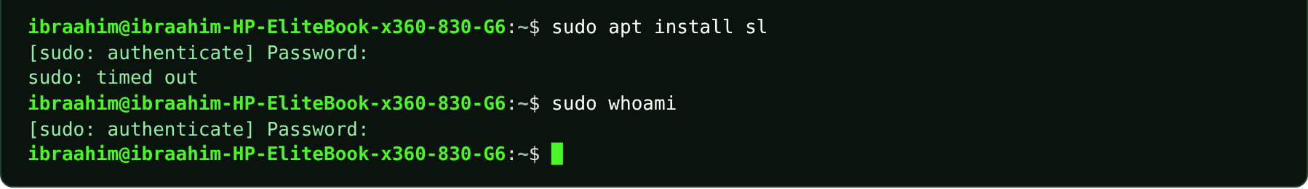

2.15 sl
Slide topic: 2.7 Variables, PATH, and ~/.bashrc
Definition
A novelty program (a steam locomotive crossing the terminal) that is not installed by default. The course runs it to show the "command not found" message and Ubuntu's suggestion, which demonstrates that Bash can only run programs found in PATH.
Why students use this command
Use it to see how Bash reports a missing command and how Ubuntu suggests the fix.
Syntax
sl [-alFc]
Options and shortcuts
Option / Shortcut | Name | Description & Example Usage
(none) | Run the locomotive animation | Function: run the locomotive animation (after installing it).  Example: sl
-a | Accident | Function: people cry for help.  Example: sl -a
-l | Little locomotive | Function: little locomotive.  Example: sl -l
-F | Fly the locomotive | Function: fly the locomotive.  Example: sl -F
-c | C51 locomotive | Function: c51 locomotive.  Example: sl -c
Examples
$ sl
$ sl # on Ubuntu Desktop with command-not-found installed
$ sl # on a machine that has it installed
Terminal output
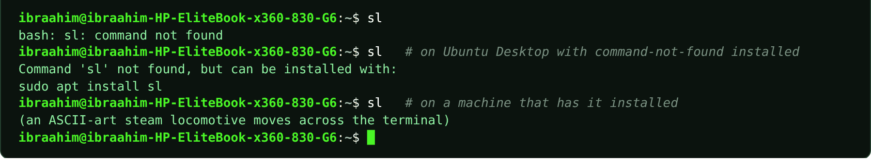

2.16 ll
Slide topic: 2.7 Variables, PATH, and ~/.bashrc
Definition
Not a real program but an alias that Ubuntu's default ~/.bashrc sets to ls -alF: a short name standing in for a longer command. It exists only in interactive Bash shells that read ~/.bashrc.
Why students use this command
Use it as a quick shortcut for a detailed directory listing.
Syntax
alias ll='ls -alF'
Options and shortcuts
Option / Shortcut | Name | Description & Example Usage
ll | Same as ls -alF | Function: same as ls -alF: all entries, long format, with type markers.  Example: cd ~/lab; ll
type ll | Shows that ll is an alias | Function: shows that ll is an alias.  Example: type ll
unalias ll | Remove the alias for this session | Function: remove the alias for this session.  Example: unalias ll
Examples
$ alias ll='ls -alF'
$ cd ~/lab; ll
$ type ll
Terminal output
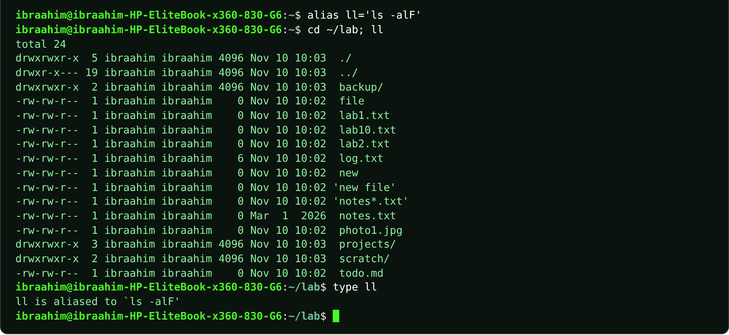

Chapter 3: Text Processing, Searching, Archiving, and Editors
42 commands in this chapter, in the order the topics appear in the slides.
COMMAND INVENTORY FOR THIS CHAPTER
Command | Slide topic
printf | 3.0 Overview: preparing the practice workspace
seq | 3.1 Viewing files: less and more
less | 3.1 Viewing and searching files
more | 3.1 Viewing and searching files
head | 3.1 Viewing and searching files
tail | 3.1 Viewing and searching files
file | 3.1 Identifying file types and metadata
stat | 3.1 Identifying file types and metadata
which | 3.1 Finding executable commands
type | 3.1 Finding executable commands
command | 3.1 Finding executable commands
whereis | 3.1 Finding executable commands
find | 3.1 Searching by filename, type, size and time
locate | 3.1 locate and updatedb
updatedb | 3.1 locate and updatedb
plocate | 3.1 locate and updatedb
grep | 3.1 Searching file contents
test | 3.2 Conditionally chaining commands
wc | 3.2 Counting lines, words and bytes
tr | 3.2 Translating and cleaning text
sort | 3.2 Sorting lines and numeric values
uniq | 3.2 uniq: collapse repeated lines
cut | 3.2 Extracting fields with cut
paste | 3.2 Joining aligned files with paste
tar | 3.3 Archives and compression
gzip | 3.3 Compressing individual files
gunzip | 3.3 Compressing individual files
bzip2 | 3.3 Comparing bzip2 and xz
bunzip2 | 3.3 Comparing bzip2 and xz
bzcat | 3.3 Comparing bzip2 and xz
xz | 3.3 Comparing bzip2 and xz
unxz | 3.3 Comparing bzip2 and xz
xzcat | 3.3 Comparing bzip2 and xz
zip | 3.3 Creating and extracting ZIP files
unzip | 3.3 Creating and extracting ZIP files
nano | 3.4 Terminal text editors: Nano
vim | 3.4 Terminal text editors: Vim
vi | 3.4 Terminal text editors: Vim
vimtutor | 3.4 Terminal text editors: Vim
ln | 3.5 Hard links and symbolic links
alias | 3.1 Executable files versus shell built-ins
python3 | 3.1 Executable files versus shell built-ins

3.1 printf
Slide topic: 3.0 Overview: preparing the practice workspace
Definition
Outputs formatted text and adds no newline unless you include \n. The course combines it with the redirection operators > (create or overwrite) and >> (append) to build the sample files names.txt, cities.txt, app.log, notes.txt, words.txt, scores.txt, users.txt and the project tree. Run this setup once inside ~/linux-ch3-lab.
Why students use this command
Use it to write exact, formatted text into files when preparing practice data.
Syntax
printf FORMAT [ARGUMENT]...
Options and shortcuts
Option / Shortcut | Name | Description & Example Usage
\n | Newline escape inside the format string | Function: newline escape inside the format string.  Example: printf "Hello\n"
> | Redirect output to a file, creating or overwriting | Function: redirect output to a file, creating or overwriting it.  Example: printf 'Ali\nHodan\nYusuf\n' > names.txt
>> | Redirect output to a file, appending to the | Function: redirect output to a file, appending to the end.  Example: printf 'Mogadishu\nGarowe\nMogadishu\n' >> cities.txt
%s | Format specifier | Function: insert the next argument as a string.  Example: printf "%s\n" Linux
%d | Format specifier | Function: insert the next argument as an integer.  Example: printf "%s has %d items\n" Basket 3
Examples
$ mkdir -p ~/linux-ch3-lab
$ cd ~/linux-ch3-lab
$ printf 'Ali\nHodan\nYusuf\n' > names.txt
$ printf 'Mogadishu\nHargeisa\n' > cities.txt
$ ls -1
$ printf 'Mogadishu\nGarowe\nMogadishu\n' >> cities.txt
$ printf 'INFO start\nERROR disk full\n' > app.log
$ printf 'WARN retry\nERROR login failed\n' >> app.log
$ mkdir -p project
$ printf 'Linux project\n' > project/README.md
$ printf 'Linux tools help. Linux is useful.\n' > notes.txt
$ printf 'gray\ngrey\n' > words.txt
$ printf '42\n100\n7\n' > scores.txt
$ printf 'ali:student:bash\nhodan:student:sh\nyusuf:admin:bash\n' > users.txt
$ mkdir -p project/src
$ printf 'mode=practice\n' > project/config.txt
$ printf '# TODO: test\n' > project/src/app.py
$ printf "%s has %d items\n" Basket 3
$ ls -1
Terminal output
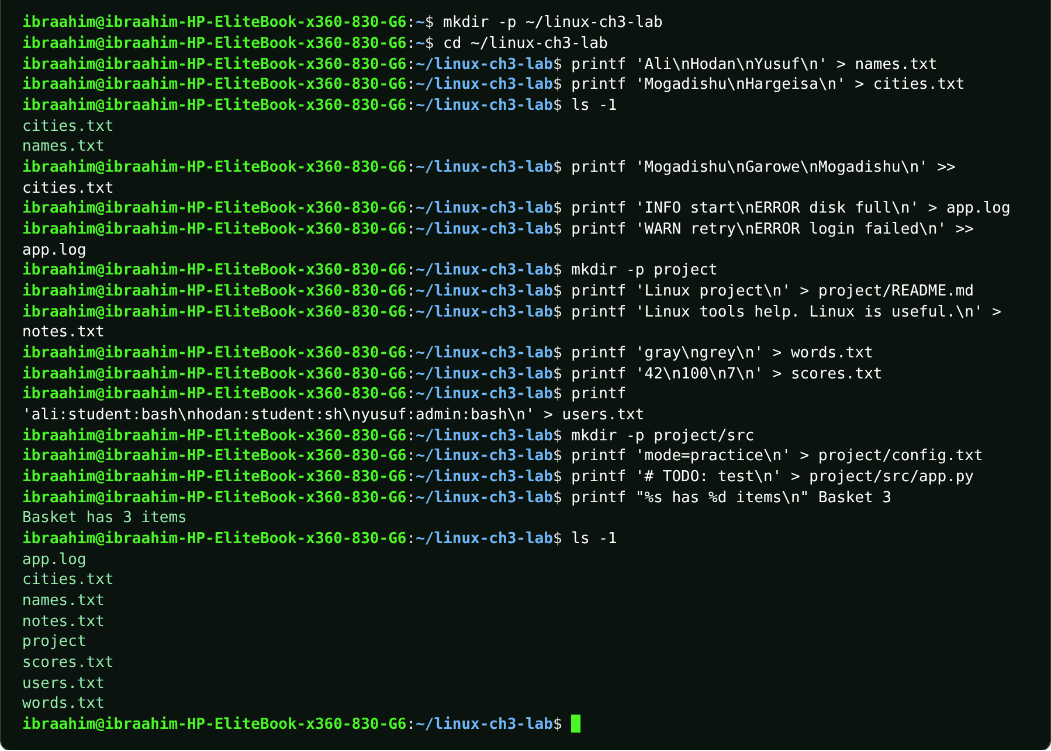

3.2 seq
Slide topic: 3.1 Viewing files: less and more
Definition
Prints a series of numbers, one per line. The course uses it to generate a 60-line practice file for the pagers.
Why students use this command
Use it to generate number sequences, which are handy for creating test files.
Syntax
seq [OPTION]... LAST | seq FIRST LAST | seq FIRST INCREMENT LAST
Options and shortcuts
Option / Shortcut | Name | Description & Example Usage
seq 5 | Print 1 to 5 | Function: print 1 to 5.  Example: seq 1 60 > long.txt
seq 2 5 | Print 2 to 5 | Function: print 2 to 5.  Example: seq 1 60 > long.txt
seq 1 2 9 | Print 1, 3, 5, 7, 9 | Function: print 1, 3, 5, 7, 9 (step 2).  Example: seq 1 60 > long.txt
-s STRING | Use STRING as separator instead of newline | Function: use STRING as separator instead of newline.  Example: seq -s, 1 5
-w | Pad with leading zeros to equal width | Function: pad with leading zeros to equal width.  Example: seq -w 8 11
Examples
$ seq 1 60 > long.txt
$ wc -l long.txt
$ seq 5
$ seq 1 2 9
$ seq -s, 1 5
$ seq -w 8 11
Terminal output
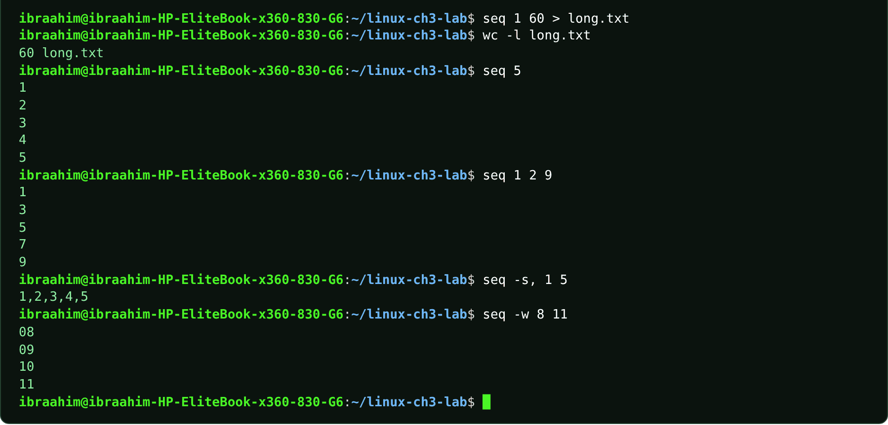

3.3 less
Slide topic: 3.1 Viewing and searching files
Definition
A pager that displays a long file one screen at a time without changing it, letting you scroll forward and backward and search. Keys: Space forward, b back, /word search, n next match, q quit.
Why students use this command
Use it to read long files and logs comfortably, with scrolling and searching.
Syntax
less [OPTION]... FILE...
Options and shortcuts
Option / Shortcut | Name | Description & Example Usage
Space / b | Forward / back one screen | Function: forward / back one screen.  Example: Press Space to go forward, b to go back
/word, n, N | Search forward, next match, previous match | Function: search forward, next match, previous match.  Example: Type /error, then press n or N
g / G | Jump to the start / end of the | Function: jump to the start / end of the file.  Example: Press g for the start, G for the end
q | Quit | Function: quit; the file stays unchanged.  Example: Press q
-N | Show line numbers | Function: show line numbers.  Example: less -N names.txt
-S | Do not wrap long lines | Function: do not wrap long lines.  Example: less -S app.log
+F | Follow the end of the file like tail | Function: follow the end of the file like tail -f.  Example: less +F app.log
Examples
$ less long.txt
Terminal output
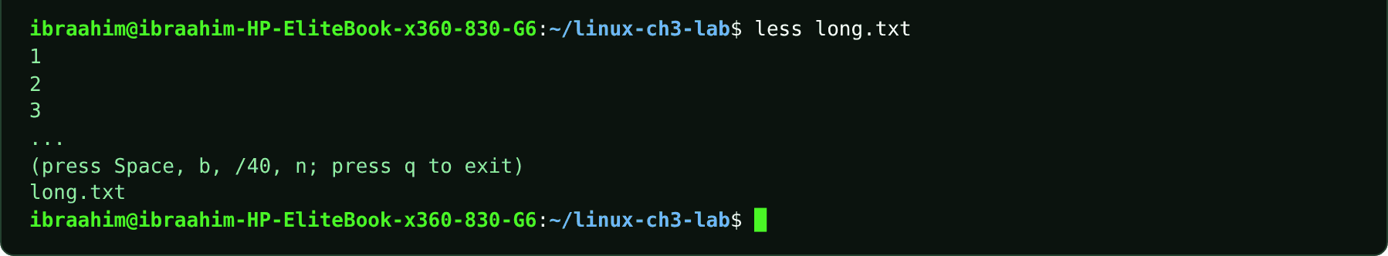

3.4 more
Slide topic: 3.1 Viewing and searching files
Definition
The older, simpler pager, which only pages forward. Press Space to advance and q to quit.
Why students use this command
Use it as a simple pager when you only need to page forward through text.
Syntax
more [OPTION]... FILE...
Options and shortcuts
Option / Shortcut | Name | Description & Example Usage
Space | Next screen | Function: next screen.  Example: Press Space
Enter | Next line | Function: next line.  Example: Press Enter
q | Quit | Function: quit.  Example: Press q
/word | Search forward | Function: search forward.  Example: Type /Ali while in more
-d | Show helpful prompts | Function: show helpful prompts.  Example: more -d names.txt
Examples
$ more long.txt | head -n 3
$ more long.txt
Terminal output
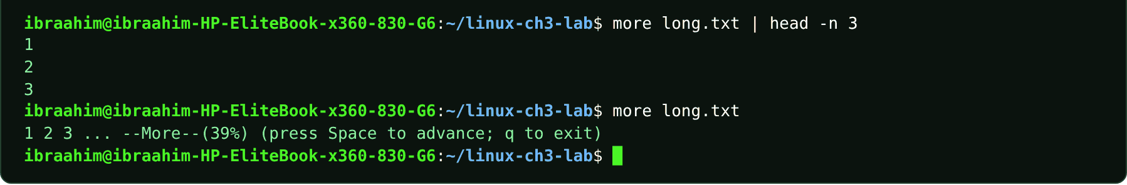

3.5 head
Slide topic: 3.1 Viewing and searching files
Definition
Displays the start of a file (the first 10 lines by default) without opening the entire file. Handy for large text, log and configuration files.
Why students use this command
Use it to preview the beginning of a large file without opening all of it.
Syntax
head [OPTION]... [FILE]...
Options and shortcuts
Option / Shortcut | Name | Description & Example Usage
-n N | Show the first N lines | Function: show the first N lines.  Example: head -n 2 names.txt
-n -N | Show everything except the last N lines | Function: show everything except the last N lines.  Example: head -n 2 names.txt
-c N | Show the first N bytes | Function: show the first N bytes.  Example: head -c 5 names.txt; echo
-q / -v | Never / always print file-name headers when several | Function: never / always print file-name headers when several files are given.  Example: head -v -n 3 names.txt
Examples
$ head -n 2 names.txt
$ head long.txt
$ head -n 3 long.txt
$ head -c 5 names.txt; echo
$ head -n 2 names.txt cities.txt
Terminal output
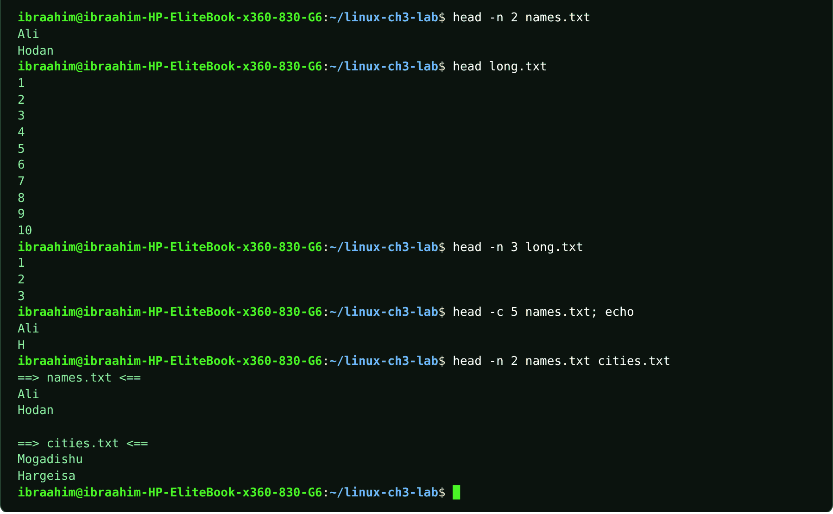

3.6 tail
Slide topic: 3.1 Viewing and searching files
Definition
Displays the end of a file (the last 10 lines by default). tail -f follows a file in real time, printing new lines as they are appended, which is ideal for logs. Press Ctrl+C to stop following.
Why students use this command
Use it to check the latest lines of a file or to watch a log grow in real time.
Syntax
tail [OPTION]... [FILE]...
Options and shortcuts
Option / Shortcut | Name | Description & Example Usage
-n N | Show the last N lines | Function: show the last N lines.  Example: tail -n 2 names.txt
-n +N | Start output at line N | Function: start output at line N.  Example: tail -n 2 names.txt
-c N | Show the last N bytes | Function: show the last N bytes.  Example: tail -c 20 notes.txt
-f | Follow | Function: keep the file open and print appended lines.  Example: timeout 3 tail -n 2 -f follow.log & sleep 1; echo "INFO done" >> follow.log; wait
-F | Follow and re-open if the file is rotated | Function: follow and re-open if the file is rotated.  Example: tail -F app.log
-n 2 -f | Combine | Function: print the last 2 lines, then follow.  Example: tail -n 2 names.txt
Examples
$ tail -n 2 names.txt
$ tail long.txt | head -n 3
$ tail -n +58 long.txt
$ cp app.log follow.log
$ timeout 3 tail -n 2 -f follow.log & sleep 1; echo "INFO done" >> follow.log; wait
Terminal output
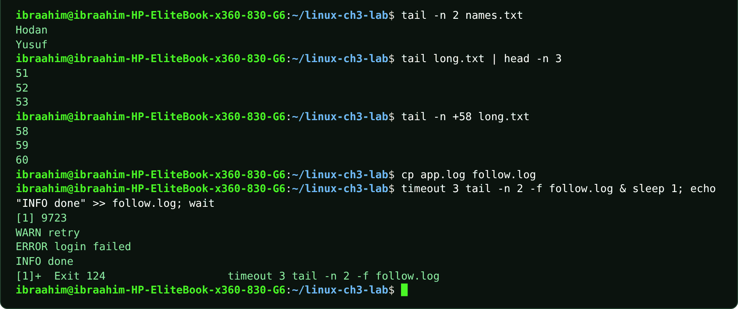

3.7 file
Slide topic: 3.1 Identifying file types and metadata
Definition
Determines a file's real type by inspecting its contents rather than its extension (report.pdf is merely a naming habit).
Why students use this command
Use it to find out what kind of data a file really contains.
Syntax
file [OPTION]... FILE...
Options and shortcuts
Option / Shortcut | Name | Description & Example Usage
-b | Brief | Function: do not print the file name.  Example: file -b names.txt
-i | Print the MIME type | Function: print the MIME type.  Example: file -i names.txt
-L | Follow symbolic links | Function: follow symbolic links.  Example: file -L ~/logs-link
-s | Read special | Function: read special (device) files.  Example: sudo file -s /dev/sda1
Examples
$ file names.txt
$ file project
$ file -b names.txt
$ file -i names.txt
$ cp names.txt picture.jpg; file picture.jpg; rm picture.jpg
$ file /bin/ls | cut -c1-80
Terminal output
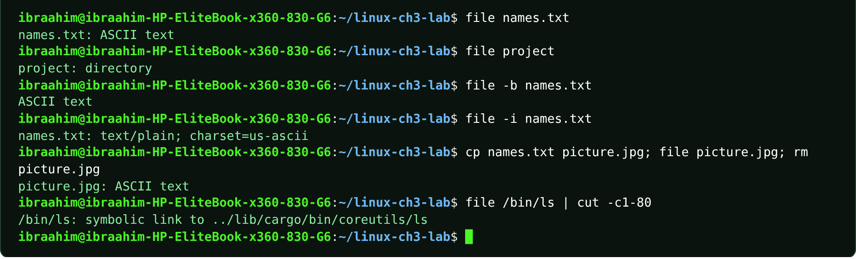

3.8 stat
Slide topic: 3.1 Identifying file types and metadata
Definition
Shows detailed filesystem metadata: name, size, blocks, inode, link count, permissions, owner, and the access, modification and change times.
Why students use this command
Use it to inspect exact file details such as size, owner, permissions and timestamps.
Syntax
stat [OPTION]... FILE...
Options and shortcuts
Option / Shortcut | Name | Description & Example Usage
(none) | Full metadata block | Function: full metadata block.  Example: stat notes.txt
-c FORMAT | Custom format, e.g. %n name, %s size, %i | Function: custom format, e.g. %n name, %s size, %i inode, %A permissions, %U owner.  Example: stat -c '%n %s bytes inode=%i perms=%A owner=%U' names.txt
-f | Show filesystem status instead of file status | Function: show filesystem status instead of file status.  Example: stat -f /
-L | Follow symbolic links | Function: follow symbolic links.  Example: stat -L ~/logs-link
-t | Terse single-line output | Function: terse single-line output.  Example: stat -t names.txt
Examples
$ stat names.txt
$ stat -c '%n %s bytes inode=%i perms=%A owner=%U' names.txt
$ stat -t names.txt
Terminal output
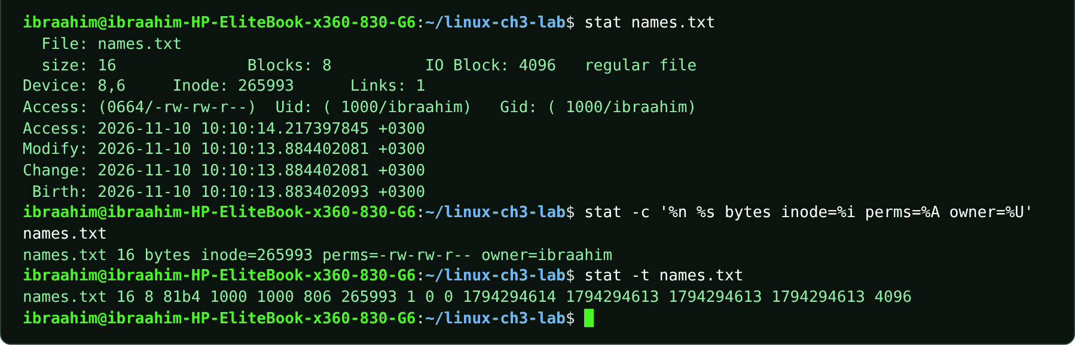

3.9 which
Slide topic: 3.1 Finding executable commands
Definition
Looks through the directories listed in PATH and prints the location of the executable that would run. For shell built-ins such as cd it may print nothing, because a built-in is not an external file.
Why students use this command
Use it to see which copy of a program the shell would actually run.
Syntax
which [-a] COMMAND...
Options and shortcuts
Option / Shortcut | Name | Description & Example Usage
-a | Print every match in PATH, not only the | Function: print every match in PATH, not only the first.  Example: which -a python3
COMMAND | Name to look up | Function: name to look up.  Example: which python3
(exit status) | 0 if all found, 1 if any not | Function: 0 if all found, 1 if any not found.  Example: which ls; echo $?
Examples
$ which ls
$ which -a python3
$ which cd; echo "exit status: $?"
$ which tar gzip
Terminal output
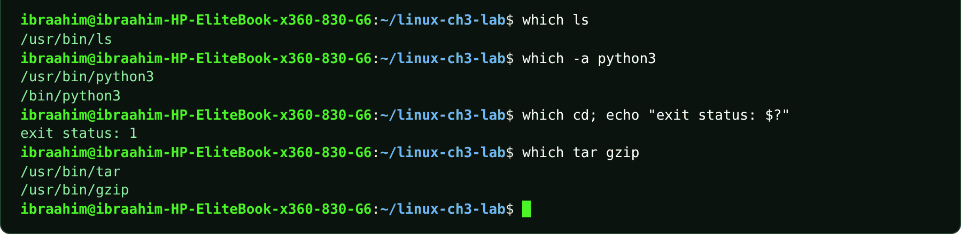

3.10 type
Slide topic: 3.1 Finding executable commands
Definition
A shell built-in that reports how Bash interprets a name: built-in, external executable, alias, keyword or function. Try it with cd, export and alias.
Why students use this command
Use it to learn whether a name is a built-in, an alias, a function or an external program.
Syntax
type [-a] [-t] NAME...
Options and shortcuts
Option / Shortcut | Name | Description & Example Usage
(none) | Describe how each name would be interpreted | Function: describe how each name would be interpreted.  Example: type ls cd
-a | Show all places the name is found | Function: show all places the name is found.  Example: alias ll="ls -alF"; type ll
-t | Print one word | Function: alias, keyword, function, builtin or file.  Example: type -t cd
-P | Force a PATH search | Function: force a PATH search.  Example: type -P ls
Examples
$ type cd
$ type ls
$ type -t cd
$ type -t ls
$ type export
$ alias ll="ls -alF"; type ll
$ type -a echo
Terminal output
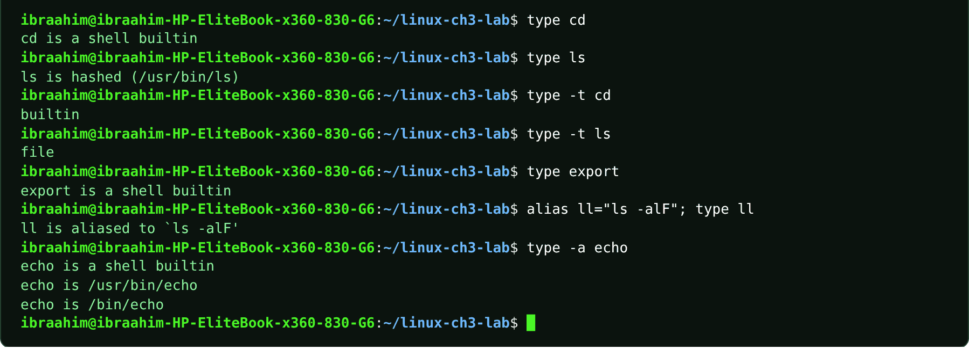

3.11 command
Slide topic: 3.1 Finding executable commands
Definition
A shell built-in that runs a command while bypassing any functions and aliases. With -v it shows how a name resolves: a path for programs, or the bare name for built-ins. Chapter 4 uses command -v htop to test whether htop is installed.
Why students use this command
Use it to check whether a program is installed or to bypass an alias.
Syntax
command [-pVv] COMMAND [ARG]...
Options and shortcuts
Option / Shortcut | Name | Description & Example Usage
-v | Print the path | Function: print the path (or name) the shell would use; prints nothing and returns 1 if not found.  Example: command -v ls
-V | Verbose description, like type | Function: verbose description, like type.  Example: command -V ls
-p | Run with a default PATH that finds the | Function: run with a default PATH that finds the standard utilities.  Example: command -p ls
Examples
$ command -v ls
$ command -v cd
$ command -v htop; echo "exit status: $?"
$ command -V ls
$ command ls names.txt
Terminal output
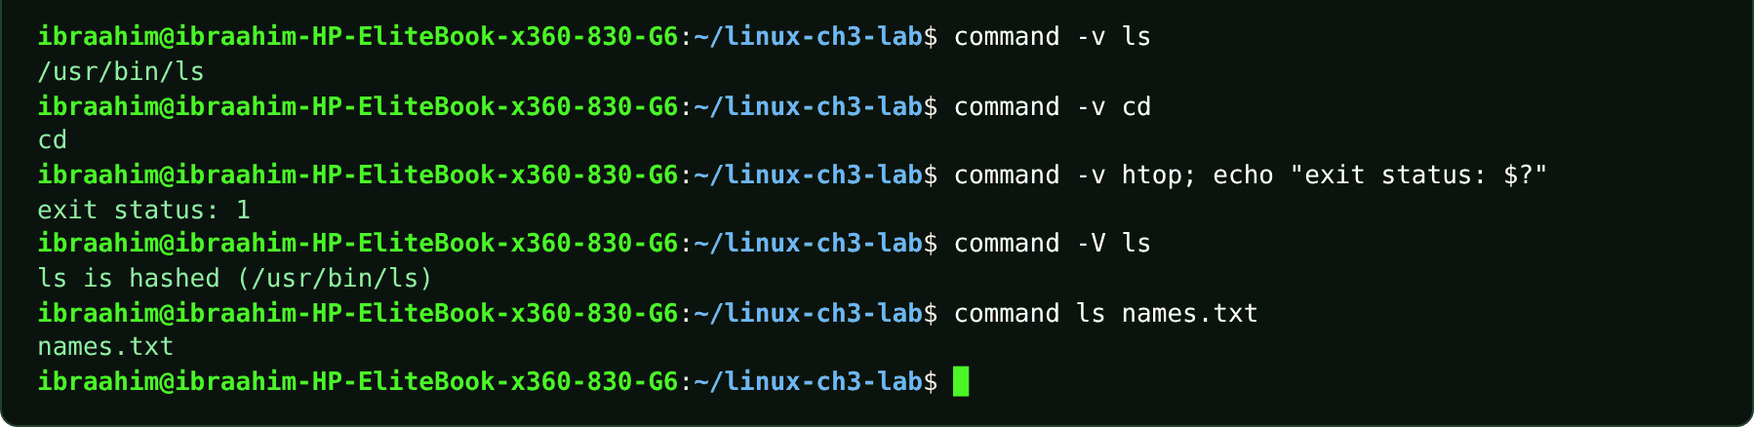

3.12 whereis
Slide topic: 3.1 Finding executable commands
Definition
Finds the executable, source files and manual pages of a command in the standard system directories.
Why students use this command
Use it to locate a program's binary, source and manual page in one step.
Syntax
whereis [OPTION]... NAME...
Options and shortcuts
Option / Shortcut | Name | Description & Example Usage
-b | Search only for binaries | Function: search only for binaries.  Example: whereis -b tar
-m | Search only for manual pages | Function: search only for manual pages.  Example: whereis -m ls
-s | Search only for sources | Function: search only for sources.  Example: whereis -s ls
-B DIR | Limit binary search to DIR | Function: limit binary search to DIR.  Example: whereis -B /usr/bin -f ls
Examples
$ whereis tar
$ whereis -b tar
$ whereis -m ls
$ whereis nonexistentcmd
Terminal output
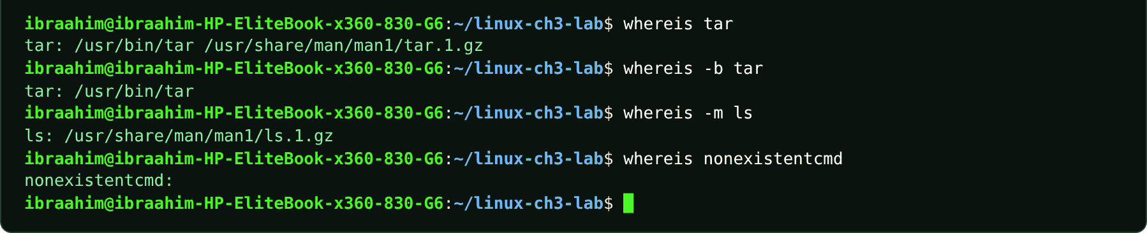

3.13 find
Slide topic: 3.1 Searching by filename, type, size and time
Definition
Searches the live directory tree for files and directories by name, type, size, modification time, permissions and more. Multiple tests in one command are combined with AND. Quote name patterns so the shell does not expand * before find receives it.
Why students use this command
Use it to search a directory tree for files by name, type, size, age or permissions.
Syntax
find [PATH...] [EXPRESSION]
Options and shortcuts
Option / Shortcut | Name | Description & Example Usage
-name PATTERN | Match the file name, case-sensitive | Function: match the file name, case-sensitive.  Example: find . -name 'names.txt'
-iname PATTERN | Match the file name, ignoring case | Function: match the file name, ignoring case.  Example: find . -iname 'NAMES.TXT'
-type f / d | Regular files / directories | Function: regular files / directories.  Example: find project -type d
-size +10c / -10M / 50M | Larger than / smaller than / exactly this | Function: larger than / smaller than / exactly this size. Units: c bytes, k KiB, M MiB, G GiB.  Example: find . -name 'names.txt' -size +10c
-mmin -30 | Modified within the last 30 minutes | Function: modified within the last 30 minutes.  Example: find . -type f -mmin -30 | head -n 4
-mtime +7 | Modified more than 7 days ago | Function: modified more than 7 days ago.  Example: find ~ -type f -mtime +7
-maxdepth N | Do not descend more than N levels | Function: do not descend more than N levels.  Example: find . -maxdepth 1 -type f -size -20c
-exec CMD {} \; | Run a command on each match | Function: run a command on each match.  Example: find project -type f -exec wc -c {} \;
-print | Print the path | Function: print the path (default action).  Example: find ~/Documents -name "*.txt" -print
Examples
$ find . -name 'names.txt'
$ find . -name '*.log'
$ find project -type d
$ find . -name 'names.txt' -size +10c
$ find . -type f -mmin -30 | head -n 4
$ find project -name "*.py" -type f
$ find . -iname 'NAMES.TXT'
$ find . -maxdepth 1 -type f -size -20c
$ find project -type f -exec wc -c {} \;
$ find . -size +50M
Terminal output
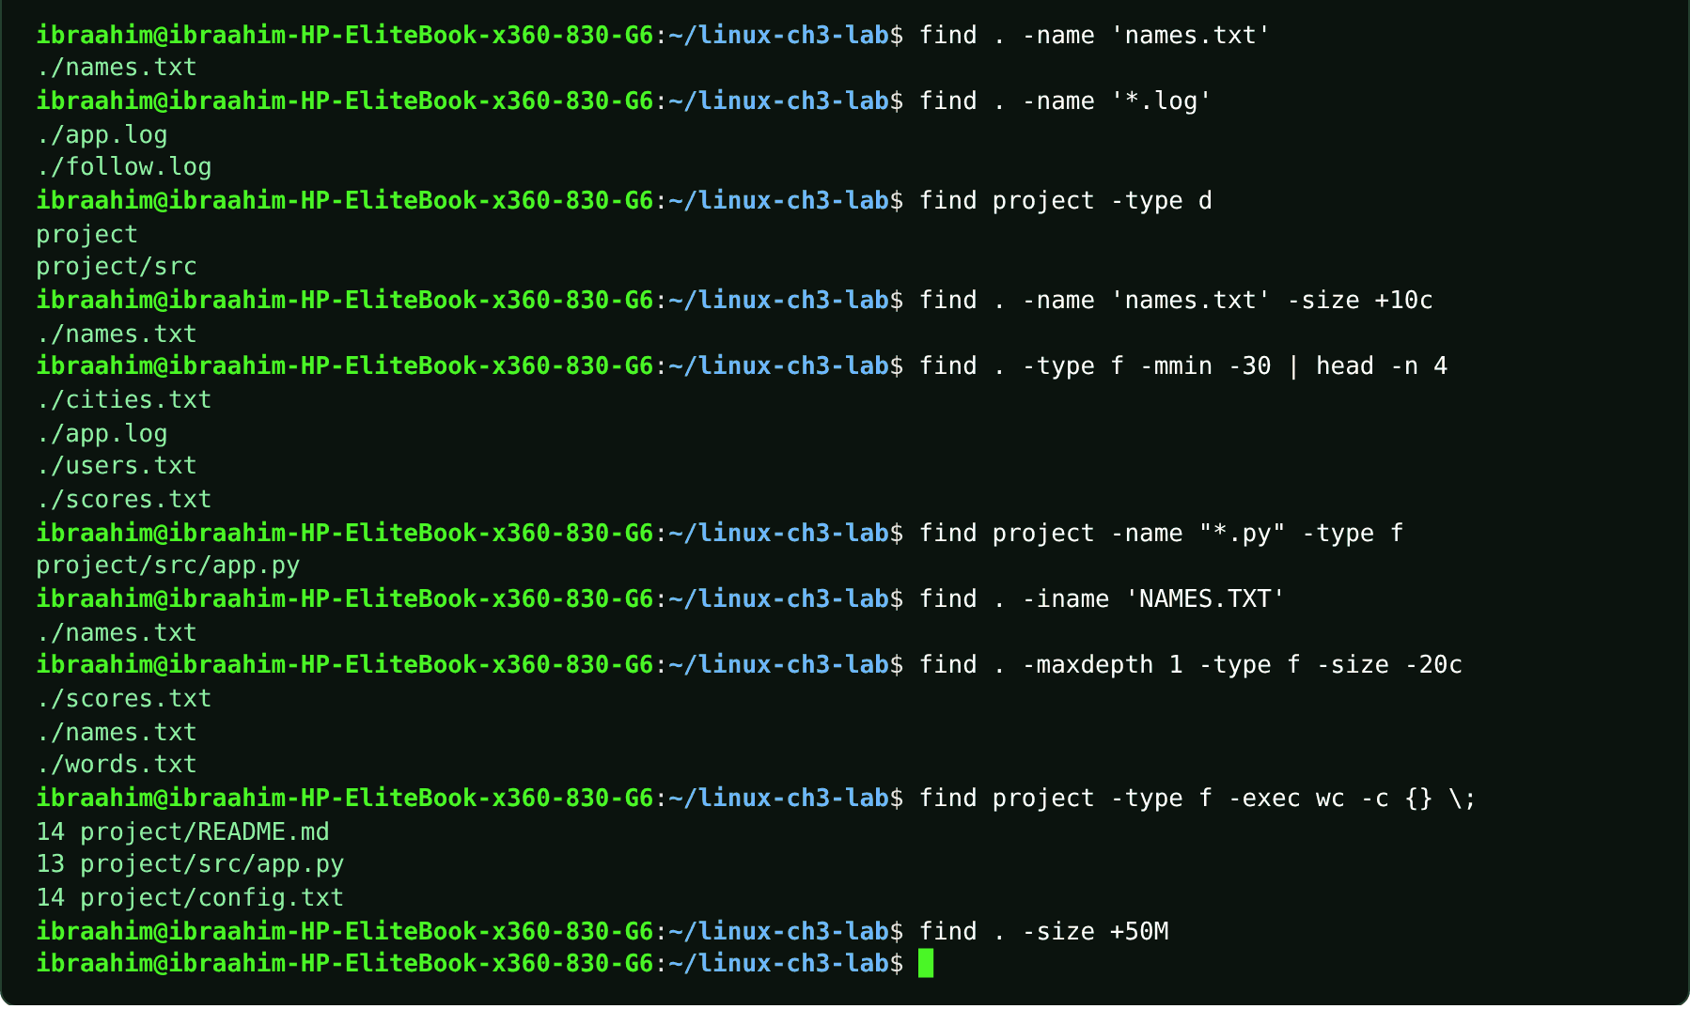

3.14 locate
Slide topic: 3.1 locate and updatedb
Definition
Finds files by name very quickly by querying a prebuilt database of paths instead of scanning the disk. The index can be out of date: a file created moments ago may not appear until updatedb runs, whereas find, which reads the live disk, sees it immediately.
Why students use this command
Use it to find a file by name almost instantly across the whole system.
Syntax
locate [OPTION]... PATTERN...
Options and shortcuts
Option / Shortcut | Name | Description & Example Usage
-i | Ignore case | Function: ignore case.  Example: locate -i readme
-c | Print only the number of matches | Function: print only the number of matches.  Example: locate -c ".txt"
-n N | Show at most N matches | Function: show at most N matches.  Example: find . -name 'recent.txt'
-b | Match the base name only | Function: match the base name only.  Example: locate -b notes.txt
-r REGEX | Use a regular expression | Function: use a regular expression.  Example: locate -r '\.log$'
Examples
$ touch recent.txt
$ locate names.txt
$ locate recent.txt
$ find . -name 'recent.txt'
Terminal output
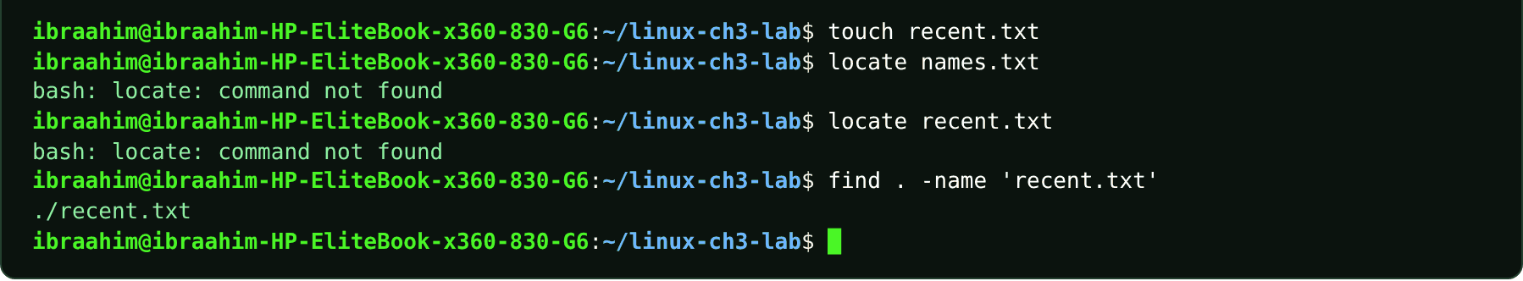

3.15 updatedb
Slide topic: 3.1 locate and updatedb
Definition
Rebuilds the database that locate reads. It normally requires administrator privileges and runs automatically once a day on Ubuntu.
Why students use this command
Use it to refresh the file index so that locate can see recently created files.
Syntax
sudo updatedb [OPTION]...
Options and shortcuts
Option / Shortcut | Name | Description & Example Usage
(none) | Rebuild the index from the configured directories | Function: rebuild the index from the configured directories.  Example: sudo updatedb
-U DIR | Index only this directory tree | Function: index only this directory tree.  Example: sudo updatedb -U /home
-o FILE | Write the database to FILE | Function: write the database to FILE.  Example: sudo updatedb -U ~/Documents -o ~/mydb.db
-v | Show the directories as they are scanned | Function: show the directories as they are scanned.  Example: sudo updatedb -v
Examples
$ sudo updatedb
$ locate recent.txt
Terminal output
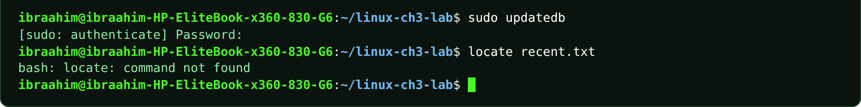

3.16 plocate
Slide topic: 3.1 locate and updatedb
Definition
A modern, faster implementation of locate used by recent Ubuntu releases. The course notes that plocate or another locate implementation may have to be installed (sudo apt install plocate).
Why students use this command
Use it for fast filename searches on recent Ubuntu systems.
Syntax
plocate [OPTION]... PATTERN...
Options and shortcuts
Option / Shortcut | Name | Description & Example Usage
-i | Ignore case | Function: ignore case.  Example: plocate -i readme
-c | Count matches | Function: count matches.  Example: plocate -c names.txt
-l N | Limit output to N matches | Function: limit output to N matches.  Example: plocate -l 5 .conf
-e | Only report files that still exist | Function: only report files that still exist.  Example: plocate -e notes.txt
-r | Regular expression | Function: regular expression.  Example: plocate -r '\.log$'
Examples
$ sudo apt install plocate
$ plocate -c names.txt
Terminal output
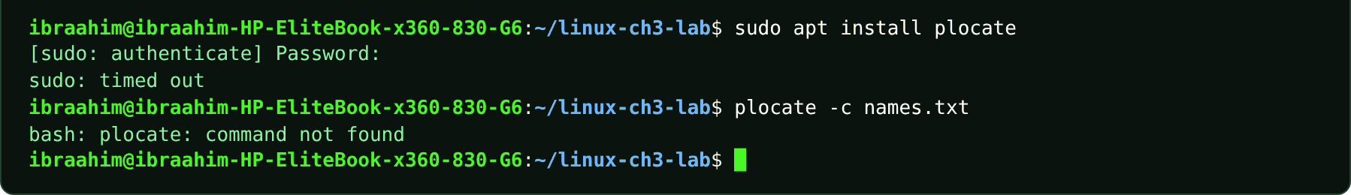

3.17 grep
Slide topic: 3.1 Searching file contents
Definition
Global Regular Expression Print: displays only the lines that match a pattern. Put the pattern before the file name and prefer single quotes. find and locate search for paths, whereas grep searches inside content. Regex symbols: . any character, * repetition, ^ start of line, $ end of line, [ ] one character from a set.
Why students use this command
Use it to search inside files for lines that contain a word or pattern.
Syntax
grep [OPTION]... PATTERN [FILE]...
Options and shortcuts
Option / Shortcut | Name | Description & Example Usage
-n | Show matching line numbers | Function: show matching line numbers.  Example: grep -n 'ERROR' app.log
-i | Ignore letter case | Function: ignore letter case.  Example: grep -in 'error' app.log
-v | Invert | Function: show lines that do not match.  Example: grep -v 'ERROR' app.log
-r / -R | Search directories recursively | Function: search directories recursively (-R follows symbolic links).  Example: grep -rn 'TODO' project
-c | Count matching lines | Function: count matching lines.  Example: grep -c 'Mogadishu' cities.txt
-m N | Stop after N matches | Function: stop after N matches.  Example: grep -m 1 'ERROR' app.log
-l | List only file names that contain a match | Function: list only file names that contain a match.  Example: grep -l 'Linux' notes.txt project/README.md
-E | Extended regular expressions | Function: extended regular expressions.  Example: grep -E 'error|failed' app.log
^ $ . * [ ] | Anchors and character classes | Function: anchors and character classes: ^Ali, failed$, gr[ae]y, b..h.  Example: grep '^Ali' names.txt
Examples
$ grep 'Ali' names.txt
$ grep -n 'ERROR' app.log
$ grep -v 'ERROR' app.log
$ grep -rn 'TODO' project
$ grep '^Ali' names.txt
$ grep 'failed$' app.log
$ grep 'gr[ae]y' words.txt
$ grep -in 'error' app.log
$ grep -c 'Mogadishu' cities.txt
$ grep -m 1 'ERROR' app.log
$ grep -l 'Linux' notes.txt project/README.md
$ grep -n error /var/log/syslog
$ grep -m 1 "model name" /proc/cpuinfo
$ grep -c ^processor /proc/cpuinfo
$ grep sudo /var/log/auth.log | tail -n 1
$ find . -name '*.log'
Terminal output
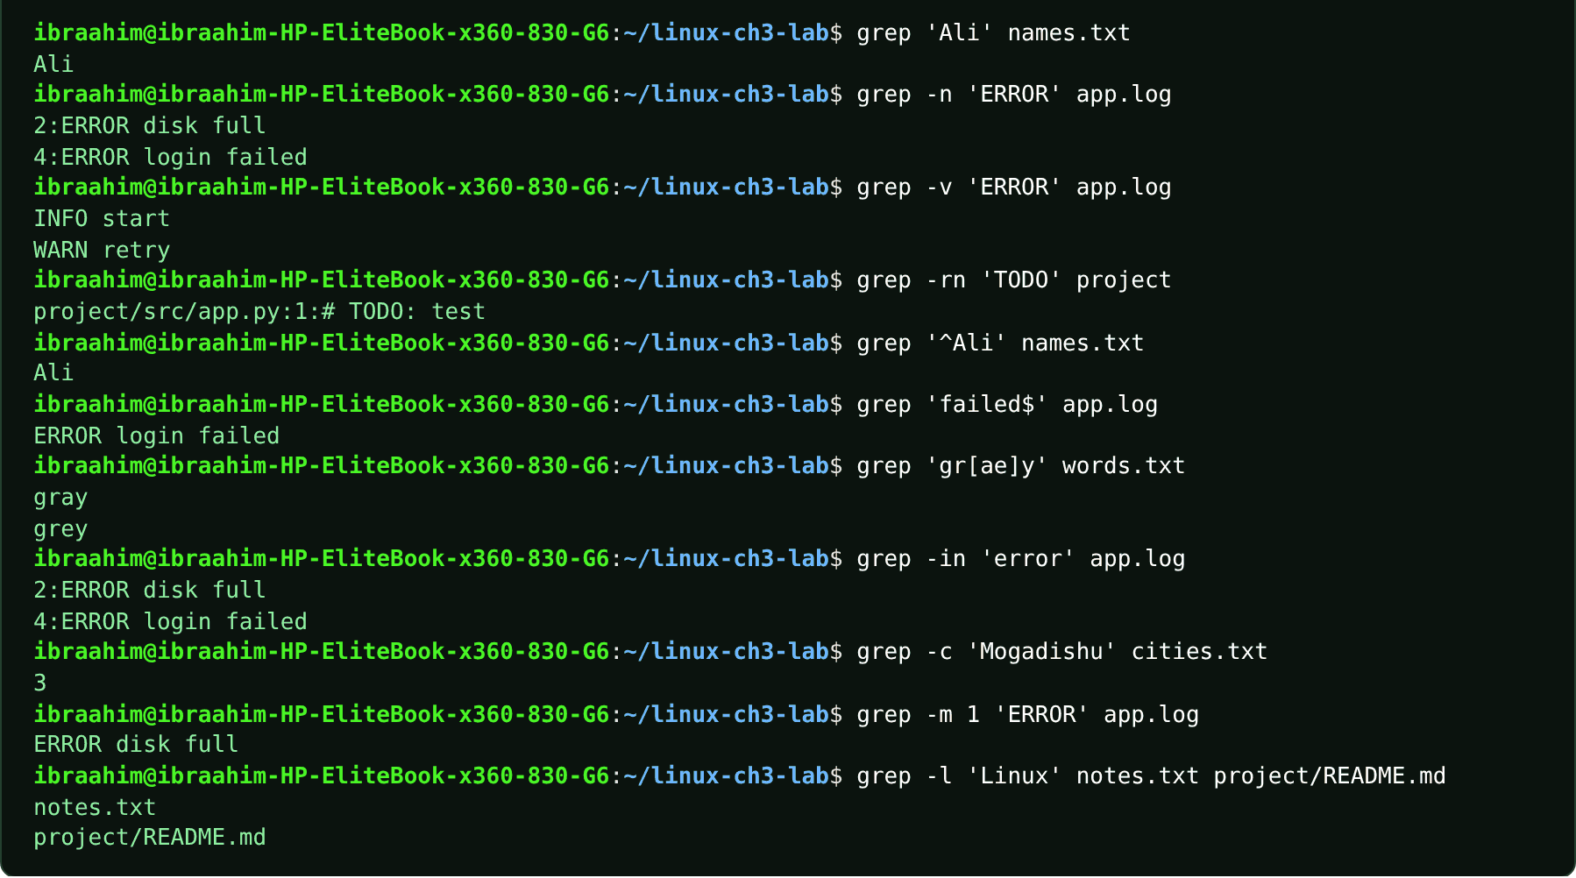
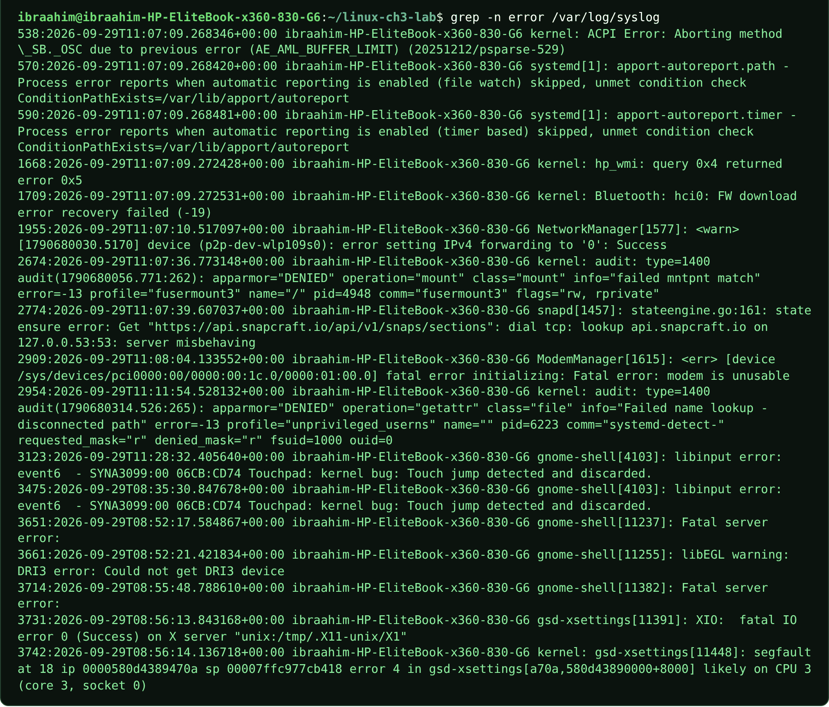
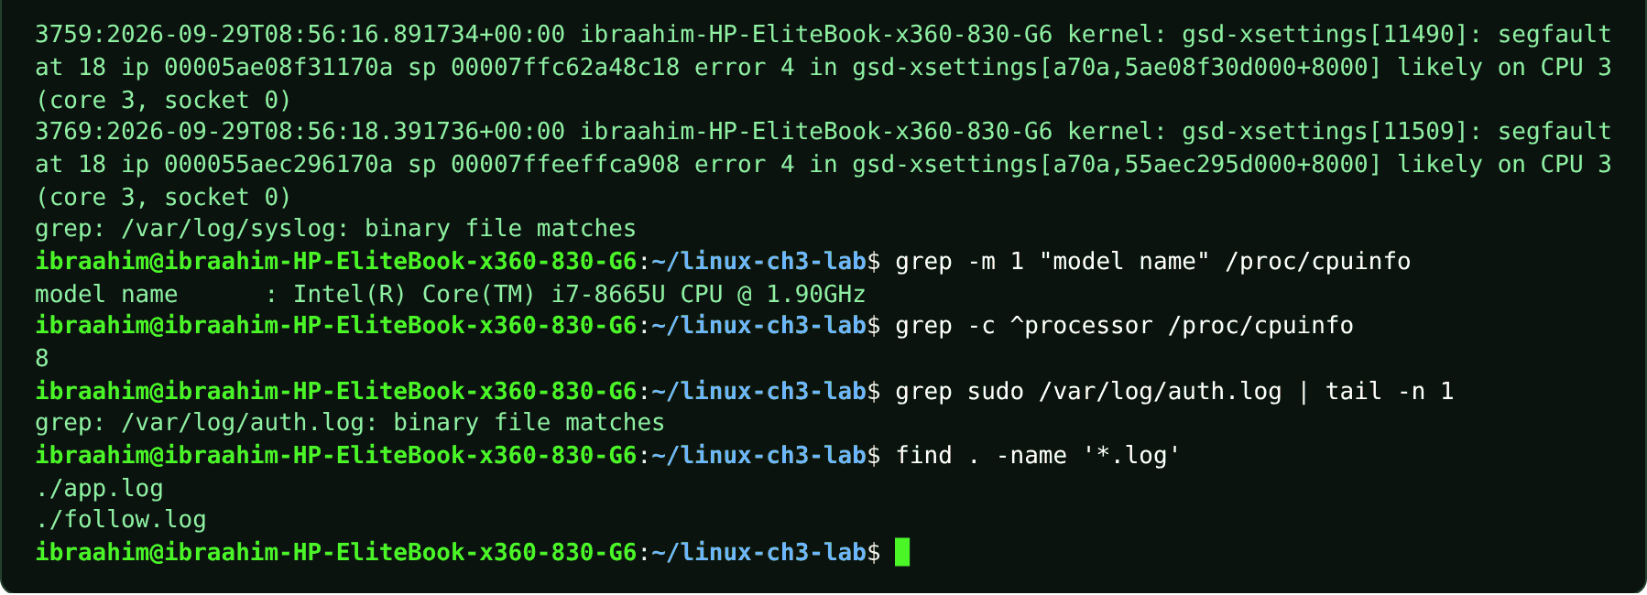

3.18 test
Slide topic: 3.2 Conditionally chaining commands
Definition
Evaluates a condition and returns exit status 0 (true) or 1 (false), printing nothing. The course uses test -f FILE (file exists) together with the || operator. The same check can be written [ -f FILE ].
Why students use this command
Use it to check conditions, such as whether a file exists, in scripts and one-liners.
Syntax
test EXPRESSION | [ EXPRESSION ]
Options and shortcuts
Option / Shortcut | Name | Description & Example Usage
-f FILE | True if FILE exists and is a regular | Function: true if FILE exists and is a regular file.  Example: test -f missing.txt || echo 'Not found'
-d DIR | True if DIR exists and is a directory | Function: true if DIR exists and is a directory.  Example: test -d project; echo $?
-e PATH | True if the path exists | Function: true if the path exists.  Example: test -e ~/notes.txt && echo exists
-s FILE | True if FILE exists and is not empty | Function: true if FILE exists and is not empty.  Example: test -s notes.txt && echo not empty
-z STRING | True if the string is empty | Function: true if the string is empty.  Example: test -z "$EMPTY" && echo empty
A -eq B | Numeric equality | Function: numeric equality (also -ne -lt -gt -le -ge).  Example: test 5 -eq 5 && echo equal
&& / || / ; | Operators that chain commands | Function: operators that chain commands: run next only on success / only on failure / always.  Example: test -f missing.txt || echo 'Not found'
Examples
$ test -f missing.txt || echo 'Not found'
$ test -f names.txt && echo "names.txt exists"
$ test -d project; echo $?
$ test -f missing.txt; echo $?
$ printf 'one\n'; printf 'two\n'
$ mkdir -p scratch && echo OK > scratch/status.txt; cat scratch/status.txt
$ cd projects || echo "Directory not found"
$ mkdir projects && cd projects; pwd; cd ..; rmdir projects
Terminal output
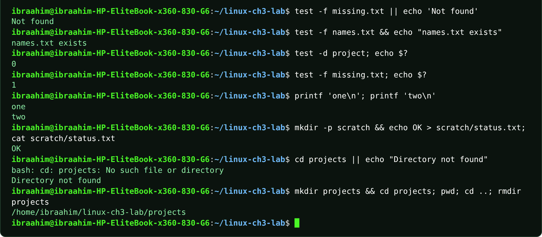

3.19 wc
Slide topic: 3.2 Counting lines, words and bytes
Definition
Word Count: counts the lines, words and bytes (or characters) in a file or in piped input. wc -l is the standard way to count matching lines.
Why students use this command
Use it to count lines, words or bytes, for example the number of matches from grep.
Syntax
wc [OPTION]... [FILE]...
Options and shortcuts
Option / Shortcut | Name | Description & Example Usage
-l | Count lines | Function: count lines (newline characters).  Example: wc -l names.txt
-w | Count words | Function: count words.  Example: wc -w notes.txt
-c | Count bytes | Function: count bytes.  Example: wc -c names.txt
-m | Count characters | Function: count characters.  Example: wc -m names.txt
(none) | Print lines, words and bytes | Function: print lines, words and bytes.  Example: wc notes.txt
< FILE | Redirect stdin | Function: prints the number with no file name.  Example: wc -l < names.txt
Examples
$ wc -l names.txt
$ wc -l < names.txt
$ grep -i 'error' app.log | wc -l
$ wc -w notes.txt
$ wc -c names.txt
$ wc -m names.txt
$ wc names.txt
$ echo -n "Somalia" | wc -m
$ grep 'ERROR' app.log | wc -l
$ cat names.txt | wc -l
$ grep 'Mogadishu' cities.txt | wc -l
$ ls /etc | wc -l
Terminal output
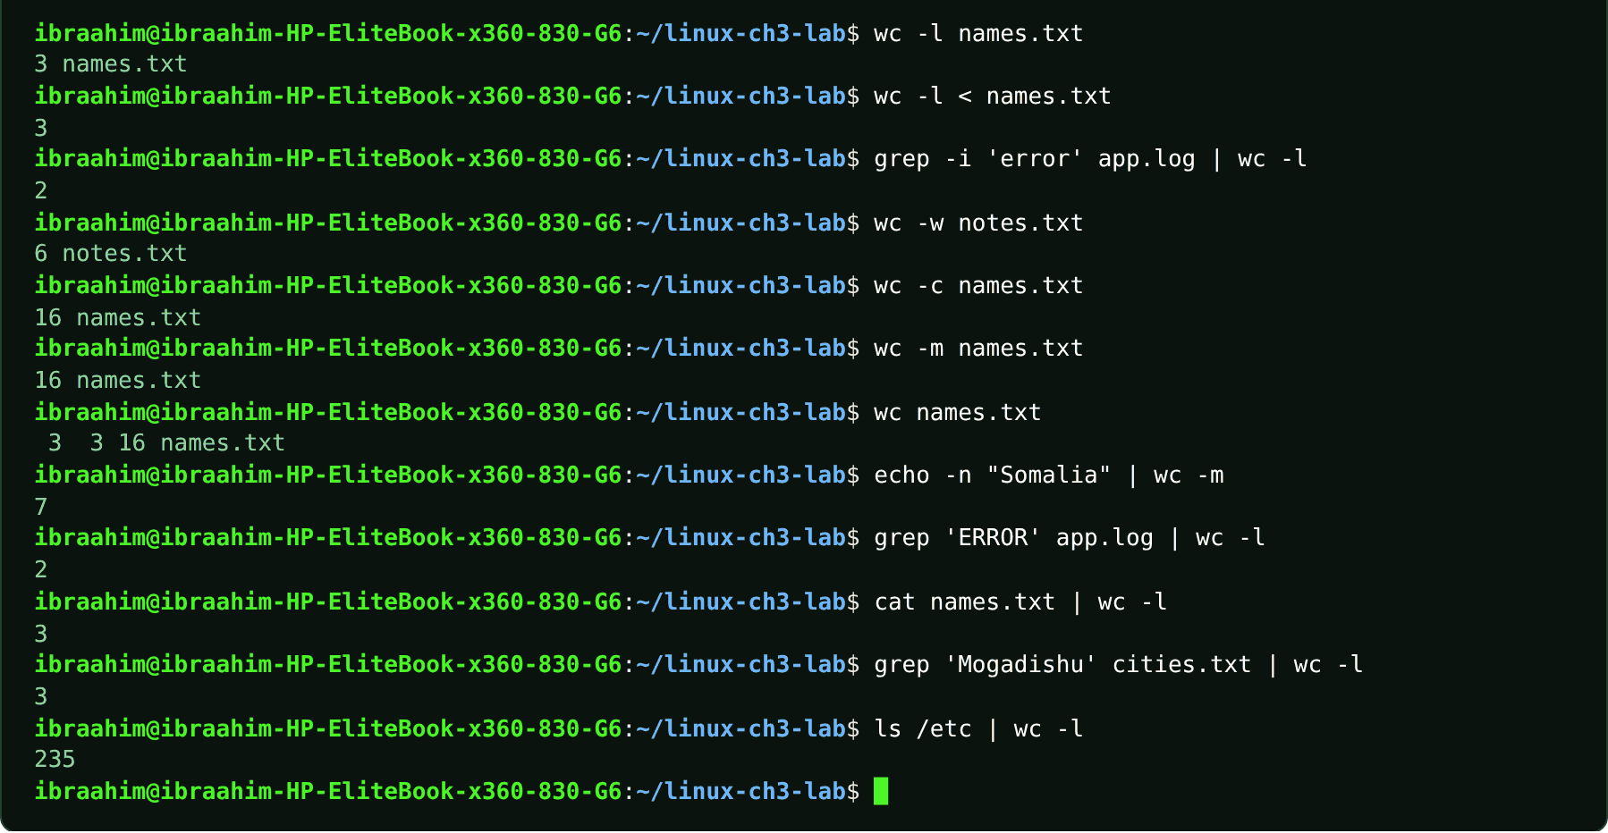

3.20 tr
Slide topic: 3.2 Translating and cleaning text
Definition
Translate: replaces, deletes or squeezes individual characters. It reads only standard input (use < or a pipe) and writes to standard output. It operates on characters, unlike cut, paste and wc.
Why students use this command
Use it to convert, delete or squeeze characters in a stream of text.
Syntax
tr [OPTION]... SET1 [SET2]
Options and shortcuts
Option / Shortcut | Name | Description & Example Usage
'a-z' 'A-Z' | Map lowercase letters to uppercase | Function: map lowercase letters to uppercase.  Example: tr 'a-z' 'A-Z' < names.txt
-d SET | Delete the characters in SET | Function: delete the characters in SET.  Example: echo 'hello world' | tr -d 'l'
-s SET | Squeeze repeated characters from SET into one | Function: squeeze repeated characters from SET into one.  Example: echo 'too many' | tr -s ' '
-c | Complement SET1 | Function: complement SET1 (everything not in the set).  Example: tr -cs '[:alpha:]' '\n' < notes.txt | tr '[:upper:]' '[:lower:]' | sort | uniq -c | sort -nr | head -n 1
-cs | Combine | Function: complement and squeeze (e.g. split text into words).  Example: tr -cs '[:alpha:]' '\n' < notes.txt | tr '[:upper:]' '[:lower:]' | sort | uniq -c | sort -nr | head -n 1
[:alpha:] [:upper:] [:lower:] | Character classes | Function: character classes.  Example: echo "hello" | tr '[:lower:]' '[:upper:]'
Examples
$ tr 'a-z' 'A-Z' < names.txt
$ echo 'too many' | tr -s ' '
$ echo 'hello world' | tr -d 'l'
$ tr -cs '[:alpha:]' '\n' < notes.txt | tr '[:upper:]' '[:lower:]' | sort | uniq -c | sort -nr | head -n 1
Terminal output
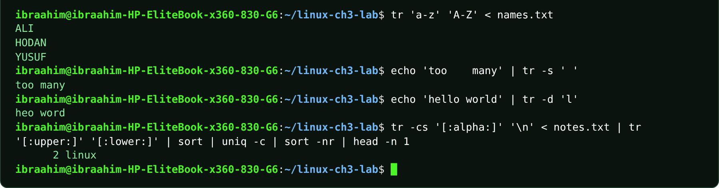

3.21 sort
Slide topic: 3.2 Sorting lines and numeric values
Definition
Orders lines alphabetically by default (so "100" comes before "7"). Use -n for numeric order and -r to reverse the result.
Why students use this command
Use it to put lines in order so that lists and data are easier to read and process.
Syntax
sort [OPTION]... [FILE]...
Options and shortcuts
Option / Shortcut | Name | Description & Example Usage
-n | Numeric sort | Function: numeric sort.  Example: sort -n scores.txt
-r | Reverse the order | Function: reverse the order.  Example: sort -rn scores.txt
-rn / -nr | Numeric, largest first | Function: numeric, largest first.  Example: sort -rn scores.txt
-u | Output only the first of equal lines | Function: output only the first of equal lines.  Example: sort -u cities.txt
-k N | Sort by field N | Function: sort by field N.  Example: sort -t: -k3 users.txt
-t CHAR | Field separator for -k | Function: field separator for -k.  Example: sort -t: -k3 users.txt
Examples
$ sort scores.txt
$ sort -n scores.txt
$ sort -rn scores.txt
$ sort cities.txt
$ sort -u cities.txt
$ sort -t: -k3 users.txt
Terminal output
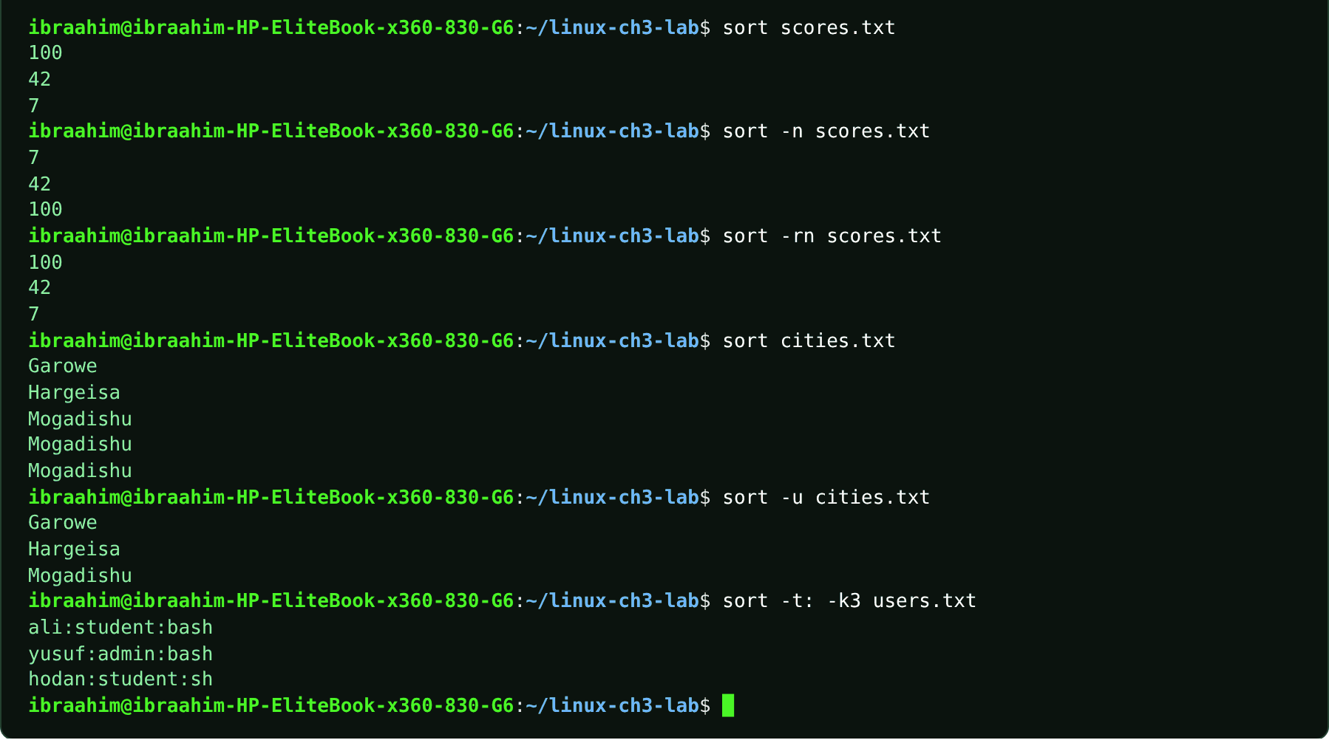

3.22 uniq
Slide topic: 3.2 uniq: collapse repeated lines
Definition
Collapses repeated adjacent lines into one. To remove all duplicates, sort first so that identical lines sit next to each other.
Why students use this command
Use it to remove or count repeated lines after sorting.
Syntax
uniq [OPTION]... [INPUT [OUTPUT]]
Options and shortcuts
Option / Shortcut | Name | Description & Example Usage
(none) | Collapse adjacent duplicates | Function: collapse adjacent duplicates.  Example: uniq names.txt
-c | Prefix each line with the number of occurrences | Function: prefix each line with the number of occurrences.  Example: sort cities.txt | uniq -c
-d | Show only lines that are duplicated | Function: show only lines that are duplicated.  Example: sort cities.txt | uniq -d
-u | Show only lines that appear once | Function: show only lines that appear once.  Example: sort cities.txt | uniq -u
-i | Ignore case | Function: ignore case.  Example: grep -i 'error' app.log | sort | uniq -c
Examples
$ sort cities.txt | uniq
$ sort cities.txt | uniq -c
$ sort cities.txt | uniq -d
$ sort cities.txt | uniq -u
$ uniq cities.txt
$ grep -i 'error' app.log | sort | uniq -c
Terminal output
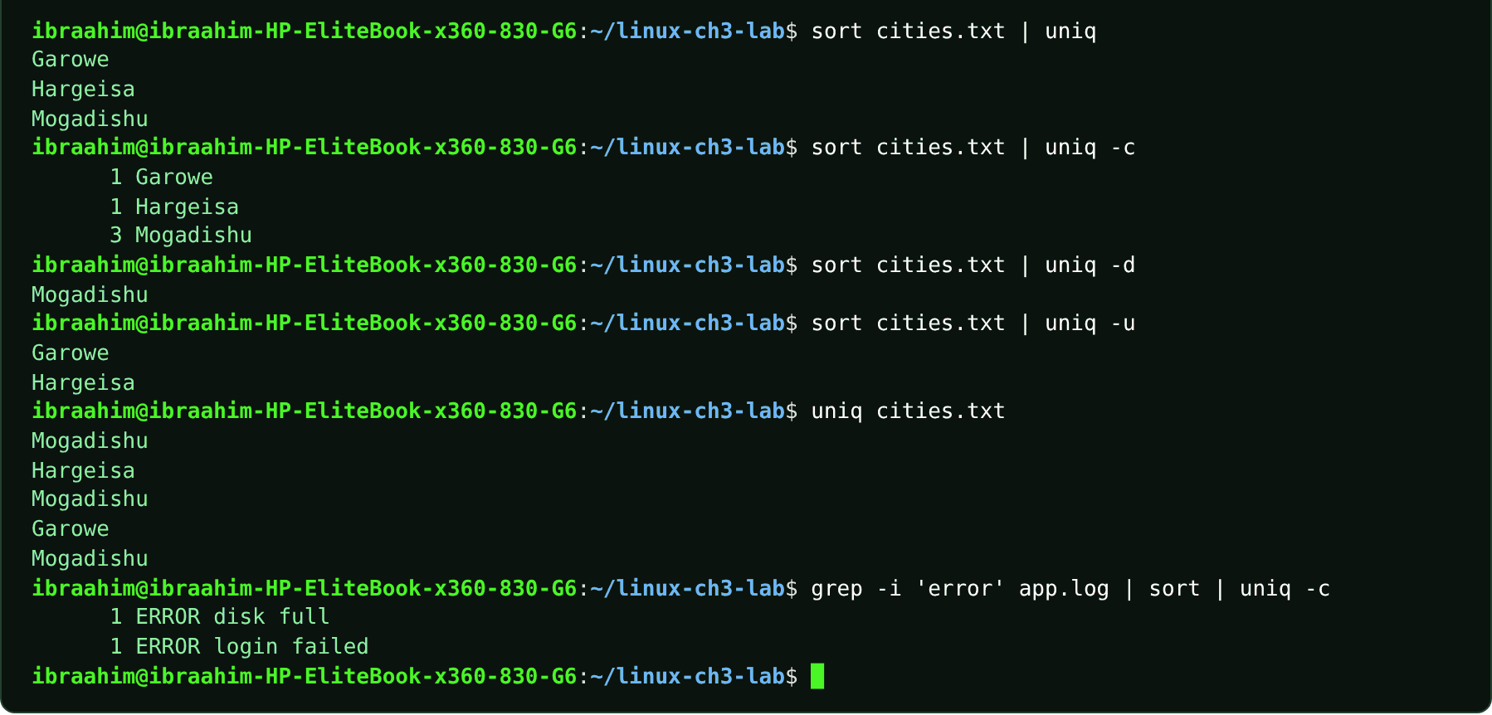

3.23 cut
Slide topic: 3.2 Extracting fields with cut
Definition
Extracts chosen characters, bytes or fields from each line of a file or of piped input. When using -f you must supply the matching delimiter with -d.
Why students use this command
Use it to pull specific columns or fields out of structured text.
Syntax
cut OPTION... [FILE]...
Options and shortcuts
Option / Shortcut | Name | Description & Example Usage
-d CHAR | Field delimiter | Function: field delimiter (default tab).  Example: cut -d: -f1 users.txt
-f LIST | Select fields | Function: 1, 1,3 or 1-3.  Example: cut -d: -f1 users.txt
-c LIST | Select character positions, e.g. 1-4 | Function: select character positions, e.g. 1-4.  Example: echo "somalia" | cut -c 1-4
-b LIST | Select byte positions | Function: select byte positions.  Example: cut -b 1-3 names.txt
--complement | Select everything except the chosen part | Function: select everything except the chosen part.  Example: cut --complement -d ',' -f 2 scores.txt
Examples
$ cut -d: -f1 users.txt
$ cut -d: -f 1,3 users.txt
$ echo "somalia" | cut -c 1-4
$ cut -d: -f3 users.txt | sort
$ cut -d: -f3 users.txt | sort | uniq -c
$ cut -d: -f3 users.txt | sort | uniq -c | sort -nr
Terminal output
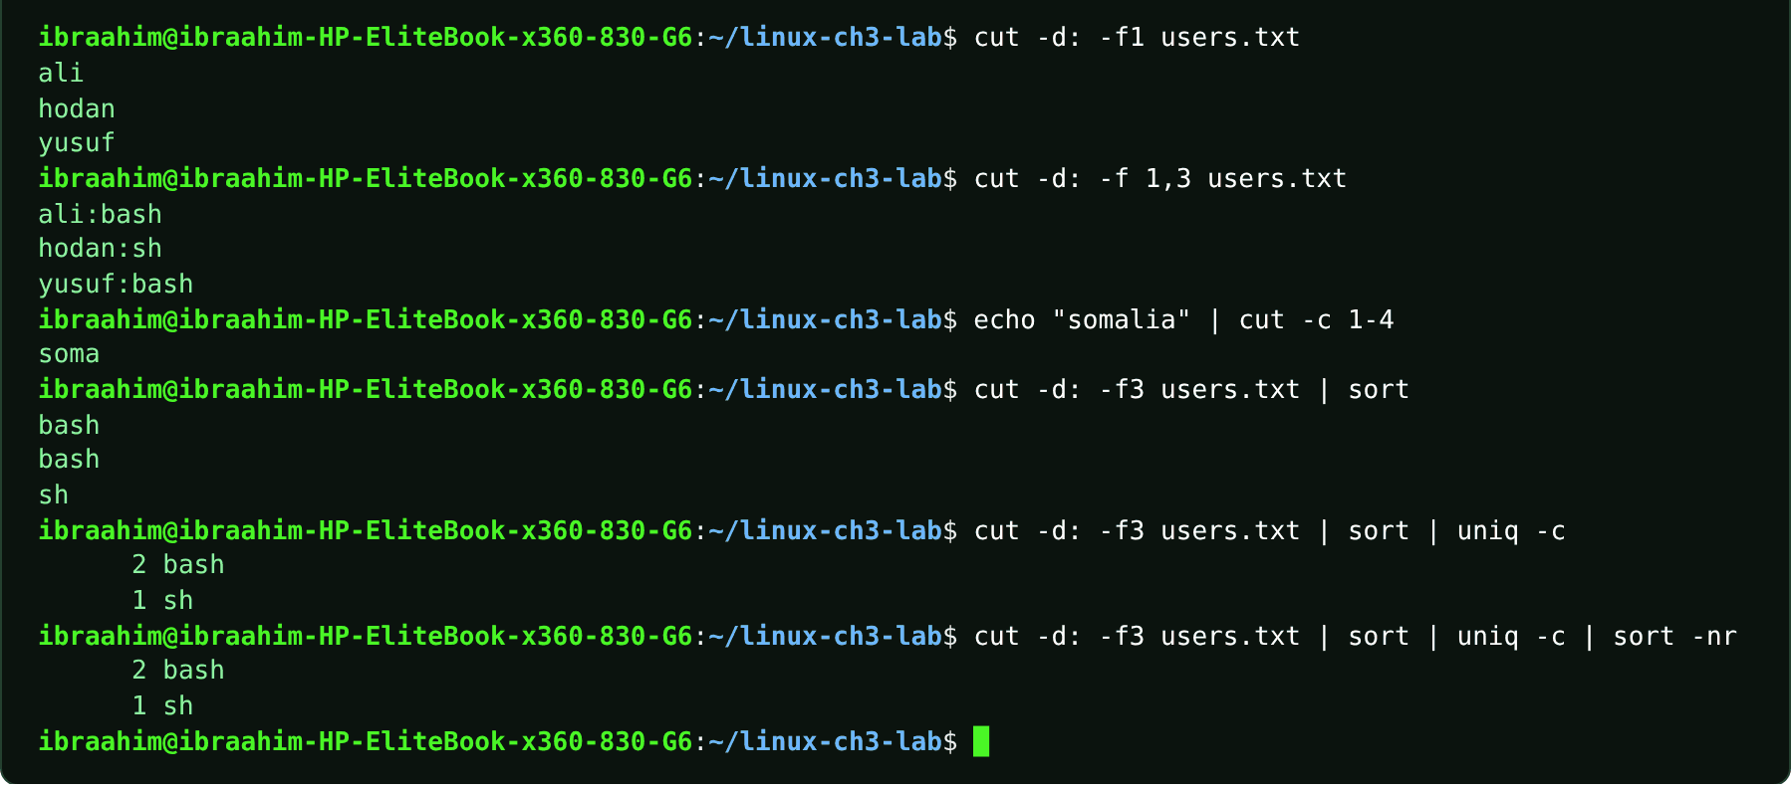

3.24 paste
Slide topic: 3.2 Joining aligned files with paste
Definition
Merges corresponding lines from two or more files into a single line, separated by a tab by default.
Why students use this command
Use it to place the lines of several files side by side.
Syntax
paste [OPTION]... [FILE]...
Options and shortcuts
Option / Shortcut | Name | Description & Example Usage
(none) | Join with tabs | Function: join with tabs.  Example: paste names.txt cities.txt
-d CHAR | Use CHAR as the separator, e.g. -d, | Function: use CHAR as the separator, e.g. -d,.  Example: paste -d, names.txt scores.txt
-s | Serial | Function: join all lines of a file into one row.  Example: paste -s -d, names.txt
-s -d, | Serial with a comma separator | Function: serial with a comma separator.  Example: paste -s -d, names.txt
Examples
$ paste names.txt scores.txt
$ paste -d, names.txt scores.txt
$ paste -s -d, names.txt
Terminal output
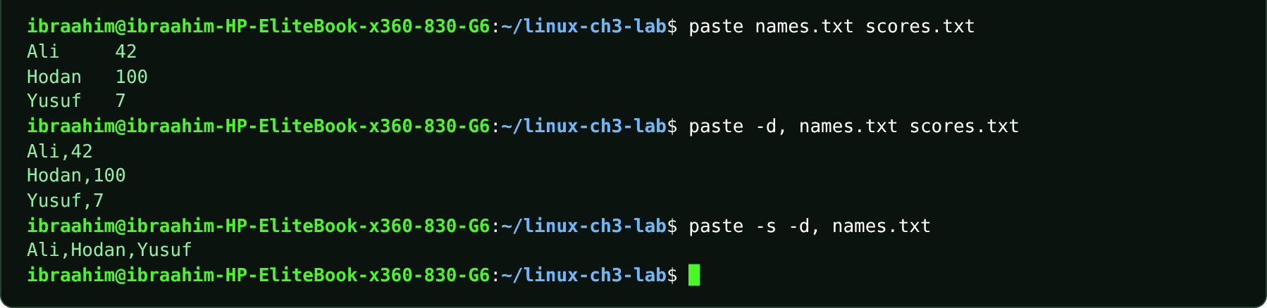

3.25 tar
Slide topic: 3.3 Archives and compression
Definition
Tape Archive: bundles many files and directories into one archive file, optionally compressed with gzip, bzip2 or xz. A plain tar does not reduce the size. Inspect an archive with -t before extracting, and restore into a separate directory using -C.
Why students use this command
Use it to bundle many files and folders into one archive for backup or transfer.
Syntax
tar [OPTION]... [-f ARCHIVE] [FILE]...
Options and shortcuts
Option / Shortcut | Name | Description & Example Usage
-c | Create a new archive | Function: create a new archive.  Example: tar -cf notes.tar notes.txt words.txt
-x | Extract files from an archive | Function: extract files from an archive.  Example: tar -xf project.tar -C restored-tar
-t | List the contents of an archive | Function: list the contents of an archive.  Example: tar -tf project.tar
-v | Verbose | Function: show processed names.  Example: tar -cvf archive.tar ~/Documents
-f FILE | The archive file name | Function: the archive file name (keep it right after -f).  Example: tar -cf archive.tar ~/Documents
-z | Filter through gzip | Function: filter through gzip (.tar.gz).  Example: tar -czf archive.tar.gz ~/Documents
-j | Filter through bzip2 | Function: filter through bzip2 (.tar.bz2).  Example: tar -cjf archive.tar.bz2 ~/Documents
-J | Filter through xz | Function: filter through xz (.tar.xz); uppercase J.  Example: tar -cJf archive.tar.xz ~/Documents
-C DIR | Change to DIR before working | Function: change to DIR before working.  Example: tar -xf project.tar -C restored-tar
Examples
$ tar -cf notes.tar notes.txt words.txt
$ tar -cvf project.tar project/
$ tar -tf project.tar
$ mkdir -p restored-tar
$ tar -xf project.tar -C restored-tar
$ ls -R restored-tar
$ tar -czf project.tar.gz project/
$ tar -cjf project.tar.bz2 project/
$ tar -cJf project.tar.xz project/
$ tar -tzf project.tar.gz
$ ls -l project.tar*
$ mkdir -p restored-gz && tar -xzf project.tar.gz -C restored-gz && ls restored-gz
Terminal output
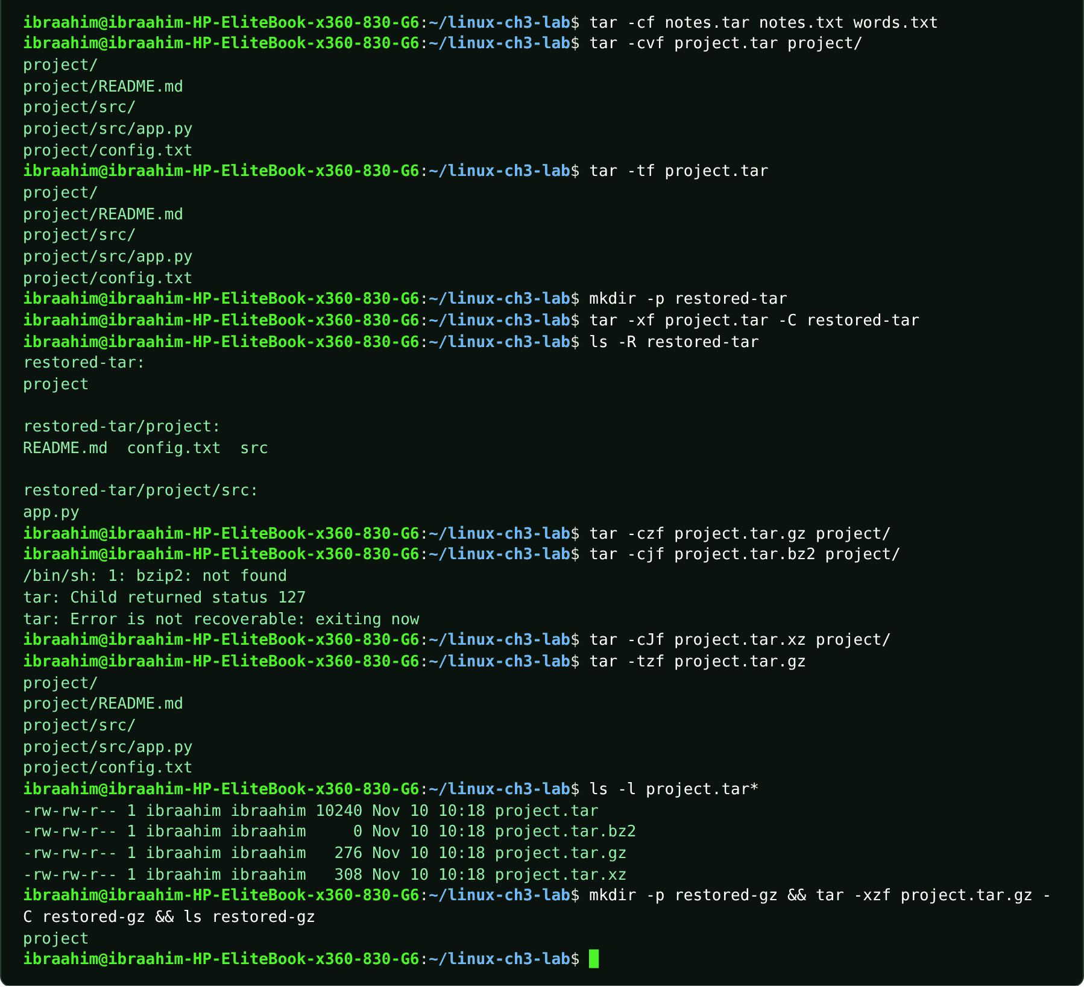

3.26 gzip
Slide topic: 3.3 Compressing individual files
Definition
Compresses a single file using the gzip algorithm. By default it replaces the original with name.gz; -k keeps the original. For directories, use tar with gzip.
Why students use this command
Use it to compress a file to save disk space.
Syntax
gzip [OPTION]... [FILE]...
Options and shortcuts
Option / Shortcut | Name | Description & Example Usage
-k | Keep the original file | Function: keep the original file.  Example: gzip -k -9 notes.txt
-9 | Best compression, slowest | Function: best compression, slowest (-1 fastest).  Example: gzip -k -9 notes.txt
-d | Decompress | Function: decompress (same as gunzip).  Example: gzip -d notes.txt.gz
-c | Write to standard output, keep the file | Function: write to standard output, keep the file.  Example: gzip -c notes.txt > notes.txt.gz
-l | List compressed and uncompressed sizes | Function: list compressed and uncompressed sizes.  Example: gzip -l notes.txt.gz
-r | Recurse into directories | Function: recurse into directories.  Example: gzip -r ~/Documents/logs
Examples
$ gzip -k -9 notes.txt
$ ls notes.txt*
$ gzip -l notes.txt.gz
Terminal output
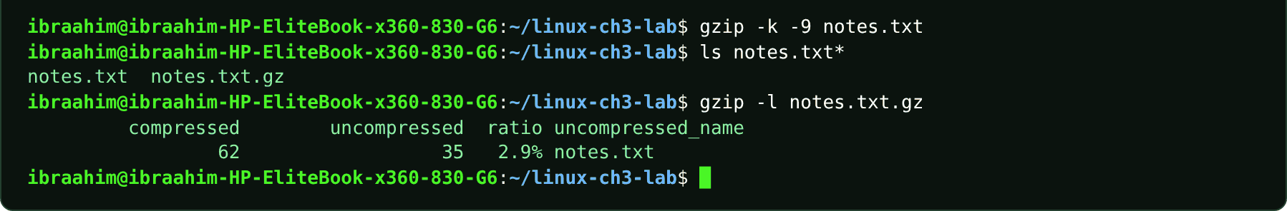

3.27 gunzip
Slide topic: 3.3 Compressing individual files
Definition
Decompresses .gz files and restores the original. gunzip -c prints the restored content without deleting the .gz file.
Why students use this command
Use it to unpack a .gz file and recover the original.
Syntax
gunzip [OPTION]... [FILE]...
Options and shortcuts
Option / Shortcut | Name | Description & Example Usage
-c | Print restored contents to the screen | Function: print restored contents to the screen; keep the .gz file.  Example: gunzip -c notes.txt.gz
-k | Keep the compressed file | Function: keep the compressed file.  Example: gunzip -k notes.txt.gz
-t | Test the integrity of the archive | Function: test the integrity of the archive.  Example: gunzip -t notes.txt.gz; echo "test status: $?"
-l | List sizes | Function: list sizes.  Example: gunzip -l notes.txt.gz
Examples
$ gunzip -c notes.txt.gz
$ gunzip -t notes.txt.gz; echo "test status: $?"
Terminal output
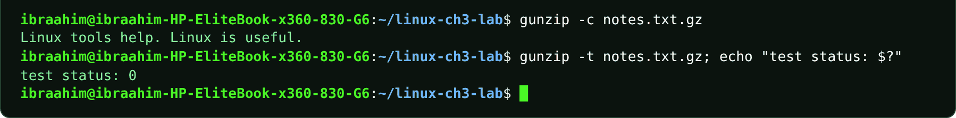

3.28 bzip2
Slide topic: 3.3 Comparing bzip2 and xz
Definition
Compresses single files into name.bz2 using the bzip2 algorithm. The result is usually smaller than gzip but slower to produce.
Why students use this command
Use it when you want better compression than gzip and can accept slower speed.
Syntax
bzip2 [OPTION]... [FILE]...
Options and shortcuts
Option / Shortcut | Name | Description & Example Usage
-k | Keep the original file | Function: keep the original file.  Example: bzip2 -k app.log
-d | Decompress | Function: decompress.  Example: bzip2 -d notes.txt.bz2
-1 ... -9 | Block size / compression level | Function: block size / compression level.  Example: bzip2 -9 notes.txt
-t | Test integrity | Function: test integrity.  Example: bzip2 -t notes.txt.bz2
-c | Write to standard output | Function: write to standard output.  Example: bzip2 -c notes.txt > notes.txt.bz2
Examples
$ bzip2 -k app.log
$ ls app.log*
Terminal output
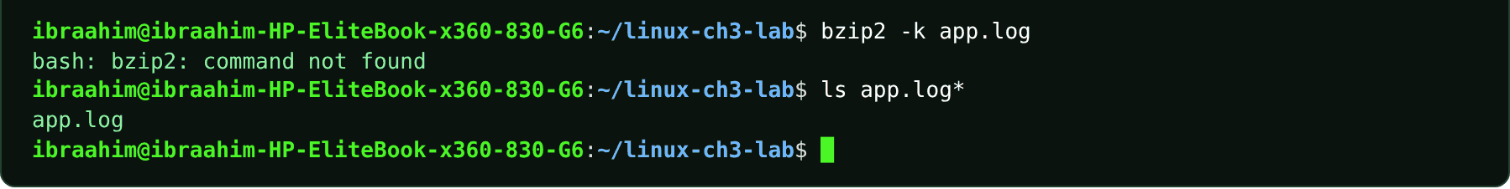

3.29 bunzip2
Slide topic: 3.3 Comparing bzip2 and xz
Definition
Decompresses .bz2 files (equivalent to bzip2 -d).
Why students use this command
Use it to unpack .bz2 files.
Syntax
bunzip2 [OPTION]... [FILE]...
Options and shortcuts
Option / Shortcut | Name | Description & Example Usage
-k | Keep the .bz2 file | Function: keep the .bz2 file.  Example: cp app.log.bz2 copy-bz.log.bz2 && bunzip2 -k copy-bz.log.bz2 && ls copy-bz.log*
-c | Print to the screen | Function: print to the screen.  Example: bunzip2 -c notes.txt.bz2
-t | Test integrity | Function: test integrity.  Example: bunzip2 -t notes.txt.bz2
Examples
$ cp app.log.bz2 copy-bz.log.bz2 && bunzip2 -k copy-bz.log.bz2 && ls copy-bz.log*
Terminal output
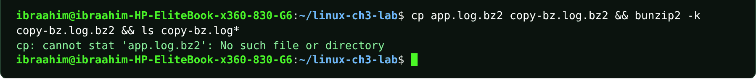

3.30 bzcat
Slide topic: 3.3 Comparing bzip2 and xz
Definition
Prints the decompressed content of a .bz2 file to standard output without creating a file.
Why students use this command
Use it to read a .bz2 file without unpacking it to disk.
Syntax
bzcat FILE.bz2...
Options and shortcuts
Option / Shortcut | Name | Description & Example Usage
FILE.bz2 | Compressed file to read | Function: compressed file to read.  Example: bzcat notes.txt.bz2
| head -n 1 | Pipe to head to preview the first line | Function: pipe to head to preview the first line.  Example: bzcat app.log.bz2 | head -n 1
Examples
$ bzcat app.log.bz2 | head -n 1
Terminal output

3.31 xz
Slide topic: 3.3 Comparing bzip2 and xz
Definition
Compresses single files into name.xz. Often smaller than gzip or bzip2, but slower.
Why students use this command
Use it for strong compression of large files.
Syntax
xz [OPTION]... [FILE]...
Options and shortcuts
Option / Shortcut | Name | Description & Example Usage
-k | Keep the original file | Function: keep the original file.  Example: xz -k app.log
-d | Decompress | Function: decompress.  Example: xz -d notes.txt.xz
-0 ... -9 | Compression level | Function: compression level.  Example: xz -9 notes.txt
-l | List information about .xz files | Function: list information about .xz files.  Example: xz -l app.log.xz
-t | Test integrity | Function: test integrity.  Example: xz -t notes.txt.xz
Examples
$ xz -k app.log
$ ls app.log*
$ xz -l app.log.xz
Terminal output
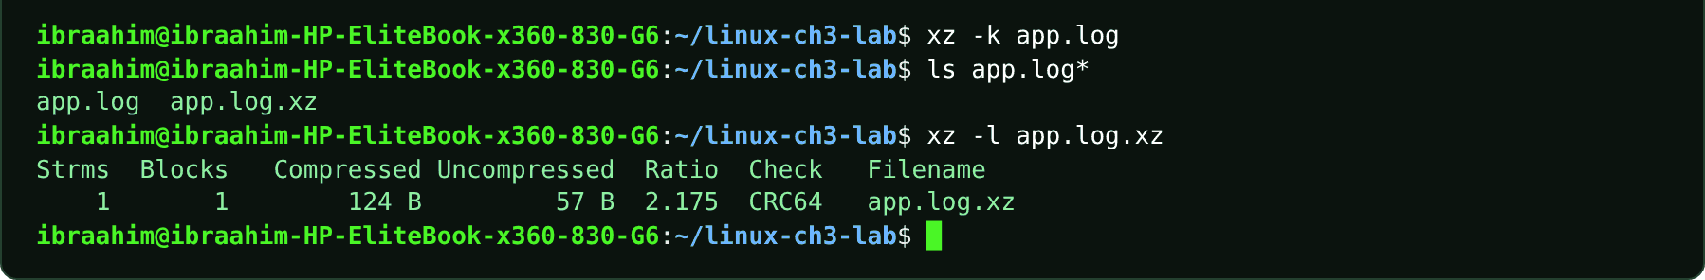

3.32 unxz
Slide topic: 3.3 Comparing bzip2 and xz
Definition
Decompresses .xz files (equivalent to xz -d).
Why students use this command
Use it to unpack .xz files.
Syntax
unxz [OPTION]... [FILE]...
Options and shortcuts
Option / Shortcut | Name | Description & Example Usage
-k | Keep the .xz file | Function: keep the .xz file.  Example: cp app.log.xz copy-xz.log.xz && unxz -k copy-xz.log.xz && ls copy-xz.log*
-c | Write to standard output | Function: write to standard output.  Example: unxz -c notes.txt.xz
-t | Test integrity | Function: test integrity.  Example: unxz -t notes.txt.xz
Examples
$ cp app.log.xz copy-xz.log.xz && unxz -k copy-xz.log.xz && ls copy-xz.log*
Terminal output
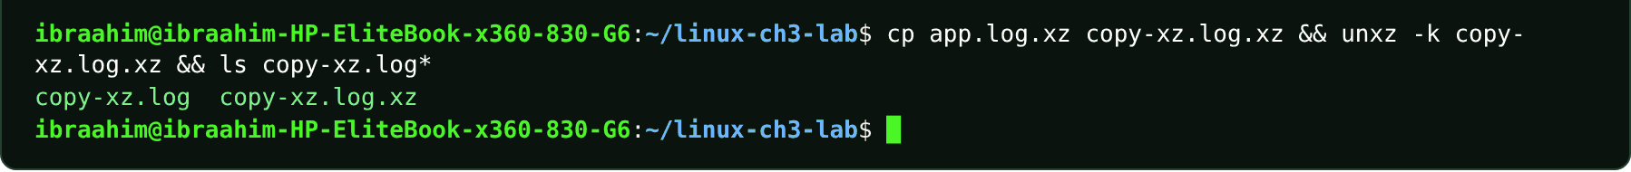

3.33 xzcat
Slide topic: 3.3 Comparing bzip2 and xz
Definition
Prints the decompressed content of a .xz file to standard output without creating a file.
Why students use this command
Use it to read a .xz file without unpacking it to disk.
Syntax
xzcat FILE.xz...
Options and shortcuts
Option / Shortcut | Name | Description & Example Usage
FILE.xz | Compressed file to read | Function: compressed file to read.  Example: xzcat notes.txt.xz
| head -n 1 | Preview the first line | Function: preview the first line.  Example: xzcat app.log.xz | head -n 1
Examples
$ xzcat app.log.xz | head -n 1
Terminal output

3.34 zip
Slide topic: 3.3 Creating and extracting ZIP files
Definition
Packs files into one compressed ZIP archive that Windows, macOS and Linux can open natively. Use -r to include directories.
Why students use this command
Use it to create archives that can be opened on Windows, macOS and Linux.
Syntax
zip [OPTION]... ARCHIVE.zip FILE...
Options and shortcuts
Option / Shortcut | Name | Description & Example Usage
-r | Include directories recursively | Function: include directories recursively.  Example: zip -r project.zip project/
-q | Quiet | Function: quiet.  Example: zip -q backup.zip notes.txt
-9 / -0 | Best compression / store only | Function: best compression / store only.  Example: zip -9 backup.zip notes.txt
-e | Encrypt with a password | Function: encrypt with a password.  Example: zip -e secret.zip notes.txt
-d | Delete an entry from an archive | Function: delete an entry from an archive.  Example: zip -d backup.zip notes.txt
Examples
$ zip -r project.zip project/
$ ls -l project.zip
Terminal output
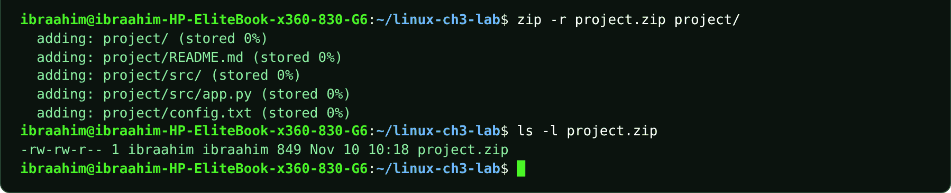

3.35 unzip
Slide topic: 3.3 Creating and extracting ZIP files
Definition
Lists, tests and extracts ZIP archives. Extract into an empty folder and watch for overwritten files.
Why students use this command
Use it to open, test or extract ZIP files you receive.
Syntax
unzip [OPTION]... ARCHIVE.zip [-d DIR]
Options and shortcuts
Option / Shortcut | Name | Description & Example Usage
-l | List entries without extracting | Function: list entries without extracting.  Example: unzip -l project.zip
-d DIR | Extract into DIR | Function: extract into DIR.  Example: unzip project.zip -d restored-zip
-t | Test the archive | Function: test the archive.  Example: unzip -t backup.zip
-o | Overwrite without prompting | Function: overwrite without prompting.  Example: unzip -o backup.zip
-n | Never overwrite | Function: never overwrite.  Example: unzip -n backup.zip
Examples
$ unzip -l project.zip
$ unzip project.zip -d restored-zip
$ ls -R restored-zip
Terminal output
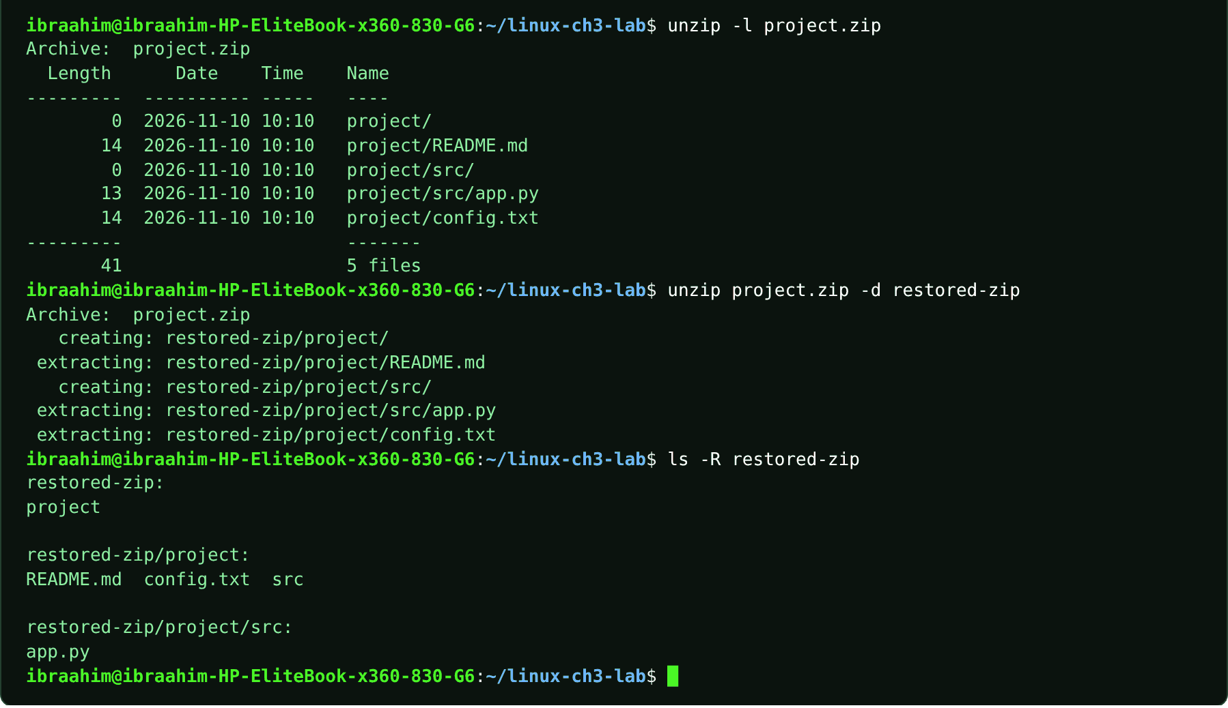

3.36 nano
Slide topic: 3.4 Terminal text editors: Nano
Definition
A beginner-friendly editor for plain text and configuration files. Shortcuts appear in the footer, where ^ means Ctrl. Ctrl+O saves (Write Out) and Enter confirms the file name; Ctrl+X exits; Ctrl+W searches; Ctrl+K cuts a line; Ctrl+U pastes; Alt+U undoes; Ctrl+G opens help.
Why students use this command
Use it to edit text and configuration files with simple on-screen shortcuts.
Syntax
nano [OPTION]... [FILE]...
Options and shortcuts
Option / Shortcut | Name | Description & Example Usage
nano FILE | Open or create FILE | Function: open or create FILE.  Example: nano project/README.md
-l | Show line numbers | Function: show line numbers.  Example: nano -l notes.txt
-B | Back up the existing file when saving | Function: back up the existing file when saving.  Example: nano -B notes.txt
+N | Start at line N | Function: start at line N.  Example: nano +5 notes.txt
-v | View only | Function: view only (read-only).  Example: nano -v notes.txt
Examples
$ nano project/README.md
$ printf "Practicing Nano\n" >> project/README.md # same result as typing the second line in nano
$ cat project/README.md
Terminal output
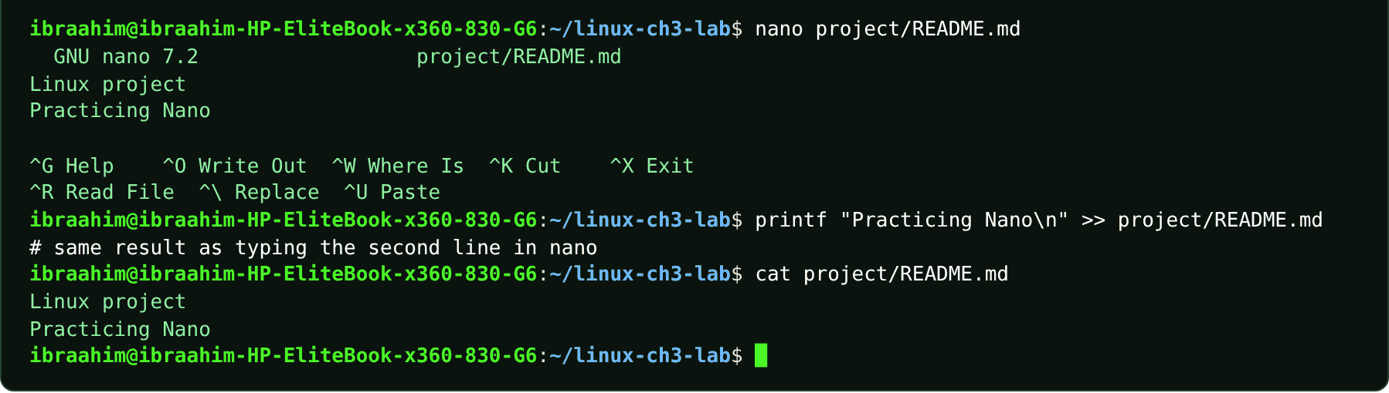

3.37 vim
Slide topic: 3.4 Terminal text editors: Vim
Definition
A modal editor. It starts in Normal mode, where keys act as commands; press i to enter Insert mode and type text, Esc to return to Normal mode, and : to open the command line. :w saves, :q quits, :wq saves and quits, :q! quits and discards changes.
Why students use this command
Use it to edit files efficiently with powerful keyboard commands, especially on servers.
Syntax
vim [OPTION]... [FILE]...
Options and shortcuts
Option / Shortcut | Name | Description & Example Usage
vim FILE | Open or create FILE in Normal mode | Function: open or create FILE in Normal mode.  Example: vim vim-practice.txt
i | Switch to Insert mode | Function: switch to Insert mode.  Example: Press i in Normal mode
Esc | Return to Normal mode | Function: return to Normal mode.  Example: Press Esc
:w / :q / :wq / :q! | Save / quit / save and quit / | Function: save / quit / save and quit / quit without saving.  Example: vim project/config.txt # press i, edit, Esc, then :q
-R | Read-only | Function: read-only.  Example: vim -R notes.txt
+N | Start at line N | Function: start at line N.  Example: vim +5 notes.txt
Examples
$ vim vim-practice.txt
$ printf "Vim practice\n" > vim-practice.txt # same file as typing it in vim
$ cat vim-practice.txt
$ vim project/config.txt # press i, edit, Esc, then :q
Terminal output
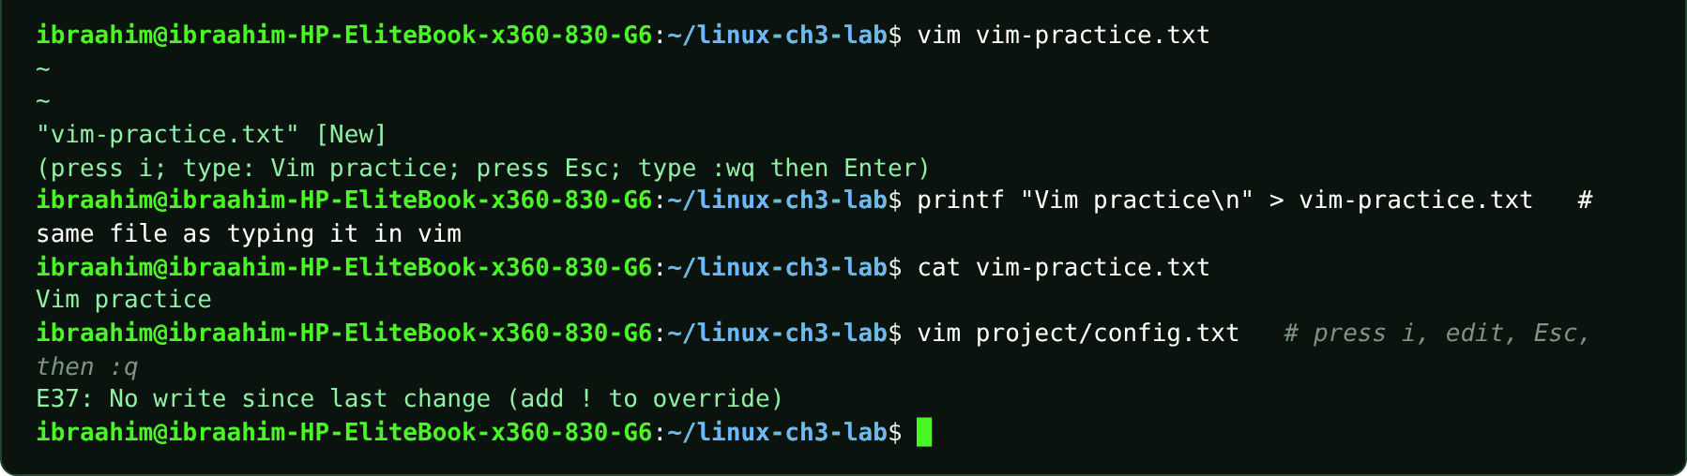

3.38 vi
Slide topic: 3.4 Terminal text editors: Vim
Definition
On Ubuntu, vi launches the same editor (vim running in compatible mode).
Why students use this command
Use it when a system provides only the classic vi name for the editor.
Syntax
vi [FILE]
Options and shortcuts
Option / Shortcut | Name | Description & Example Usage
vi FILE | Open FILE | Function: open FILE; behaves like vim.  Example: vi hello.txt
Examples
$ vi hello.txt
Terminal output
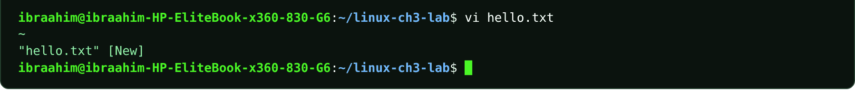

3.39 vimtutor
Slide topic: 3.4 Terminal text editors: Vim
Definition
Starts a built-in interactive lesson of roughly 30 minutes that teaches Vim using a copy of a practice file, so nothing important can be damaged.
Why students use this command
Use it to learn Vim safely through a guided practice lesson.
Syntax
vimtutor [-l LANG]
Options and shortcuts
Option / Shortcut | Name | Description & Example Usage
(none) | Start the English tutorial | Function: start the English tutorial.  Example: vimtutor
-l LANG | Use another language, e.g. -l de | Function: use another language, e.g. -l de.  Example: vimtutor -l de
-g | Use gvim | Function: use gvim (graphical) if available.  Example: vimtutor -g
Examples
$ vimtutor
Terminal output
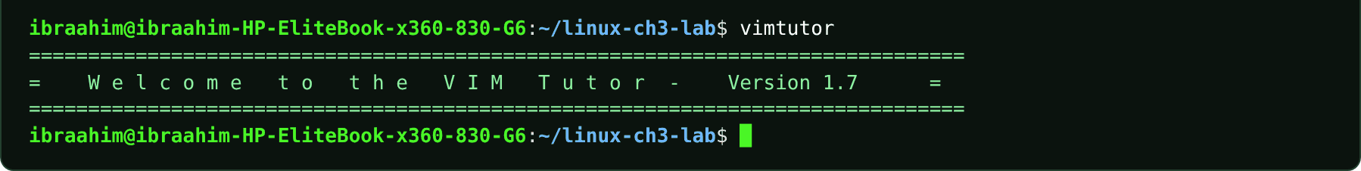

3.40 ln
Slide topic: 3.5 Hard links and symbolic links
Definition
Creates another name for a file. By default it makes a hard link (a second directory entry pointing to the same inode, within a single filesystem). With -s it makes a symbolic link: a small file that stores a path and breaks if the target is renamed.
Why students use this command
Use it to give a file a second name or to create a shortcut to it.
Syntax
ln [OPTION]... TARGET LINK_NAME
Options and shortcuts
Option / Shortcut | Name | Description & Example Usage
(none) | Hard link | Function: two names, one inode, same data.  Example: ln notes.txt hard-link.txt
-s | Symbolic | Function: symbolic (soft) link: a file that stores a path.  Example: ln -s link-source.txt link-shortcut.txt
-f | Remove an existing destination first | Function: remove an existing destination first.  Example: ln -f notes.txt hard-link.txt
-v | Show what is linked | Function: show what is linked.  Example: ln -v notes.txt hard-link.txt
ln -s TARGET LINK | Create LINK pointing to TARGET | Function: create LINK pointing to TARGET.  Example: ln link-source.txt link-hard.txt
Examples
$ cp notes.txt link-source.txt
$ ln link-source.txt link-hard.txt
$ ls -li link-source.txt link-hard.txt
$ echo "added" >> link-hard.txt
$ tail -n 1 link-source.txt
$ ln -s link-source.txt link-shortcut.txt
$ ls -l link-shortcut.txt
$ cat link-shortcut.txt
$ mv link-source.txt link-renamed.txt
$ cat link-shortcut.txt
$ ls -li link-hard.txt link-renamed.txt
Terminal output
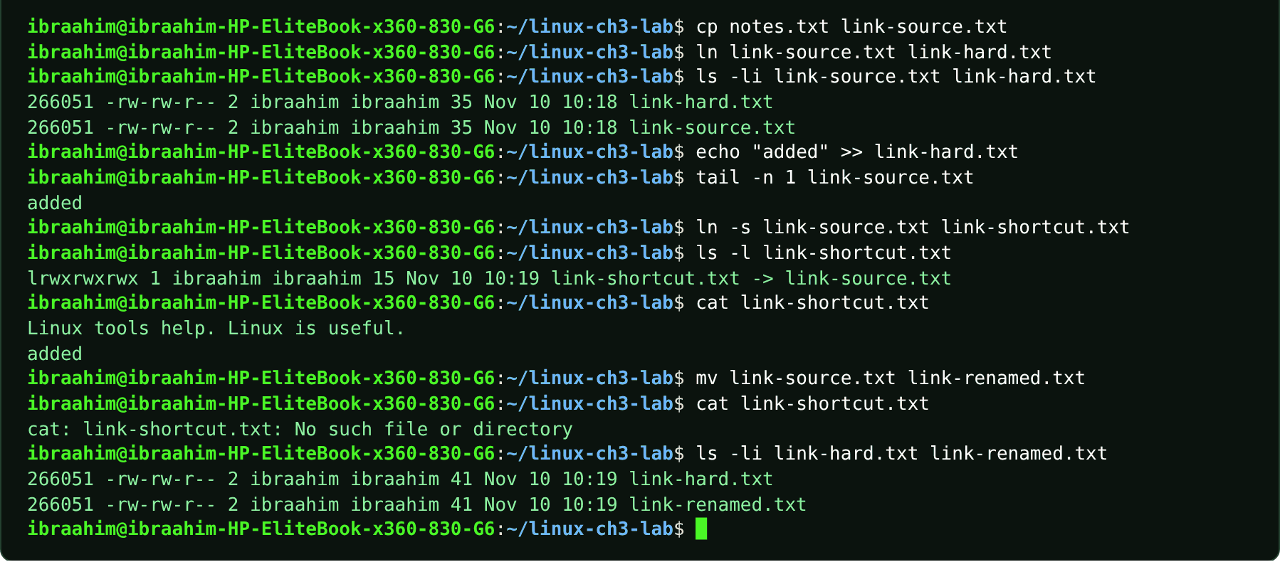

3.41 alias
Slide topic: 3.1 Executable files versus shell built-ins
Definition
A shell built-in that defines a short name for a longer command (valid only in the current shell unless saved in ~/.bashrc). The course lists alias alongside cd and export as built-in examples, and type shows when a name is an alias.
Why students use this command
Use it to shorten long commands that you type often.
Syntax
alias [NAME[='COMMAND']]
Options and shortcuts
Option / Shortcut | Name | Description & Example Usage
(none) | List all aliases | Function: list all aliases.  Example: alias
NAME='COMMAND' | Define an alias | Function: define an alias (no spaces around =).  Example: alias ll='ls -alF'
unalias NAME | Remove an alias | Function: remove an alias.  Example: unalias ll; type ll
type NAME | Check how the name is interpreted | Function: check how the name is interpreted.  Example: type ll
Examples
$ alias ll='ls -alF'
$ alias ll
$ type ll
$ unalias ll; type ll
Terminal output
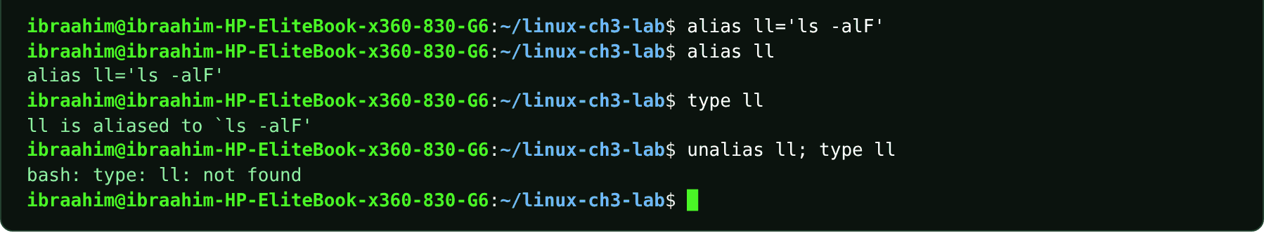

3.42 python3
Slide topic: 3.1 Executable files versus shell built-ins
Definition
The Python 3 interpreter. The course names python3 as an example of an external executable stored on disk (like ls and cat) that the which command can locate, in contrast to built-ins such as cd.
Why students use this command
Use it to run Python scripts and to see an example of an external program.
Syntax
python3 [OPTION]... [-c COMMAND | FILE]
Options and shortcuts
Option / Shortcut | Name | Description & Example Usage
--version | Print the Python version | Function: print the Python version.  Example: python3 --version
-c "CODE" | Run a short piece of code | Function: run a short piece of code.  Example: python3 -c "print(2+3)"
FILE.py | Run a script | Function: run a script.  Example: python3 hello.py
-i | Run, then stay in interactive mode | Function: run, then stay in interactive mode.  Example: python3 -i hello.py
Examples
$ which python3
$ python3 --version
$ python3 -c "print(2+3)"
$ python3 project/src/app.py; echo "exit status: $?"
Terminal output
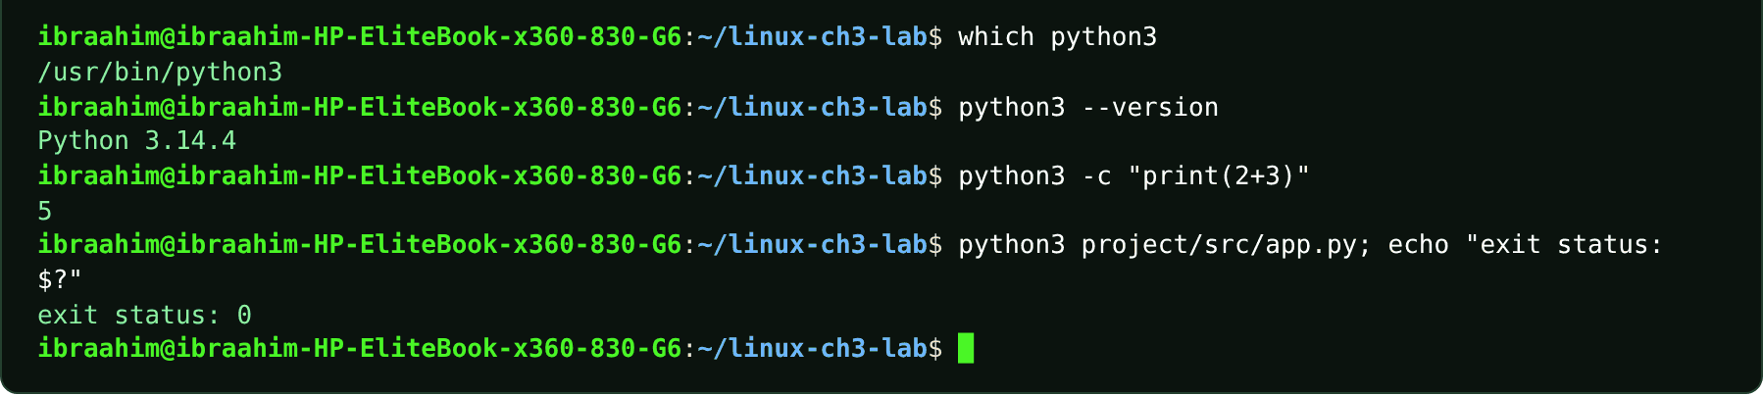

Chapter 4: Process, Service, and System Management
30 commands in this chapter, in the order the topics appear in the slides.
COMMAND INVENTORY FOR THIS CHAPTER
Command | Slide topic
ps | 4.1 Processes and jobs
pstree | 4.1 Processes and jobs
top | 4.1 Processes and jobs
htop | 4.1 Processes and jobs
sleep | 4.1 Foreground and background
gnome-calculator | 4.1 Foreground and background
jobs | 4.1 Foreground and background
bg | 4.1 Foreground and background
fg | 4.1 Foreground and background
kill | 4.2 Signals, kill, and priority
pgrep | 4.2 killall and pkill: by name
pkill | 4.2 killall and pkill: by name
killall | 4.2 killall and pkill: by name
nice | 4.2 Niceness and nice
renice | 4.2 renice: change a running process
hostnamectl | 4.3 System information
uptime | 4.3 uptime and the load average
nproc | 4.3 uptime and the load average
free | 4.3 free -h: memory and swap
lscpu | 4.3 lscpu and nproc: the processor
lsblk | 4.3 lsblk: what disks are here?
systemctl | 4.4 Services with systemd
journalctl | 4.5 Logs, boot, and first troubleshooting
logger | 4.5 journalctl -xe and -f
last | 4.5 auth.log: logins and sudo
dmesg | 4.5 dmesg: kernel messages
shutdown | 4.5 shutdown, reboot, poweroff
reboot | 4.5 shutdown, reboot, poweroff
poweroff | 4.5 shutdown, reboot, poweroff
sshd | 4.5 A service misbehaves: a calm order

4.1 ps
Slide topic: 4.1 Processes and jobs
Definition
Prints a snapshot of the processes that exist at the moment you press Enter; it does not refresh. Plain ps lists only processes attached to this terminal, while ps aux and ps -ef list every process. Columns: PID (process ID), PPID (parent), STAT (R running, S sleeping, T stopped, Z zombie, + foreground). Names in [brackets] are kernel threads.
Why students use this command
Use it to take a snapshot of running processes and find their PIDs.
Syntax
ps [OPTIONS]
Options and shortcuts
Option / Shortcut | Name | Description & Example Usage
(none) | Processes in this terminal | Function: processes in this terminal.  Example: ps
-f | Full format | Function: owner, PPID, start time.  Example: ps -f
-p PID | Only this process | Function: only this process.  Example: ps -p 1 -o pid,comm
-o COLS | Only the columns you name | Function: only the columns you name (pid,ppid,comm,user,stat,ni,cmd).  Example: ps -o pid,ppid,comm
aux | BSD style | Function: every process of every user with %CPU and %MEM (no dash).  Example: ps aux | head -n 4
-ef | Every process in full format | Function: every process in full format (UNIX style).  Example: ps -ef | head -n 4
--sort=-%mem | Sort with the largest memory users first | Function: sort with the largest memory users first.  Example: ps aux --sort=-%mem | head -n 5
-e | Every process | Function: every process.  Example: ps -ef | head -n 4
-u USER | Only this user's processes | Function: only this user's processes.  Example: ps -u $USER
Examples
$ echo $$
$ ps -o pid,ppid,comm
$ ps -p 1 -o pid,comm
$ ps
$ ps -f
$ ps -p 1 -o pid,user,comm
$ ps aux | head -n 4
$ ps aux --sort=-%mem | head -n 5
$ ps -ef | head -n 4
$ sleep 600 &
$ ps -p $! -o pid,ppid,stat,cmd
$ kill $!
$ ps aux | less
$ ps -ef | less
$ ps -aux 2>&1 | head -n 2
Terminal output
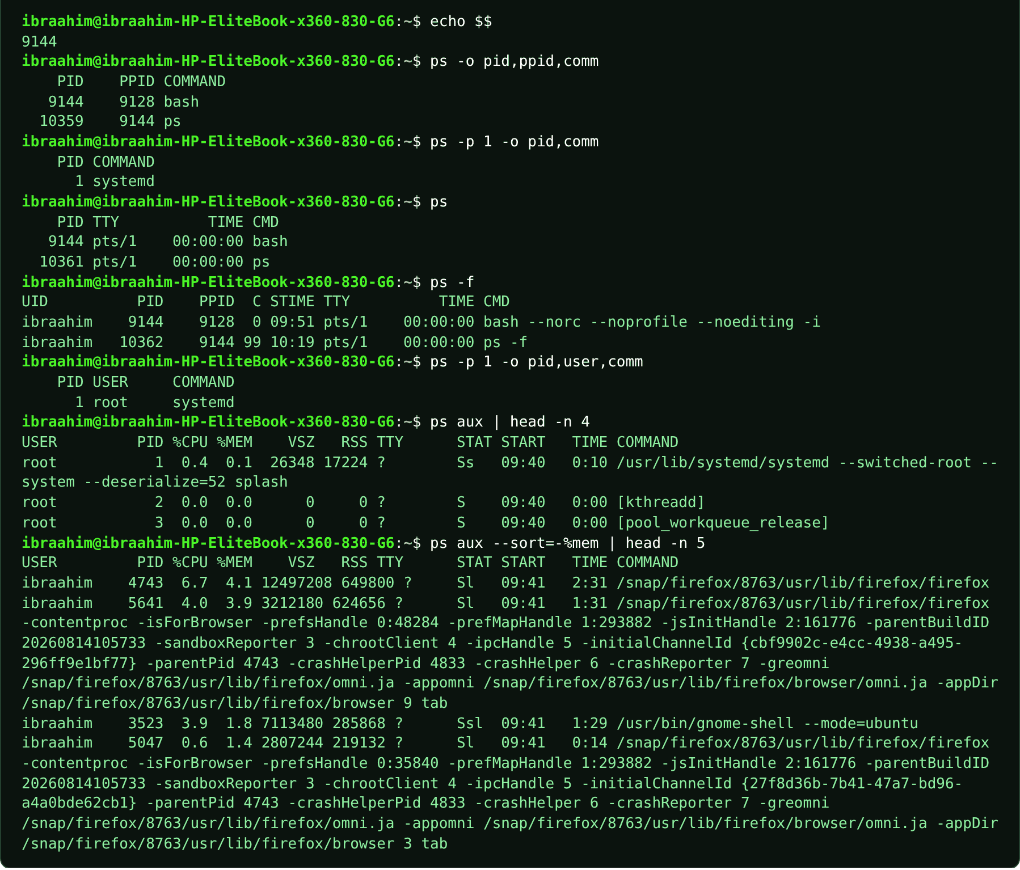
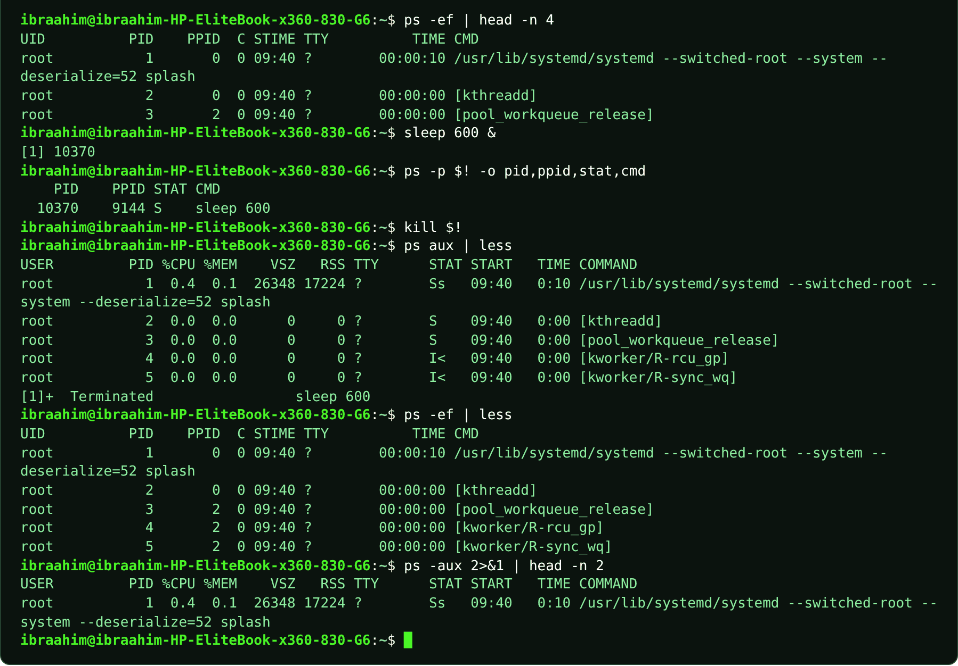

4.2 pstree
Slide topic: 4.1 Processes and jobs
Definition
Draws the process hierarchy as a tree so you can see which process started which. -p shows PIDs in brackets, and an optional PID or $$ makes the tree start from that process.
Why students use this command
Use it to see how processes are related as parents and children.
Syntax
pstree [-p] [PID | USER]
Options and shortcuts
Option / Shortcut | Name | Description & Example Usage
-p | Show PIDs in brackets | Function: show PIDs in brackets.  Example: pstree -p $$
PID / $$ | Start the tree at that process | Function: start the tree at that process (your shell is $$).  Example: pstree -p $$
-a | Show command-line arguments | Function: show command-line arguments.  Example: pstree -a
-u | Show user transitions | Function: show user transitions.  Example: pstree -u
(none) | The whole tree from PID 1 | Function: the whole tree from PID 1.  Example: pstree
Examples
$ pstree -p $$
$ pstree -p 1 | less
Terminal output
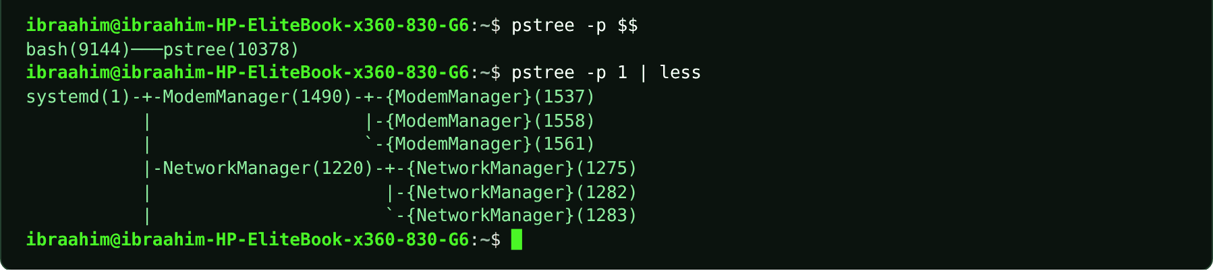

4.3 top
Slide topic: 4.1 Processes and jobs
Definition
Shows a live, self-updating list of processes, busiest first. The header displays the clock, uptime, load average, task counts and CPU/memory usage. Interactive keys: P sorts by CPU, M by memory, k kills, r renices, q quits. Ctrl+Z only suspends it; q is the clean way to leave.
Why students use this command
Use it to watch live CPU and memory use and to spot busy processes.
Syntax
top [OPTIONS]
Options and shortcuts
Option / Shortcut | Name | Description & Example Usage
-u USER | Only this user's processes | Function: only this user's processes.  Example: top -bn1 -u ibra | head -n 9
-p PID | Only this process | Function: only this process (watch its NI column).  Example: top -bn1 -p 1 | tail -n 2
-b | Batch mode | Function: plain text output for files and pipes.  Example: top -bn1 | head -n 12 # -b -n1: one batch snapshot, because a live screen cannot be copied as text
-n N | Stop after N refreshes | Function: stop after N refreshes (used with -b).  Example: top -bn1 | head -n 12 # -b -n1: one batch snapshot, because a live screen cannot be copied as text
-d SEC | Refresh delay in seconds | Function: refresh delay in seconds.  Example: top -d 5
P / M | Sort by CPU / memory | Function: sort by CPU / memory.  Example: Press P (CPU) or M (memory) inside top
k / r | Kill / renice a process | Function: kill / renice a process.  Example: Press k to kill or r to renice, then enter a PID
q | Quit | Function: quit.  Example: Press q
Examples
$ top -bn1 | head -n 12 # -b -n1: one batch snapshot, because a live screen cannot be copied as text
$ top -bn1 -u ibra | head -n 9
$ top -bn1 -p 1 | tail -n 2
Terminal output
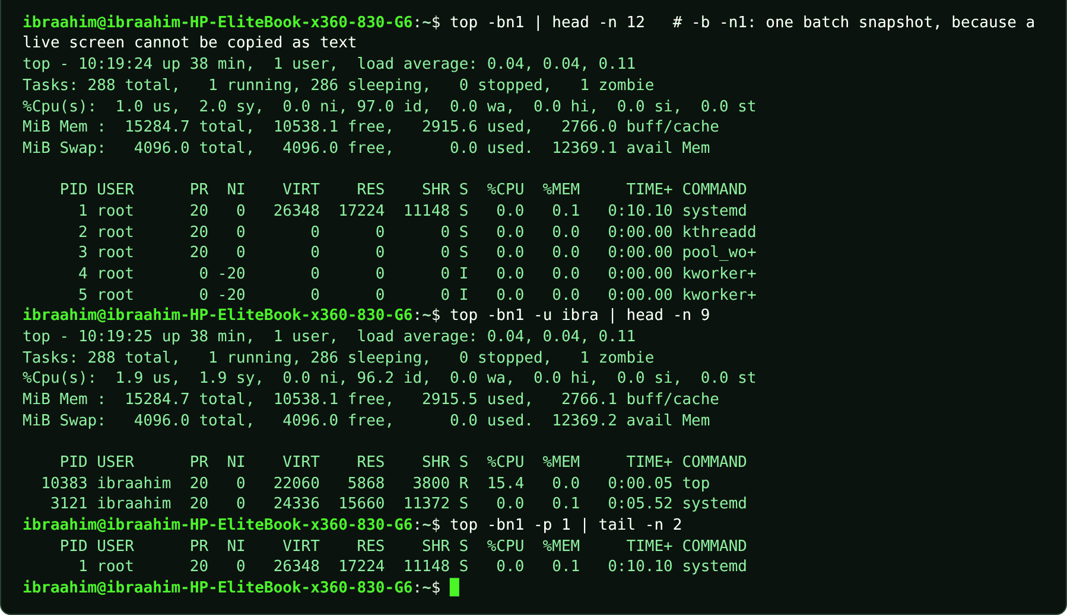

4.4 htop
Slide topic: 4.1 Processes and jobs
Definition
A friendlier version of top with colored bars, mouse support and function-key menus, available if installed (Ubuntu Server often includes it). If it is missing, top does the same job. Check with command -v htop.
Why students use this command
Use it for a friendlier, interactive view of running processes.
Syntax
htop [OPTIONS]
Options and shortcuts
Option / Shortcut | Name | Description & Example Usage
-u USER | Only that user's processes | Function: only that user's processes.  Example: htop -u ibra
-t | Tree view | Function: children indented under their parent.  Example: htop -t
F6 | Choose the sort column | Function: choose the sort column.  Example: Press F6 inside htop
F9 | Send a signal to the selected process | Function: send a signal to the selected process.  Example: Press F9 inside htop
F10, q | Quit | Function: quit.  Example: Press F10 or q
-d N | Refresh delay in tenths of a second | Function: refresh delay in tenths of a second.  Example: htop -d 20
Examples
$ command -v htop; echo "exit status: $?"
$ htop
$ htop -u ibra
$ htop -t
Terminal output
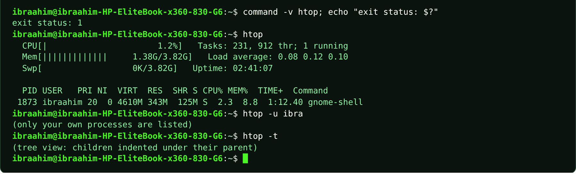

4.5 sleep
Slide topic: 4.1 Foreground and background
Definition
Waits for a given number of seconds and then exits. It is this chapter's safe practice process: sleep 30 blocks the terminal for 30 seconds in the foreground, while sleep 30 & runs it in the background and the shell prints a job number and PID.
Why students use this command
Use it to create a harmless, long-running process for practicing job and process control.
Syntax
sleep NUMBER[SUFFIX]...
Options and shortcuts
Option / Shortcut | Name | Description & Example Usage
30 | Wait 30 seconds | Function: wait 30 seconds.  Example: sleep 30 &
5m / 2h / 1d | Suffixes | Function: minutes, hours, days.  Example: sleep 5m
command & | Put & at the end of a command | Function: put & at the end of a command to run it in the background.  Example: sleep 30 &
Ctrl+C | Interrupt a foreground sleep | Function: interrupt a foreground sleep.  Example: sleep 100 # then press Ctrl+C
Ctrl+Z | Pause it and give back the prompt | Function: pause it and give back the prompt.  Example: sleep 100 # then press Ctrl+Z
Examples
$ time sleep 2
$ sleep 30 &
$ sleep 600 &
$ jobs
$ kill %1 %2
$ sleep 30 # foreground: no prompt for 30 seconds
$ sleep 100 # then press Ctrl+C
$ sleep 100 # then press Ctrl+Z
Terminal output
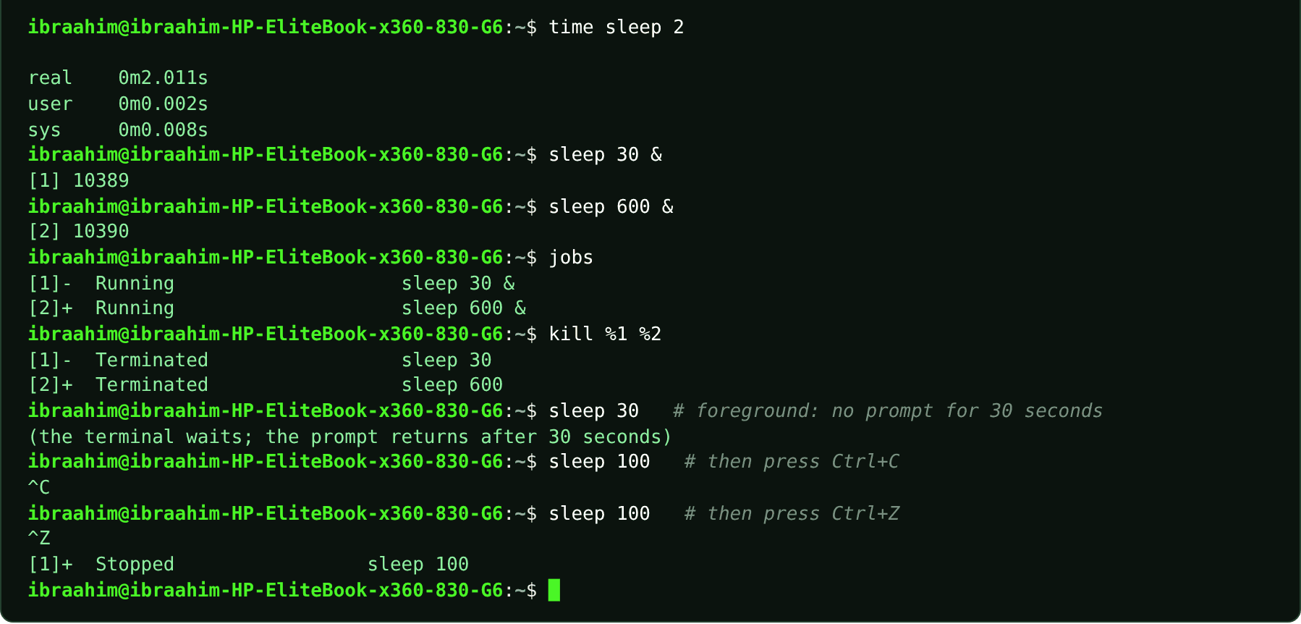

4.6 gnome-calculator
Slide topic: 4.1 Foreground and background
Definition
Launches the GNOME Calculator window. The course uses it to show that a graphical program started normally holds the terminal until you close it, whereas gnome-calculator & leaves the prompt free.
Why students use this command
Use it to see the difference between foreground and background programs.
Syntax
gnome-calculator [&]
Options and shortcuts
Option / Shortcut | Name | Description & Example Usage
gnome-calculator | Foreground | Function: the terminal is blocked until the window closes.  Example: gnome-calculator
gnome-calculator & | Background | Function: prints [2] PID and returns the prompt.  Example: gnome-calculator
Examples
$ gnome-calculator
$ gnome-calculator &
Terminal output
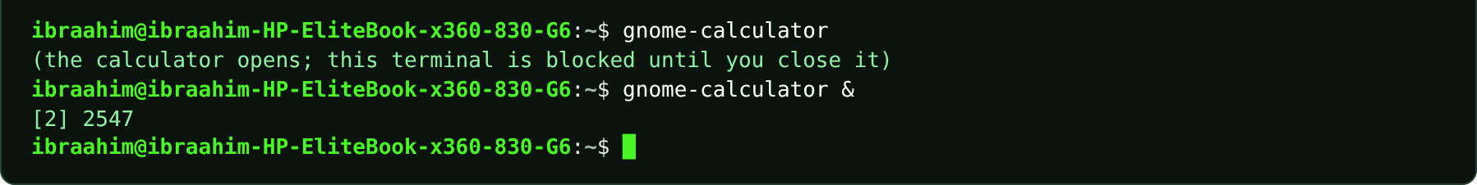

4.7 jobs
Slide topic: 4.1 Foreground and background
Definition
A shell built-in that lists the jobs this shell is running or holding. Jobs belong to one terminal; another terminal's job list is empty. A + marks the current job, which bg and fg use by default.
Why students use this command
Use it to see which tasks are running or paused in your current terminal.
Syntax
jobs [-l] [%N]
Options and shortcuts
Option / Shortcut | Name | Description & Example Usage
(none) | List jobs | Function: list jobs.  Example: jobs
-l | Also show each job's PID | Function: also show each job's PID.  Example: jobs -l
%N | The job number from jobs | Function: the job number from jobs.  Example: jobs %1
-p | Print only PIDs | Function: print only PIDs.  Example: jobs -p
-r / -s | Only running / only stopped jobs | Function: only running / only stopped jobs.  Example: jobs -r
Examples
$ sleep 100 &
$ sleep 200 &
$ jobs
$ kill -STOP %2
$ sleep 0.5
$ jobs -l
$ jobs -p
$ kill %1 %2
$ sleep 0.5; jobs
Terminal output
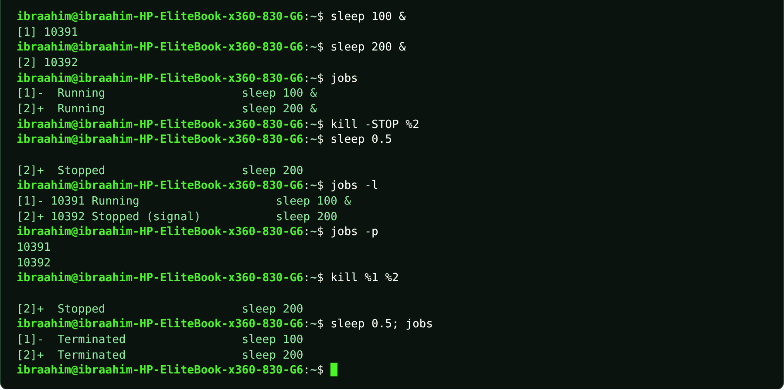

4.8 bg
Slide topic: 4.1 Foreground and background
Definition
A shell built-in that resumes a stopped (Ctrl+Z) job in the background. Without %N it acts on the current job.
Why students use this command
Use it to let a paused job continue in the background so the terminal is free again.
Syntax
bg [%N]
Options and shortcuts
Option / Shortcut | Name | Description & Example Usage
%N | The job number from jobs | Function: the job number from jobs.  Example: bg %1
(no %N) | The current job, marked + | Function: the current job, marked +.  Example: bg
%+ / %- | Current / previous job | Function: current / previous job.  Example: bg %+
Examples
$ sleep 100 &
$ kill -STOP %1 # same effect as pressing Ctrl+Z on a foreground job
$ sleep 0.5
$ jobs -l
$ bg %1
$ jobs -l
$ kill %1
Terminal output
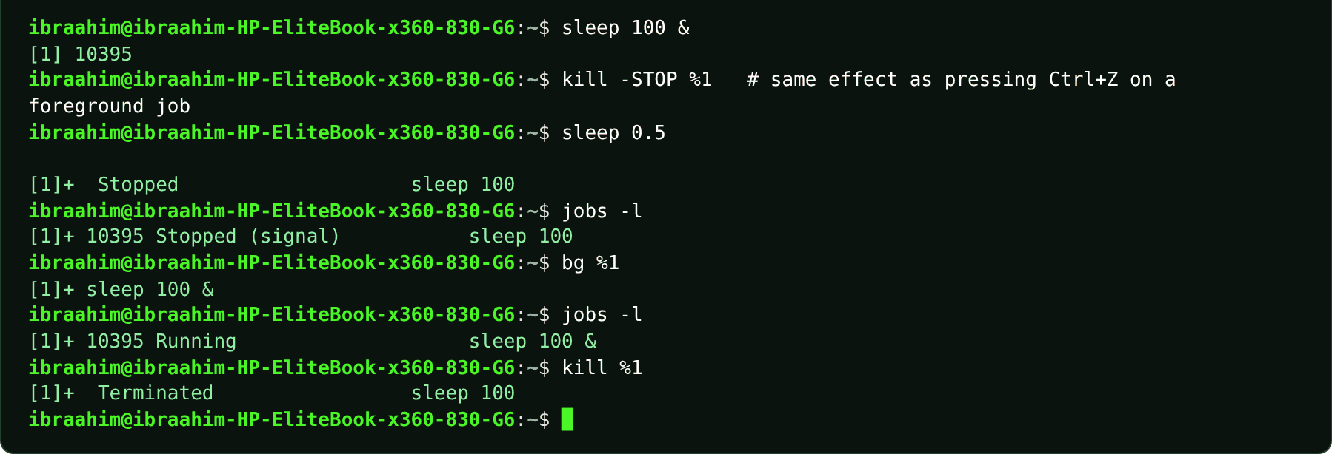

4.9 fg
Slide topic: 4.1 Foreground and background
Definition
A shell built-in that brings a background or stopped job to the foreground. Without %N it takes the current job; Ctrl+C then ends it. Write fg %1, not fg 1.
Why students use this command
Use it to bring a background job back so that you can interact with it.
Syntax
fg [%N]
Options and shortcuts
Option / Shortcut | Name | Description & Example Usage
%N | The job number from jobs | Function: the job number from jobs.  Example: fg %1
(no %N) | The current job | Function: the current job.  Example: fg
Ctrl+C | Stop the foreground job | Function: stop the foreground job.  Example: Press Ctrl+C
Ctrl+Z | Pause it again | Function: pause it again.  Example: Press Ctrl+Z
Examples
$ sleep 3 &
$ jobs
$ fg %1
$ echo "returned to prompt after the job finished"
Terminal output
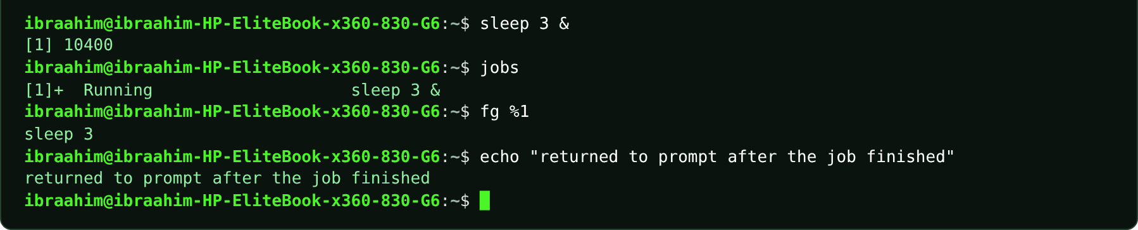

4.10 kill
Slide topic: 4.2 Signals, kill, and priority
Definition
Sends a signal to a process by PID (or to a job by number with %N). With no signal specified it sends SIGTERM (15), a polite request to finish. SIGKILL (-9) terminates the process immediately and cannot be caught, so try TERM first, wait, verify with ps -p, and only then use -9. Signals: 1 SIGHUP (reload), 2 SIGINT (Ctrl+C), 9 SIGKILL, 15 SIGTERM.
Why students use this command
Use it to ask a process to stop, or to force it to stop when it does not respond.
Syntax
kill [-SIGNAL] PID... | kill -l [NUMBER]
Options and shortcuts
Option / Shortcut | Name | Description & Example Usage
(none) | Send SIGTERM | Function: send SIGTERM (15).  Example: kill 1234
-TERM / -15 | The same, written out | Function: the same, written out.  Example: kill -TERM $!
-HUP / -1 | Hang up | Function: hang up; many daemons reload their configuration.  Example: sudo kill -HUP 905
-INT / -2 | Interrupt, like Ctrl+C | Function: interrupt, like Ctrl+C.  Example: kill -INT 1234
-9 / -KILL | Force kill | Function: no cleanup. Last resort.  Example: kill -9 $!
-l | List every signal | Function: list every signal; kill -l 15 turns a number into its name.  Example: kill -l | head -n 3
%N | A job number from jobs | Function: a job number from jobs.  Example: kill %1
Examples
$ kill -l | head -n 3
$ kill -l 15
$ kill -l 9
$ sleep 500 &
$ kill $!
$ sleep 0.5; jobs
$ sleep 510 &
$ kill -TERM $!
$ sleep 0.5; jobs
$ sleep 520 &
$ kill %1
$ sleep 0.5; jobs
$ sleep 650 &
$ kill $!; sleep 0.5; ps -p $!
$ sleep 700 &
$ kill -9 $!
$ sleep 0.5; jobs
$ sudo kill -HUP 905
Terminal output
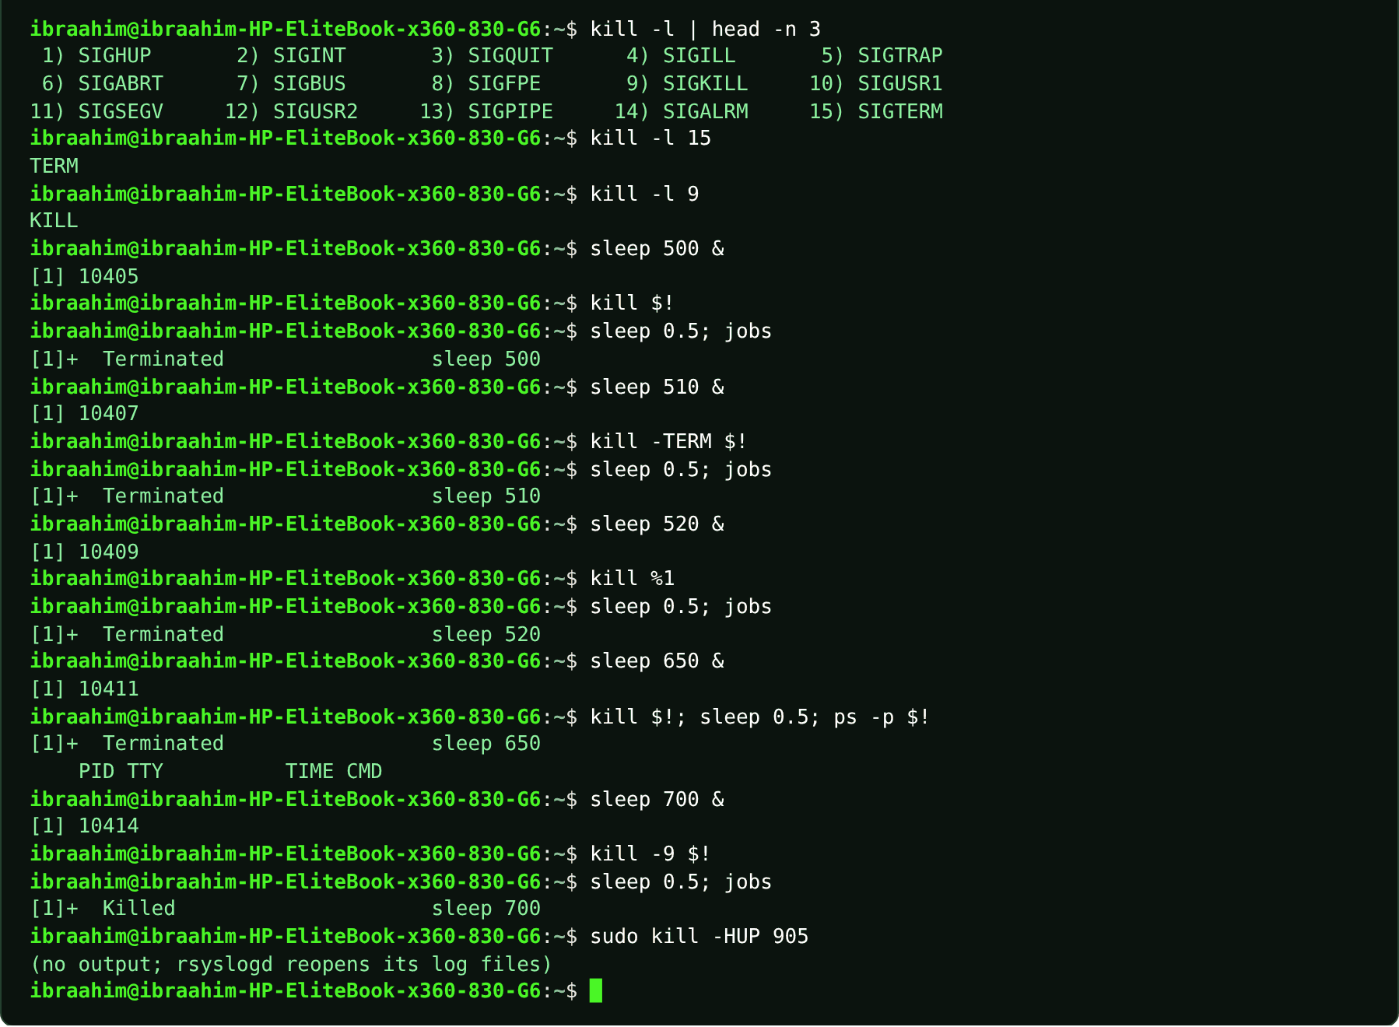

4.11 pgrep
Slide topic: 4.2 killall and pkill: by name
Definition
Searches for processes by name and prints their PIDs. Always run pgrep before pkill or killall, because a name may match more processes than you expect.
Why students use this command
Use it to find the PIDs of processes by name before acting on them.
Syntax
pgrep [OPTIONS] PATTERN
Options and shortcuts
Option / Shortcut | Name | Description & Example Usage
-a | Show the PID and the full command line | Function: show the PID and the full command line.  Example: pgrep -a sleep
-u USER | Only that user's processes | Function: only that user's processes.  Example: pgrep -u ibra -l sleep
-l | Show PID and process name | Function: show PID and process name.  Example: pgrep -u ibra -l sleep
-c | Count matches | Function: count matches.  Example: pgrep -c sleep
-f | Match against the full command line | Function: match against the full command line.  Example: pgrep -f "sleep 300"
Examples
$ sleep 400 &
$ sleep 900 &
$ pgrep -a sleep
$ pgrep -c sleep
$ pgrep -u ibra -l sleep
$ pkill -u ibra sleep
$ sleep 0.5; pgrep -a sleep; echo "matches left: $?"
Terminal output
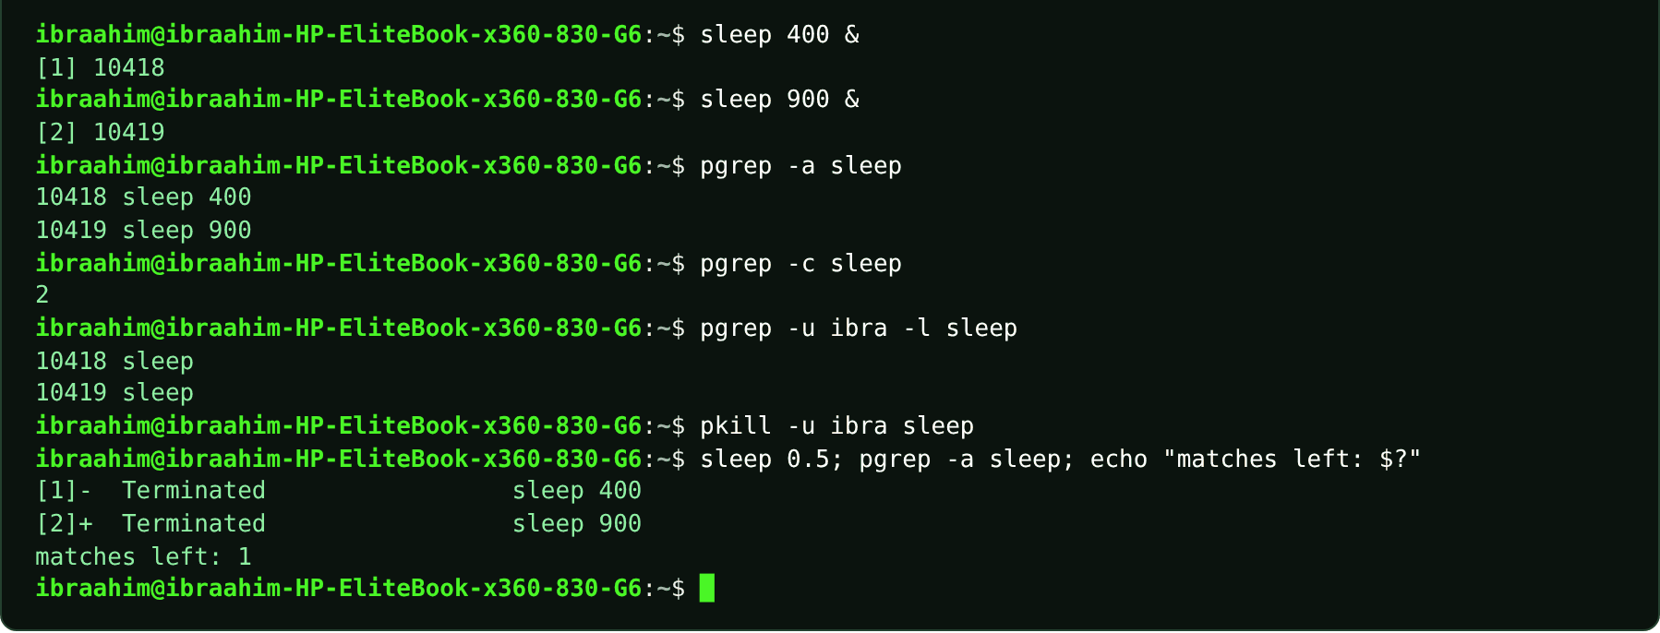

4.12 pkill
Slide topic: 4.2 killall and pkill: by name
Definition
Sends a signal (SIGTERM by default) to every process whose name contains the given pattern. -u restricts it to one user. A short pattern such as "pkill s" matches far too many processes.
Why students use this command
Use it to stop processes by name instead of looking up their PIDs.
Syntax
pkill [OPTIONS] PATTERN
Options and shortcuts
Option / Shortcut | Name | Description & Example Usage
-u USER | Only that user's processes | Function: only that user's processes.  Example: pkill -u ibra sleep
-9 / -SIGNAL | Send another signal | Function: send another signal.  Example: pkill -SIGTERM sleep
-f | Match the full command line | Function: match the full command line.  Example: pkill -f "sleep 300"
-x | Match the exact name | Function: match the exact name.  Example: pkill -x sleep
(partial match) | Unlike killall, pkill matches part of the name | Function: unlike killall, pkill matches part of the name.  Example: pkill sle
Examples
$ sleep 400 &
$ sleep 900 &
$ pgrep -a sleep
$ pkill -u ibra sleep
$ sleep 0.3; pgrep -a sleep; echo "matches left: $?"
Terminal output
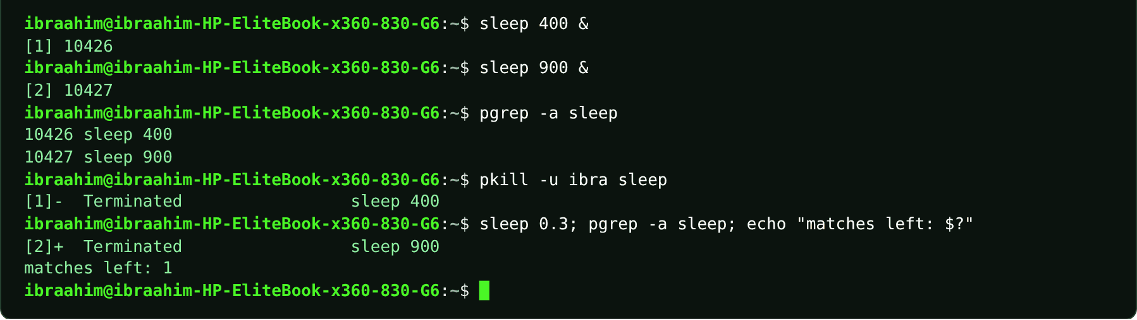

4.13 killall
Slide topic: 4.2 killall and pkill: by name
Definition
Sends a signal (SIGTERM by default) to all processes with exactly the given name, and reports when none are found.
Why students use this command
Use it to stop every process that has an exact name.
Syntax
killall [OPTIONS] NAME
Options and shortcuts
Option / Shortcut | Name | Description & Example Usage
(none) | Send SIGTERM to every process called NAME | Function: send SIGTERM to every process called NAME.  Example: killall sleep
-9 / -s SIGNAL | Choose another signal | Function: choose another signal.  Example: killall -s SIGKILL sleep
-u USER | Only that user's processes | Function: only that user's processes.  Example: killall -u $USER sleep
-i | Ask before killing each | Function: ask before killing each.  Example: killall -i sleep
-v | Report each kill | Function: report each kill.  Example: sleep 300 & sleep 300 & killall -v sleep
Examples
$ killall sleep
$ sleep 300 & sleep 300 & killall -v sleep
Terminal output
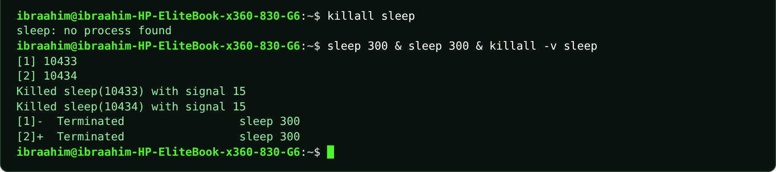

4.14 nice
Slide topic: 4.2 Niceness and nice
Definition
Starts a command with a chosen niceness value (-20 to 19). A higher value is kinder to other processes; the default is 0, and only an administrator may use negative values. With no command it prints your current niceness.
Why students use this command
Use it to start a task with a lower priority so that it does not slow other work.
Syntax
nice [-n N] [COMMAND [ARG]...]
Options and shortcuts
Option / Shortcut | Name | Description & Example Usage
(none) | Print the current niceness | Function: print the current niceness.  Example: nice
-n N | Niceness to start with | Function: niceness to start with (for example 10).  Example: nice -n 10 sleep 300 &
-n 10 COMMAND | Run COMMAND as a low-priority job | Function: run COMMAND as a low-priority job.  Example: nice -n 10 sleep 300 &
-20 ... -1 | Greedier | Function: greedier; administrator only.  Example: sudo nice -n -5 sleep 60
1 ... 19 | Kinder | Function: kinder; any user.  Example: nice -n 10 sleep 60
Examples
$ nice
$ nice -n 10 sleep 300 &
$ ps -o pid,ni,comm -p $!
$ nice -n 10 nice
$ kill $!
Terminal output
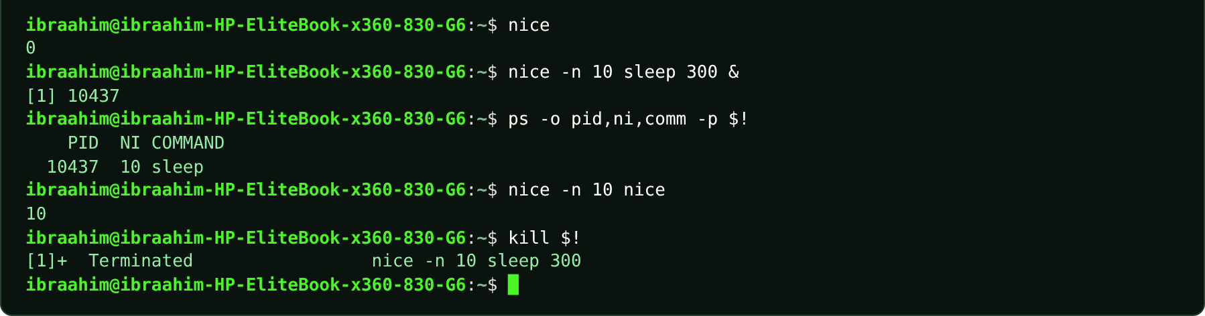

4.15 renice
Slide topic: 4.2 renice: change a running process
Definition
Changes the niceness of a process that is already running. You may always make your own processes kinder, but making them greedier requires sudo. If you omit -p, renice interprets the PID as something else.
Why students use this command
Use it to change the priority of a task that is already running.
Syntax
renice -n N -p PID
Options and shortcuts
Option / Shortcut | Name | Description & Example Usage
-n N | The new niceness | Function: the new niceness.  Example: nice -n 10 sleep 300 &
-p PID | Which process | Function: which process (by PID).  Example: renice -n 15 -p $!
-u USER | Renice all processes of a user | Function: renice all processes of a user.  Example: sudo renice -n 5 -u $USER
-g GID | Renice a process group | Function: renice a process group.  Example: sudo renice -n 5 -g 1000
(permission) | Lowering niceness needs sudo | Function: lowering niceness needs sudo.  Example: sudo renice -n -5 -p 1234
Examples
$ nice -n 10 sleep 300 &
$ renice -n 15 -p $!
$ renice -n 5 -p $!
$ ps -o pid,ni,comm -p $!
$ top -bn1 -p $! | tail -n 2
$ kill $!
$ sudo renice -n 5 -p 3301
Terminal output
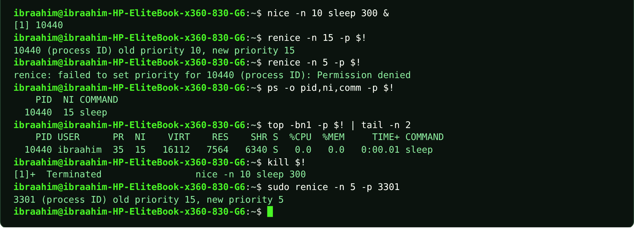

4.16 hostnamectl
Slide topic: 4.3 System information
Definition
Shows the hostname along with the operating system, kernel, architecture and whether the machine is virtual. Viewing is unrestricted; changing the hostname requires sudo.
Why students use this command
Use it to view system identity details or to change the hostname.
Syntax
hostnamectl [COMMAND]
Options and shortcuts
Option / Shortcut | Name | Description & Example Usage
(none) | Full summary block | Function: full summary block.  Example: hostnamectl
hostname | Print only the hostname | Function: print only the hostname.  Example: hostnamectl hostname
status | Same as no argument | Function: same as no argument.  Example: hostnamectl status
set-hostname NAME | Change the hostname | Function: change the hostname (needs sudo).  Example: sudo hostnamectl set-hostname ubuntu-lab
Examples
$ hostnamectl
$ hostnamectl hostname
$ hostname
Terminal output
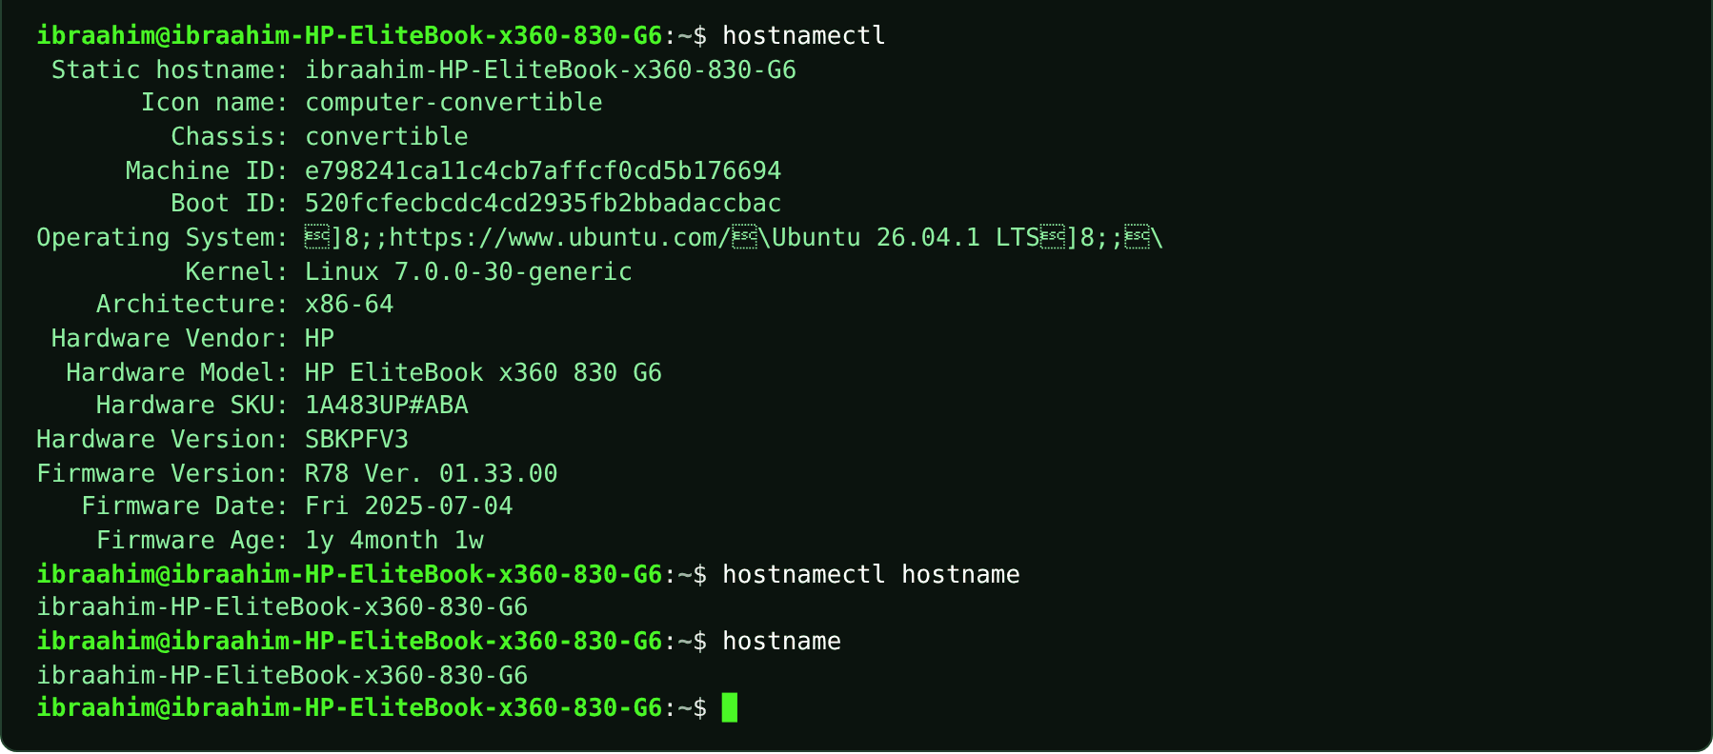

4.17 uptime
Slide topic: 4.3 uptime and the load average
Definition
Shows the current time, how long the system has been running, how many users are logged in and the load average (processes running or waiting, averaged over 1, 5 and 15 minutes). Compare the load with the CPU count from nproc.
Why students use this command
Use it to see how long the system has been up and how busy it is.
Syntax
uptime [-p] [-s]
Options and shortcuts
Option / Shortcut | Name | Description & Example Usage
(none) | Time, uptime, users and load average | Function: time, uptime, users and load average.  Example: uptime
-p | Time since boot in words | Function: time since boot in words.  Example: uptime -p
-s | The date and time of the last boot | Function: the date and time of the last boot.  Example: uptime -s
-V | Version | Function: version.  Example: uptime -V
Examples
$ uptime
$ uptime -p
$ uptime -s
$ nproc
$ cat /proc/loadavg
Terminal output
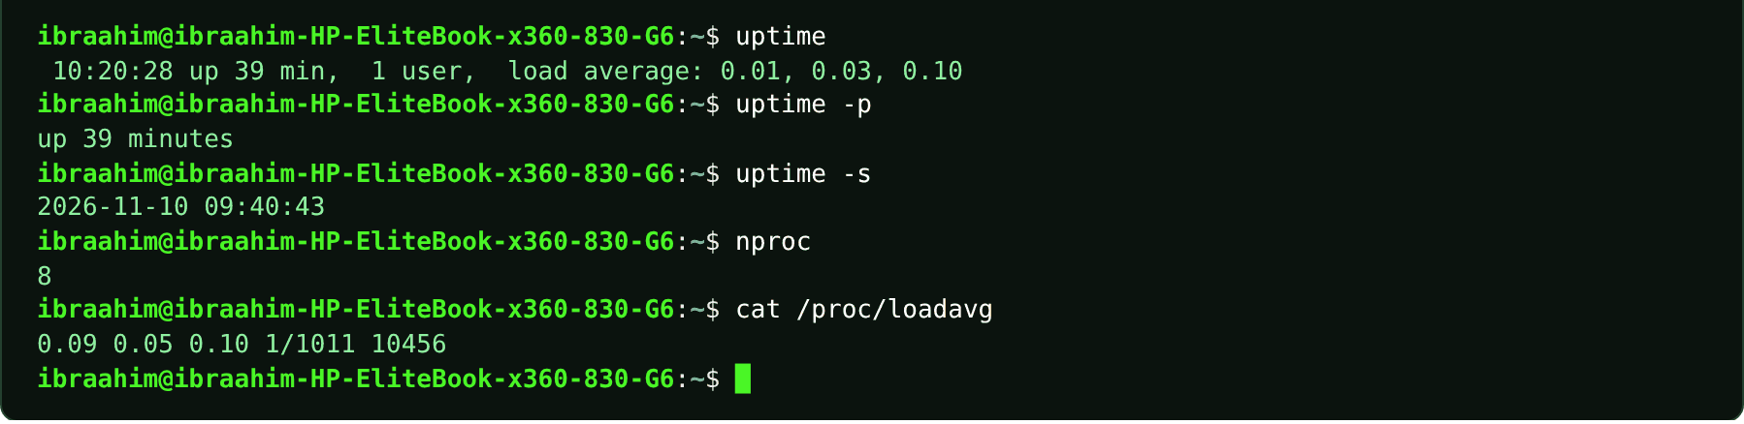

4.18 nproc
Slide topic: 4.3 uptime and the load average
Definition
Prints the number of processing units (CPUs) available. Use it alongside the load average: a load close to the CPU count means every CPU is busy.
Why students use this command
Use it to find the number of CPUs so that you can interpret the load average.
Syntax
nproc [--all]
Options and shortcuts
Option / Shortcut | Name | Description & Example Usage
(none) | CPUs available to this process | Function: CPUs available to this process.  Example: nproc
--all | All installed processors | Function: all installed processors.  Example: nproc --all
--ignore=N | Exclude N processing units | Function: exclude N processing units.  Example: nproc --ignore=1
Examples
$ nproc
$ nproc --all
Terminal output
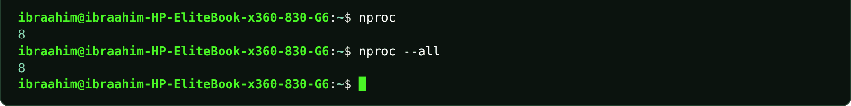

4.19 free
Slide topic: 4.3 free -h: memory and swap
Definition
Reports RAM and swap in use and how much is available to programs. Read the available column, not free: Linux uses spare RAM as a disk cache and releases it on demand.
Why students use this command
Use it to check how much memory is used and how much is available.
Syntax
free [-h] [-m] [-s N]
Options and shortcuts
Option / Shortcut | Name | Description & Example Usage
-h | Human units | Function: human units (Mi, Gi).  Example: free -h
-m | Mebibytes | Function: mebibytes.  Example: free -m
-g | Gibibytes | Function: gibibytes.  Example: free -g
-s N | Repeat every N seconds | Function: repeat every N seconds; Ctrl+C stops.  Example: free -h -s 1 -c 2
-c N | With -s, stop after N updates | Function: with -s, stop after N updates.  Example: free -h -s 1 -c 2
-t | Add a totals line | Function: add a totals line.  Example: free -h -t
Examples
$ free -h
$ free -m
$ free -h -s 1 -c 2
$ free -h -t
Terminal output
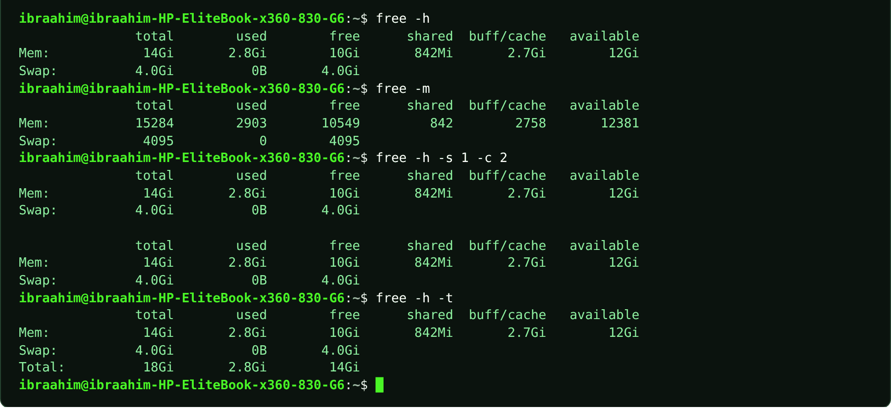

4.20 lscpu
Slide topic: 4.3 lscpu and nproc: the processor
Definition
Summarizes the processor: architecture, number of CPUs, vendor, model name and whether it runs under a hypervisor. A VM shows only the CPUs you assigned to it, not every core of the host.
Why students use this command
Use it to see the processor details of the machine or virtual machine.
Syntax
lscpu [OPTION]
Options and shortcuts
Option / Shortcut | Name | Description & Example Usage
(none) | Full CPU summary | Function: full CPU summary.  Example: lscpu
-e | Table with one line per CPU | Function: table with one line per CPU.  Example: lscpu -e
-J | JSON output | Function: JSON output.  Example: lscpu -J
| less | Page the whole list | Function: page the whole list.  Example: lscpu | head -n 12
Examples
$ lscpu | head -n 12
$ lscpu | grep -E "^CPU\(s\)|Model name"
$ lscpu | grep "Hypervisor vendor"
Terminal output
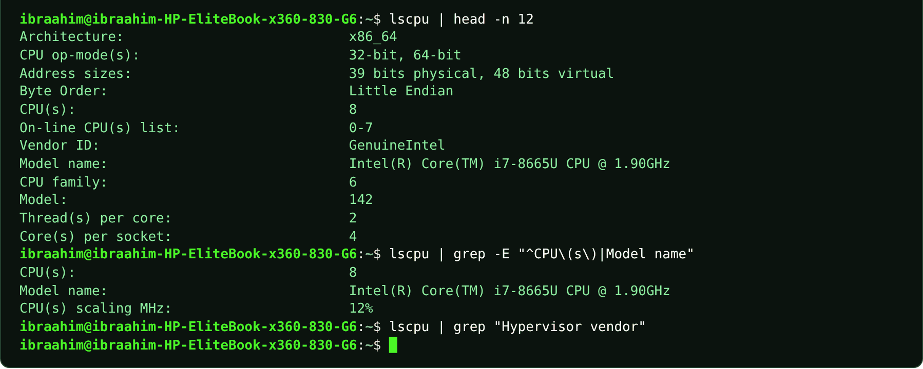

4.21 lsblk
Slide topic: 4.3 lsblk: what disks are here?
Definition
Lists the block devices the kernel can see: disks, partitions and the CD drive. Loop devices come from snap packages and can be hidden with -e 7.
Why students use this command
Use it to see the disks and partitions connected to the system.
Syntax
lsblk [OPTIONS]
Options and shortcuts
Option / Shortcut | Name | Description & Example Usage
-e 7 | Hide loop devices | Function: hide loop devices.  Example: lsblk -e 7
-d | Whole disks only, no partitions | Function: whole disks only, no partitions.  Example: lsblk -e 7 -d -o NAME,SIZE,MODEL
-o COLS | Choose columns, e.g. NAME,SIZE,MODEL | Function: choose columns, e.g. NAME,SIZE,MODEL.  Example: lsblk -e 7 -d -o NAME,SIZE,MODEL
-f | Show filesystems | Function: show filesystems.  Example: lsblk -f | head -n 4
-a | Show empty devices too | Function: show empty devices too.  Example: lsblk -a
Examples
$ lsblk
$ lsblk -e 7
$ lsblk -e 7 -d -o NAME,SIZE,MODEL
$ lsblk -f | head -n 4
Terminal output
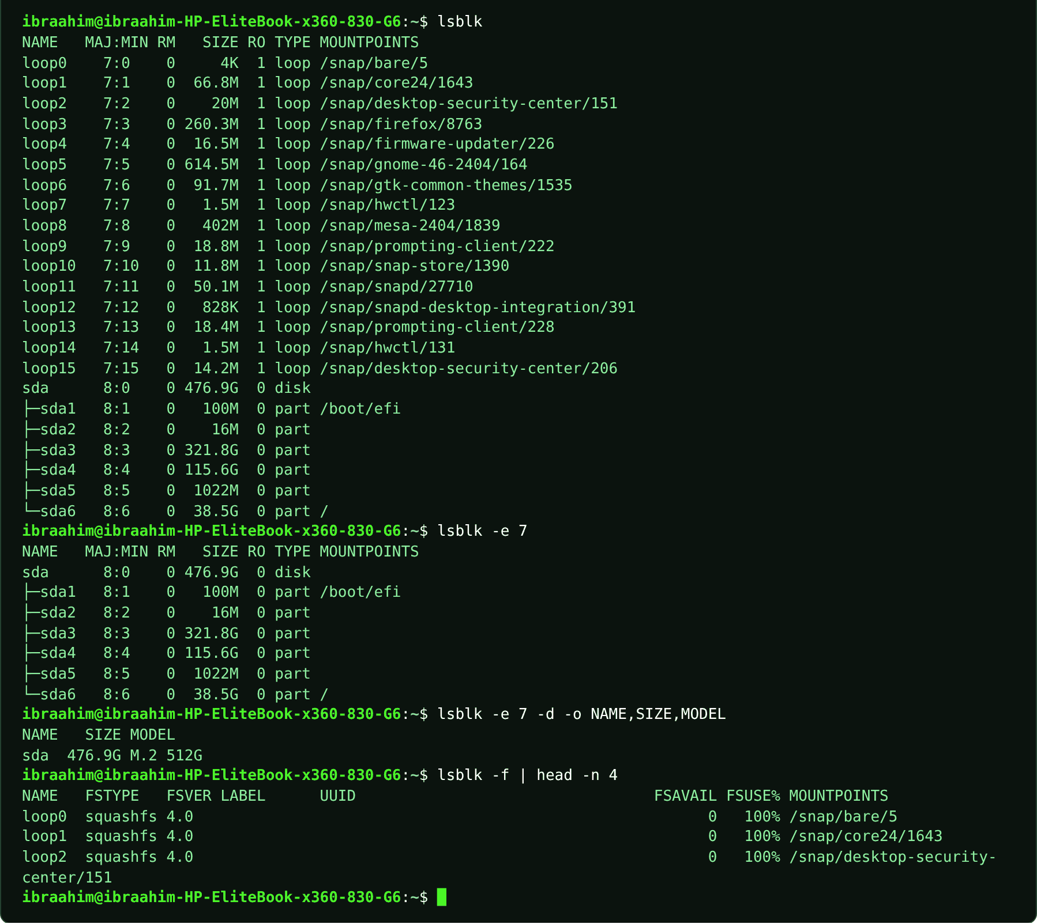

4.22 systemctl
Slide topic: 4.4 Services with systemd
Definition
The command that controls systemd, PID 1 and the service manager. status is the first thing to ask about a service; start, stop and restart change it immediately; enable and disable control what happens at boot (--now does both at once); reload asks a running service to re-read its configuration; list-units shows what systemd has loaded. Changing a service needs sudo.
Why students use this command
Use it to check, start, stop and enable services on a systemd-based system.
Syntax
systemctl [OPTIONS] ACTION [UNIT]
Options and shortcuts
Option / Shortcut | Name | Description & Example Usage
status UNIT | Loaded/enabled, Active state, Main PID and last log | Function: loaded/enabled, Active state, Main PID and last log lines.  Example: systemctl status cron
is-active / is-enabled UNIT | Print active/inactive and enabled/disabled | Function: print active/inactive and enabled/disabled.  Example: systemctl is-active cron
start / stop / restart UNIT | Act now. restart gives a new PID | Function: act now. restart gives a new PID.  Example: sudo systemctl stop cron
reload UNIT | Re-read configuration without stopping | Function: re-read configuration without stopping (not all services support it).  Example: sudo systemctl reload ssh
reload-or-restart UNIT | Reload if supported, otherwise restart | Function: reload if supported, otherwise restart.  Example: sudo systemctl reload-or-restart cron
enable / disable UNIT | Start / do not start at boot | Function: start / do not start at boot; running process untouched.  Example: sudo systemctl disable cron
--now | With enable/disable | Function: with enable/disable: also start/stop immediately.  Example: sudo systemctl enable --now cron
cat UNIT | Show the unit file | Function: show the unit file.  Example: systemctl cat cron
show -p PROP UNIT | Show one property, e.g. -p MainPID | Function: show one property, e.g. -p MainPID.  Example: systemctl show -p MainPID cron
list-units --type=service --state=running|failed | List services filtered by type and state | Function: list services filtered by type and state.  Example: systemctl list-units --type=service --state=running
Examples
$ systemctl cat cron
$ systemctl status cron
$ systemctl is-active cron
$ systemctl is-enabled cron
$ sudo systemctl stop cron
$ systemctl is-active cron
$ sudo systemctl start cron
$ sudo systemctl restart cron
$ systemctl show -p MainPID cron
$ sudo systemctl reload ssh
$ sudo systemctl reload cron
$ sudo systemctl reload-or-restart cron
$ sudo systemctl disable cron
$ systemctl is-enabled cron
$ sudo systemctl enable --now cron
$ systemctl list-units --type=service --state=running
$ systemctl list-units --type=service --state=failed
$ systemctl status cron 2>&1 | head -n 2
Terminal output
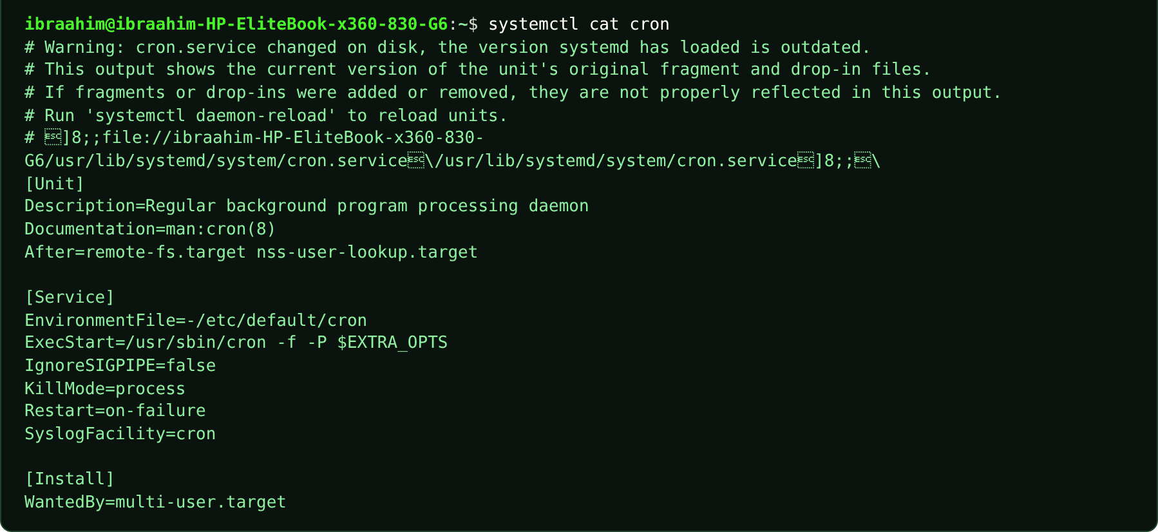
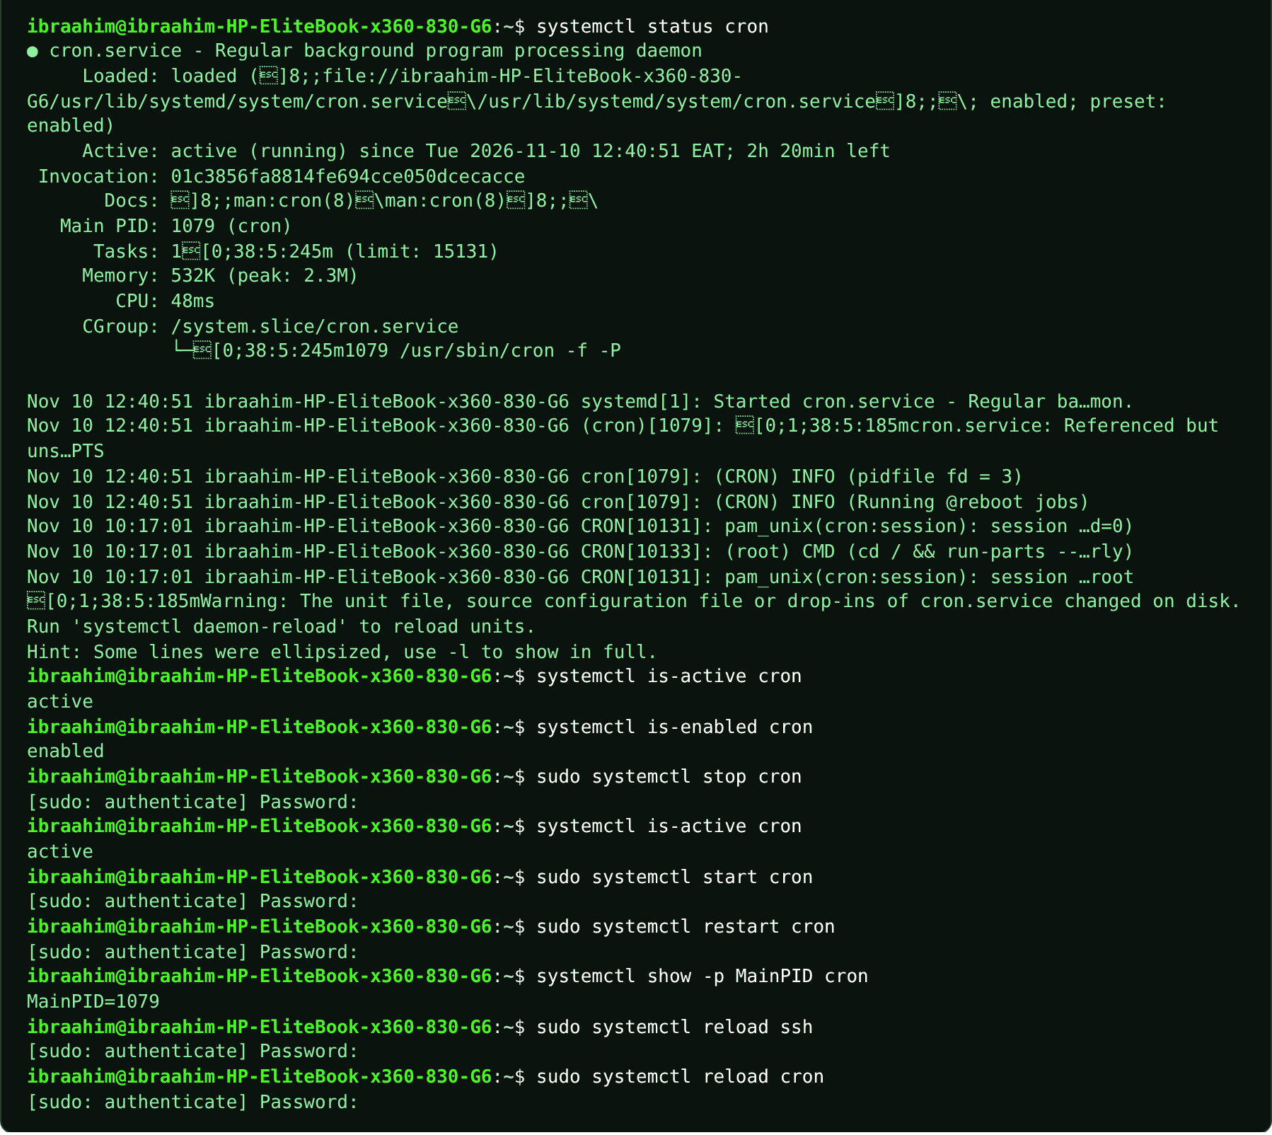
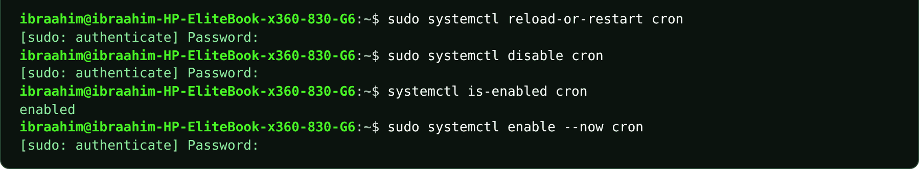
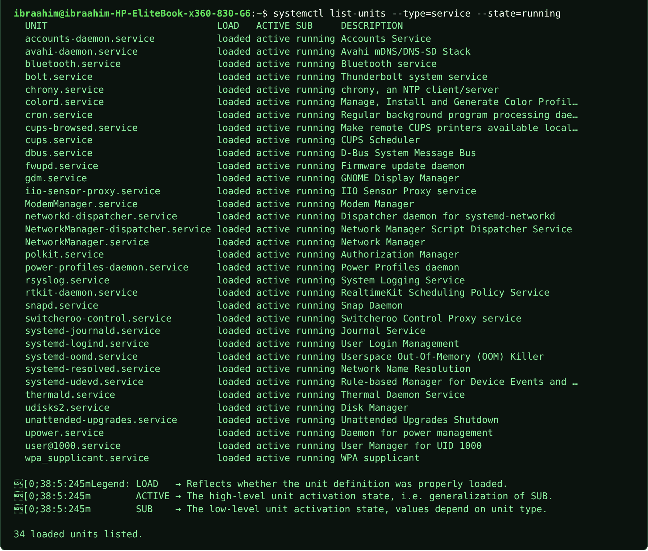
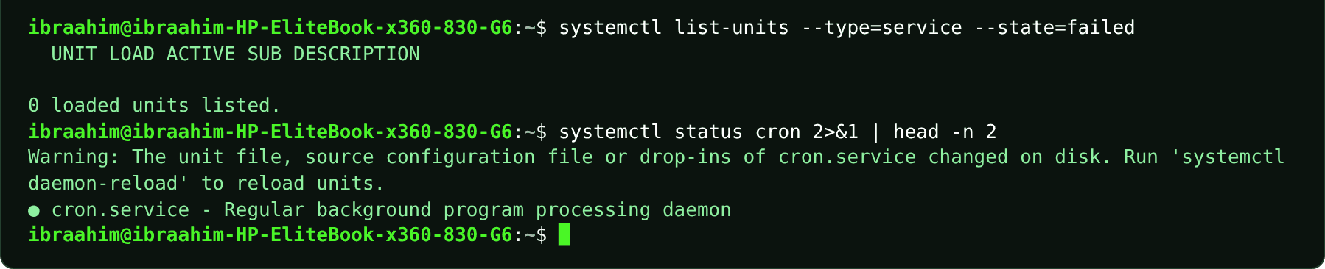

4.23 journalctl
Slide topic: 4.5 Logs, boot, and first troubleshooting
Definition
Reads the systemd journal, which collects messages from the kernel and every service, oldest first, in a pager. Narrow it down with -n (last N entries), -b (current boot), -p err (errors and worse), -u UNIT (a single service), --since, -xe (jump to the end with explanations), -f (follow live) and -k (kernel messages). "Insufficient permissions" means you should add sudo. _COMM=sudo filters by program.
Why students use this command
Use it to read system and service logs when troubleshooting.
Syntax
journalctl [OPTIONS] [MATCH]
Options and shortcuts
Option / Shortcut | Name | Description & Example Usage
-n N | The last N entries | Function: the last N entries.  Example: journalctl -n 3
-b | This boot only | Function: this boot only.  Example: journalctl -b
-p err | Errors and worse | Function: errors and worse.  Example: journalctl -b -p err
-u UNIT | One service only | Function: one service only.  Example: journalctl -u cron -n 4
--since "1 hour ago" | Start time | Function: start time (keep the quotes).  Example: journalctl -u cron --since "1 hour ago"
-e / -x / -xe | Jump to the end / add explanations / | Function: jump to the end / add explanations / both.  Example: journalctl -xe
-f | Follow new lines | Function: follow new lines; Ctrl+C stops.  Example: journalctl -f
-k | Kernel messages only | Function: kernel messages only.  Example: journalctl -k -b
_COMM=sudo | Show entries written by the sudo program | Function: show entries written by the sudo program.  Example: journalctl _COMM=sudo -n 1
Examples
$ journalctl -n 3
$ journalctl -b
$ journalctl -b -p err
$ journalctl -u cron -n 4
$ journalctl -u cron --since "1 hour ago"
$ journalctl -u ssh -n 20
$ journalctl -xe
$ journalctl -f
$ journalctl -u cron -f
$ journalctl _COMM=sudo -n 1
$ journalctl -k -b
$ journalctl -n 3 2>&1 | head -n 3
$ journalctl --version | head -n 1
Terminal output
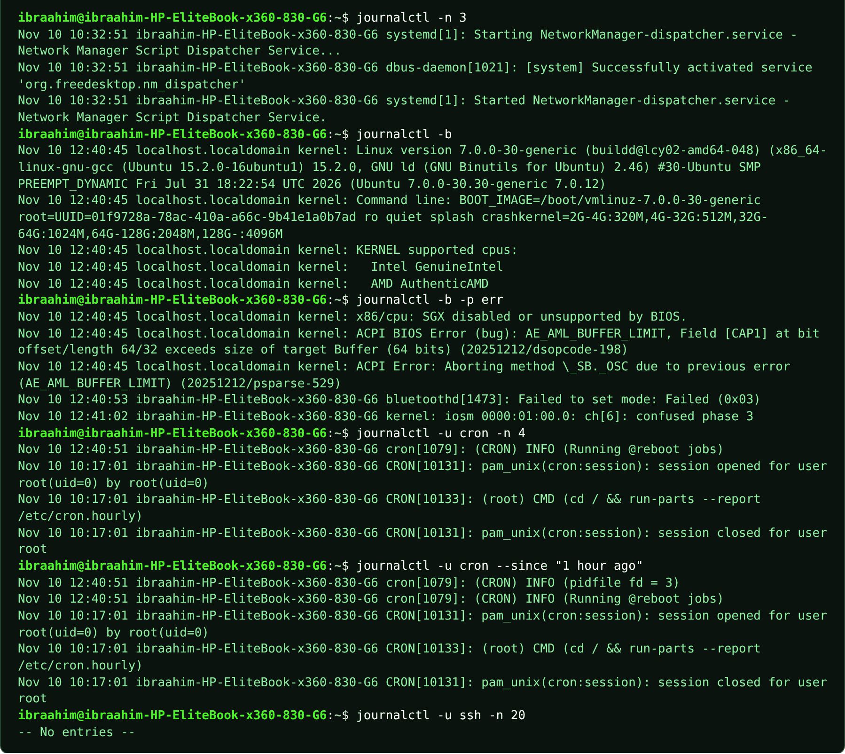
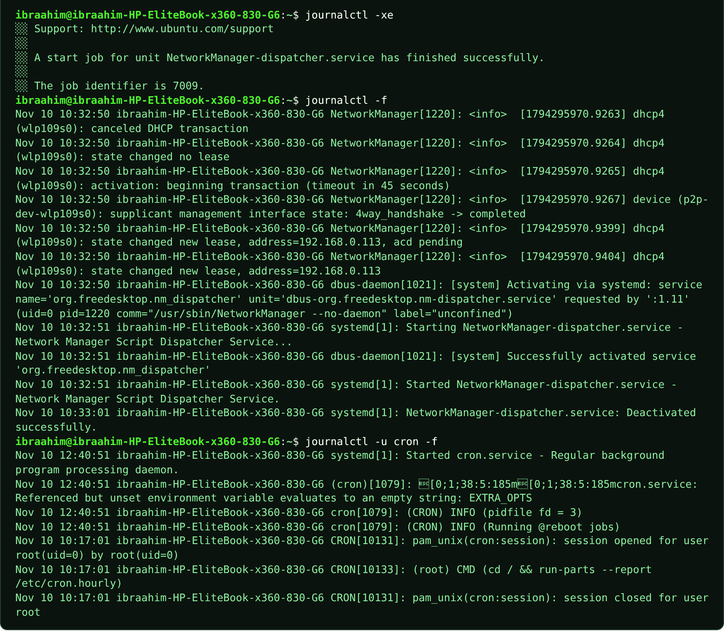
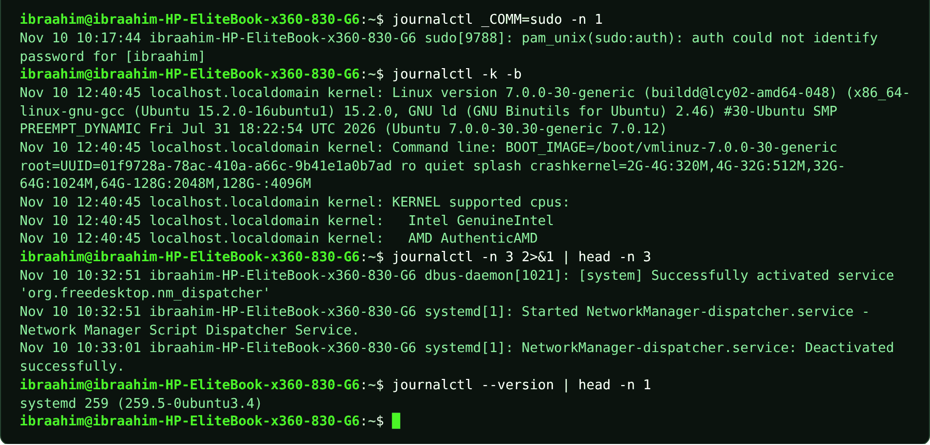

4.24 logger
Slide topic: 4.5 journalctl -xe and -f
Definition
Writes a message into the system log, which is useful for testing: run it in a second terminal while journalctl -f is open in the first.
Why students use this command
Use it to write test messages into the system log.
Syntax
logger [OPTIONS] [MESSAGE]
Options and shortcuts
Option / Shortcut | Name | Description & Example Usage
MESSAGE | The text to log | Function: the text to log.  Example: logger "Test message"
-t TAG | Tag the entry with a name | Function: tag the entry with a name.  Example: logger -t myapp "Test message"
-p PRIORITY | Facility.level, e.g. user.err | Function: facility.level, e.g. user.err.  Example: logger -p user.err "Test error"
-i | Log the process ID | Function: log the process ID.  Example: logger -i "Test message"
Examples
$ logger "week 8 test from ibra"
$ journalctl -f
Terminal output
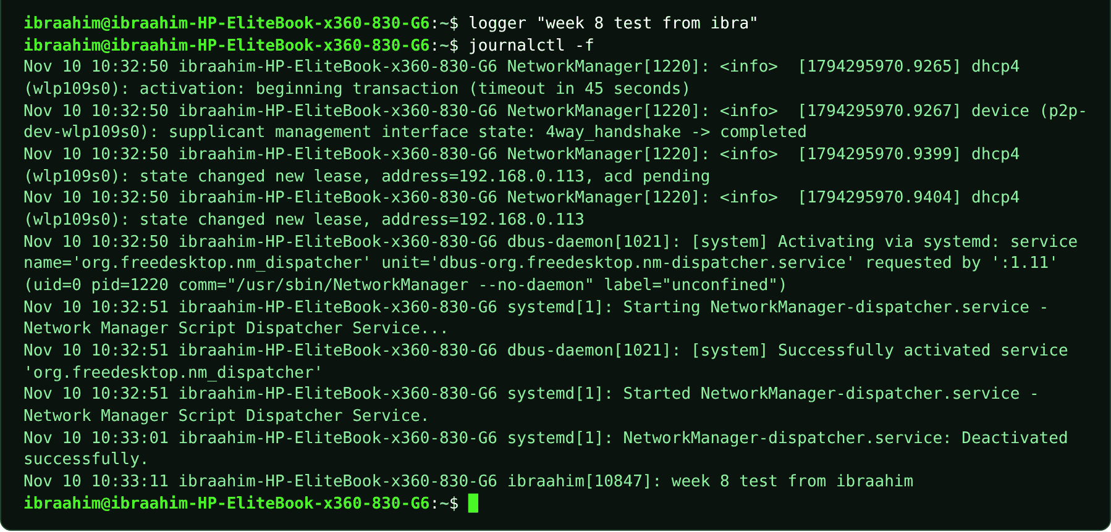

4.25 last
Slide topic: 4.5 auth.log: logins and sudo
Definition
Shows a list of recent logins and reboots, read from /var/log/wtmp.
Why students use this command
Use it to review who logged in recently and when the system rebooted.
Syntax
last [OPTIONS] [USER]
Options and shortcuts
Option / Shortcut | Name | Description & Example Usage
-n N | Show the last N lines | Function: show the last N lines.  Example: last -n 2
-x | Include shutdown and runlevel changes | Function: include shutdown and runlevel changes.  Example: last -x
-F | Print full login and logout times | Function: print full login and logout times.  Example: last -F
USER | Only this user | Function: only this user.  Example: last $USER
reboot | Show reboot records | Function: show reboot records.  Example: last reboot
Examples
$ last -n 2
$ last -n 2
Terminal output
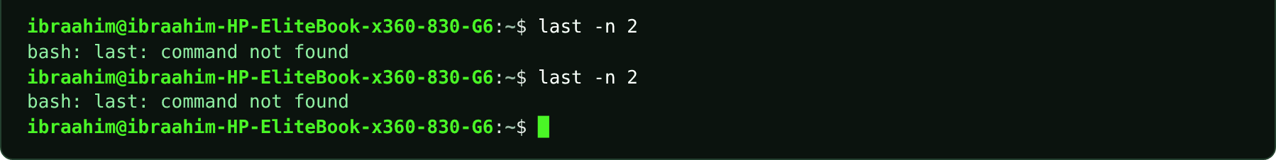

4.26 dmesg
Slide topic: 4.5 dmesg: kernel messages
Definition
Prints the kernel's own messages: hardware detected at boot, drivers loaded and devices appearing. Ubuntu restricts it to administrators, so a normal user gets "Operation not permitted" and must add sudo.
Why students use this command
Use it to read kernel messages when diagnosing hardware or driver problems.
Syntax
sudo dmesg [-T]
Options and shortcuts
Option / Shortcut | Name | Description & Example Usage
(none) | Kernel ring buffer, times in seconds | Function: kernel ring buffer, times in seconds.  Example: sudo dmesg
-T | Readable clock times | Function: readable clock times.  Example: sudo dmesg -T | tail -n 2
-l err,warn | Only errors and warnings | Function: only errors and warnings.  Example: sudo dmesg -l err,warn
-w | Follow new messages | Function: follow new messages.  Example: sudo dmesg -w
| less | Page from the very first boot message | Function: page from the very first boot message.  Example: sudo dmesg -T | tail -n 2
Examples
$ dmesg
$ sudo dmesg -T | tail -n 2
$ sudo dmesg | less
Terminal output
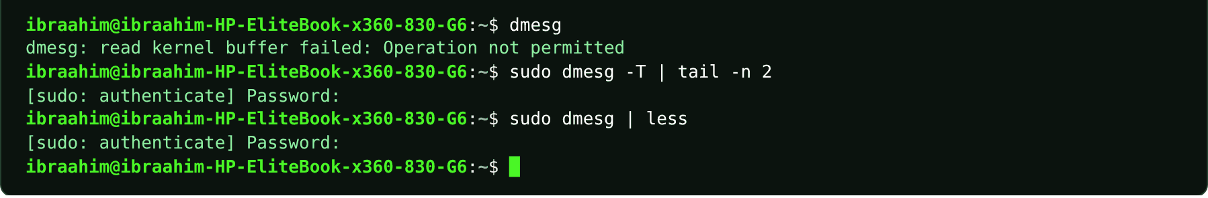

4.27 shutdown
Slide topic: 4.5 shutdown, reboot, poweroff
Definition
Powers the machine off cleanly so that services stop in order and the disk is fully written. Needs sudo. TIME can be now, +N minutes or a clock time. -r reboots instead of powering off; -c cancels a scheduled shutdown. Take a VM snapshot before boot experiments.
Why students use this command
Use it to power off or schedule a shutdown without risking data loss.
Syntax
sudo shutdown [-r] TIME [MESSAGE]
Options and shortcuts
Option / Shortcut | Name | Description & Example Usage
now | Immediately | Function: immediately.  Example: sudo shutdown now
+N | In N minutes | Function: in N minutes.  Example: sudo shutdown +5
-r | Reboot instead of power off | Function: reboot instead of power off.  Example: sudo shutdown -r +5 "Rebooting for the lab"
-c | Cancel a planned shutdown | Function: cancel a planned shutdown.  Example: sudo shutdown -c
-h | Halt/power off | Function: halt/power off (default).  Example: sudo shutdown -h now
Examples
$ sudo shutdown -r +5 "Rebooting for the lab"
$ sudo shutdown -c
Terminal output
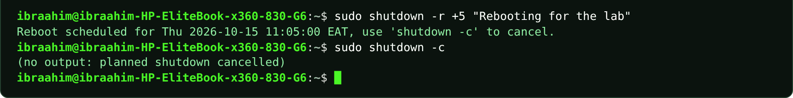

4.28 reboot
Slide topic: 4.5 shutdown, reboot, poweroff
Definition
Restarts the machine immediately (needs sudo).
Why students use this command
Use it to restart the system immediately after updates or changes.
Syntax
sudo reboot
Options and shortcuts
Option / Shortcut | Name | Description & Example Usage
(none) | Restart immediately | Function: restart immediately.  Example: sudo reboot
-f | Force without stopping services | Function: force without stopping services (dangerous).  Example: sudo reboot -f
--help | Usage summary | Function: usage summary.  Example: reboot --help
Examples
$ sudo reboot
Terminal output

4.29 poweroff
Slide topic: 4.5 shutdown, reboot, poweroff
Definition
Stops all services and switches the machine off immediately (needs sudo). In VirtualBox, "Power off the machine" is like pulling the plug; running poweroff from inside Linux is the clean way.
Why students use this command
Use it to switch the machine off cleanly.
Syntax
sudo poweroff
Options and shortcuts
Option / Shortcut | Name | Description & Example Usage
(none) | Power off immediately | Function: power off immediately.  Example: sudo poweroff
-f | Force | Function: force (dangerous).  Example: sudo poweroff -f
--help | Usage summary | Function: usage summary.  Example: poweroff --help
Examples
$ sudo poweroff
Terminal output

4.30 sshd
Slide topic: 4.5 A service misbehaves: a calm order
Definition
The OpenSSH server daemon. In the troubleshooting routine, sudo sshd -t checks the configuration file for errors before you restart the service; no output means the file is fine.
Why students use this command
Use it to validate the SSH server configuration before restarting the service.
Syntax
sudo sshd -t
Options and shortcuts
Option / Shortcut | Name | Description & Example Usage
-t | Test the configuration and exit | Function: test the configuration and exit.  Example: sudo sshd -t
-T | Test and print the effective configuration | Function: test and print the effective configuration.  Example: sudo sshd -T
-f FILE | Use another configuration file | Function: use another configuration file.  Example: sudo sshd -t -f /etc/ssh/sshd_config
Examples
$ sudo sshd -t
$ ls /etc/ssh
Terminal output


